
Volume 1 Number 1 | k-f-g-online.info | Co-Edited by: | D. Keeney & M. Winner
Welcome to the first issue of
The Keeney Researcher an online genealogy newsletter.

 | Please consider sharing information you may have. It may help someone hurdle a brick wall and they will appreciate it. And you never know they may even have something that they can share with you. Even sharing a photograph of an ancestor is a step in the right direction. | 
Send items to either Dan Keeney or Mary Winner using 'The Keeney Family Researcher'
for the subject line.

Submitted by Sharon Galitz a newspaper story:
Joliet Signal, 27 July 1858,

"Haskins, John, shot by Nelson Kinney, Monee, 7/17."
"MURDER - Two men, partners in the plastering business at Monee, in this county (Will, Illinois), named John Haskins and Nelson Kinney, got into an affray, on the 17th inst., which resulted in Kinney's shooting Haskins, who died from the effect of the wound received, on the day following. It appears that Kinney was jealous of Haskins, suspecting him of undue intimacy with his wife, which was the cause of the quarrel. Haskins died confessing the crime of which Kinney suspected him. The latter is in custody."
Note from: Sharon Galitz
The correct names were John L. Haskin and George Nelson Keeney. They were brothers-in-law; John Haskin was married to Clarissa Elizabeth Keeney. No marriage has ever been found for George Nelson Keeney, and Clarissa Keeney Haskin went on to marry twice more.

Jim Person sent this in after I requested if he knew anything about it. I had remembered reading it some time ago but forgot where I had seen it online.
Eli Keeney (1845-1879)
son of Captain Jonathan Keeney died in a shoot out at the Headquarters saloon in Bozeman, MT. His brother Elias was also at the bar. Not to be confused with their uncle's Eli and Elias Keeney sons of John Jr. Keeney. My grandpa Bud always insisted that Eli Keeney (1828-1878), whose grave he maintained in the Keeney Cemetery, was the Eli that died in the shootout. I tried to explain it to him once but he got very angry so I never tried to correct him again.
Bud was Vaderon E. Keeney (1921 - 2012)
Editors note the date of the Friday mentioned would have been 31 October 1879
The following is a transcription from the newspaper article from Bozeman:

A Double Tragedy. A double tragedy, in which two men met their death at the hands of each other, occurred about six o'clock on Friday evening last, in the Headquarters Saloon. The circumstances, as near as we have been able to gather them were as follows:
On Friday evening, in the Headquarters Saloon, Wm. Roberts and Eli Keeney, strangers to each other, had a dispute and quarrel, during which Keeney called Roberts a liar, etc. Roberts said, "I am a boy yet, but little more than twenty-one, but I am man enough not to take the lie from anyone." He then asked Keeney if he was "heeled." Keeney said "no." Whereupon Roberts took off his revolver and cartridge belt and handed them to E. J. Keeney, brother of Eli, with who he was acquainted, to hold, while they fought it out. They then engaged in a rough and tumble fight in which Keeney came out second best. Keeney then left the saloon, and Wm. Roberts, his brother Sim, and E. J. Keeney stepped out on the sidewalk in front of the saloon together. Here E. J. Keeney said to Wm. Roberts: "Do you know who that man is you just whipped?" Roberts said, "no." Keeney then said, "He is my brother." "My God," said Roberts, "If I'd known that I'd have taken anything from him." E. J. Keeney then said, "That's all right, he insulted you and deserved thrashing."

In a few moments the party re-entered the saloon, where they were soon joined by Eli Keeney, who, it seems, had during his brief absence gone up the street about one and a half blocks to his buggy, in which his wife was seated, waiting for him to go home. He took his revolver from under the seat and returned to the saloon, as above stated. On entering the saloon he was met by his brother, E. J. who talked to him about the matter, telling him he was making a fool of himself, etc., and endeavored to persuade him to start for home. While they were talking together, Keeney advanced toward Roberts, who was standing at the corner of the piano stand, and when almost close enough to touch him, suddenly and unexpectedly drew his revolver and fired, the ball taking effect in Robert's body. Blood spouted freely from the wound, and the man staggered, but rallying, pulled his revolver and fired at Keeney.

Both, fell, when Roberts fired at Keeney the second time. In the meantime, and almost simultaneously with the first shot fired by Wm. Roberts, Sim Roberts also fired at Keeney. Seeing his brother and his assassin both lying on the floor, Sim commenced backing out of the room. J. L. Sanborn, a deputy sheriff, then attempted to arrest him, but Sim kept him and others at bay by firing his revolver over them, and under them through the floor. He then went to Fridley Bros. Stables, selected his horse, carefully reloaded his revolver and started, heedless of attempts on the part of the sheriff to halt him as he left the stable.

When the shooting commenced the saloon was full, but it was soon emptied, and when the shooting was over the building was promptly closed by authorities and the Coroner sent for. On his arrival the bodies were found just as they fell, Roberts with one wound, the ball having entered his body on the left of the median line, just below the lower rib, ranging upward, cutting off the main artery to the heart in its course and lodging in the back. He lived about ten minutes, but never spoke.

An examination of Keeney's body showed him to be wounded in three places, any one of which would of killed him almost instantly. One shot had just chipped his chin and then passed through his neck, severing the spinal cord in its passage. Another shot had entered the opening of the left ear, passed through the lower portion of the cerebrum and came out on the other side of the head,
about two inches from the opening of the right ear. The other shot entered his body on the front edge of the left shoulder; it also passed entirely through the body, breaking the backbone in its course and coming out of the back near the inside of the shoulder blade. The shot through the head was undoubtedly fired by Sim Roberts. The shot through the neck, by Wm. Roberts before he or Keeney had fallen, the position of the men, the course of the ball and the hole in the floor, through which one ball had passed, leading unmistakably to this conclusion.

The Coroner's Jury, after a thorough examination into all the circumstances of the case, gave a verdict in accordance with the facts above recited, viz: That Wm. Roberts came to his death from a pistol shot fired with felonious intent by Eli Keeney, and Eli Keeney came to his death at the hands of Wm. Roberts, in self defense.

Eli Keeney came to Montana about two months since, from Oregon. He was known to be a very quarrelsome disposition, especially when under the influence of liquor, as was frequently the case. He leaves a wife and two children.

Wm. Roberts came to Montana from Wyoming, in July of last. He was born in Texas in July, 1857, but has been engaged in herding cattle in Wyoming and Nebraska since 1876. Since he has been in Montana he has been working for the Montana Cattle Co., whose herds range on the Muscleshell. His father and mother are both dead, but he leaves a step-mother and two step-brothers in Texas.

Sim Roberts left his home in Texas in May 1878, and went to Wyoming, where he assisted his brother in herding until February 1879, when he came to Montana and went to work for the Montana Cattle Company. He is two years younger than his brother William, being 20 years of age last October. On the night of the shooting, he says he would never have left the saloon but for Sanborn's attempt to arrest him. He was a stranger in town, was not aware that Sanborn was an officer of the law. Fearful that in the excitement following the shooting and death of two men, the people might mob him, he concluded to leave town if possible. He rode from here to Benson's
landing, on a horse without saddle or bridle, in three hours, making ten miles an hour.

He immediately sent in a friend to see that his brother was properly buried and ascertain if it would be safe for him to return and surrender himself to the officers of the law. The messenger arrived him Saturday, with a request to Sim to come in and attend the funeral of his brother, which was set for 2:30 pm Sunday. The message did not overtake Mr. Roberts, however, until 4 pm Sunday, on Sweet Grass, 116 miles from Bozeman. He immediately started for town, and arrived here Monday evening. No attempt being made to arrest him, on Tuesday he voluntarily appeared before Probate Judge McPherson, waived examination and gave bonds in the sum of $4,000 to appear before the Grand Jury, which convenes in Bozeman on Monday next.

Eli Keeney was buried on Saturday last. A committee of citizens, consisting of G. W. Wakefield, Nelson Story, Geo. Ash, Warren Evans, Walter Cooper, L. S. Wilson, J. D. Chestnut, H. B. Galfee, P. O. Worsham and J. S. Mendenhall, in the absence of relatives, took charge of the body of William Roberts, and the funeral took place on Sunday from the M. E. Church, Rev. C. L. Richards officiating. The funeral was one of the largest ever seen in Bozeman.
Source: The Avant Courier, 6 November 1879, Bozeman, Gallatin Co., Montana [the above article also showed a diagram of the crime scene] Another version located online.

Mary Winner found this online @ http://www.langeonline.com/Heritage/bjorkman.html
It can also be found @ http://genforum.genealogy.com/keeney/messages/385.html

I thought I was related to the John who married Sarah Webster but the ages didn't make sense. I now see that I am related to the other John.

PROOF FOR JOHN KEENEY m. SARAH WEBSTER (courtesy of Gwen Boyer Bjorkman)
Donald Lines Jacobus and Edgar Francis Waterman, Hale, House, and Related Families, (Baltimore: Genealogical Pub. Co., 1978, c1952), p. 587 and also Donald Lines Jacobus, “John Case Family of Glastonbury, Conn”. The American Genealogist (July 1949) 25:205-206.

Sarah Webster m. John Keeney [b. 1699] son of Joseph Keeney and Hannah Hills [not John Keeney b. 1712]. John Keeney (b.22 May 1699) m. 1st Mercy Smith, b. abt. 1706, dau of Samuel and Mary (Church) Smith and 2nd after 1749, Sarah (Webster) Case, b. at Glastonbury, 13 Jan 1718/19, dau of Jonathan and Esther (Judd) Webster, widow of John Case.

On 17 July 1727 Jonathan Webster’s deed from John & Mercy Keeny. Wee John Keeny and Mercy his wife of the Town of Hartford in the County of Hartford … for 30L to Jonathan Webster of Glastonbury … a piece of land partly in Glastonbury and partly in Hartford bounded west upon the Connecticut River, east on present county road, north on land in the improvement of the widow Mary Smith and south on the land of Mary Smith the younger … [Glastonbury, Hartford Co, CT DB 3:156]

On 18 Feb. 1746/7, Jonathan Webster of Hartford conveyed for love to his son-in-law John Case and Sarah his wife of Glastonbury [Glastonbury Deeds, 5:26]. This deed seems to have been missed by the compilers of the Webster Genealogy, which states that Sarah Webster married a Keeney, that being proved by her father's will.

The inventory of the estate of John Case of Glastonbury was taken 1 July 1749 by Jonathan Webster of Glastonbury and Timothy Porter, Jr., of Hartford. Jonathan Webster was surety on the bond of the widow, Sarah Case. The small estate was insolvent and half of it was set out to the widow. [Manwaring's Digest, 3:521.]"

Therefore Sarah Webster Case m. John Keeney after this 1749 inventory and before Jonathan Webster’s will was written in 14 Sep 1758 where he names his dau Sarah Keeney [Hartford Wills from the Webster Genealogy]

While all of this was going on, our John Keeney [b. 1712] was having children: Anna b. 1739, Mark b. 1740, Ephraim b. 1742, Mary B. 1746, Esther b. 1754 and more. Our John Keeney was in the deed records of Stratford, Fairfield Co. from 1737 to 1752 and in Kent, Litchfield Co. from 1752 to 1774 and in Washington in 1784. It would have been quite unlikely for Sarah Webster Case who was married to John Case up until his death in 1749 to have been the mother of these children b. 1739 to 1754.

Andrew Jackson Keeney  1822 - 1898 | Eli Keeney  1828 - 1878
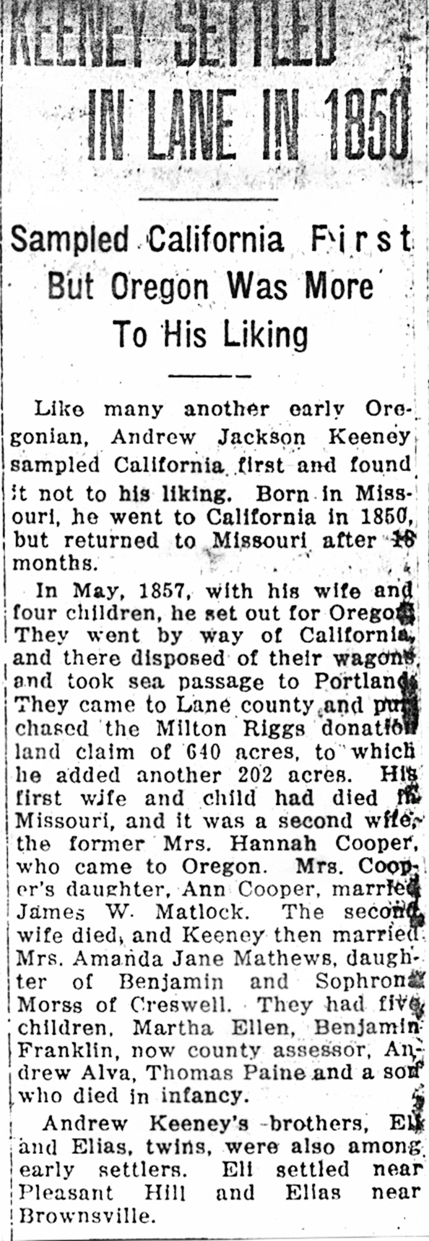 | 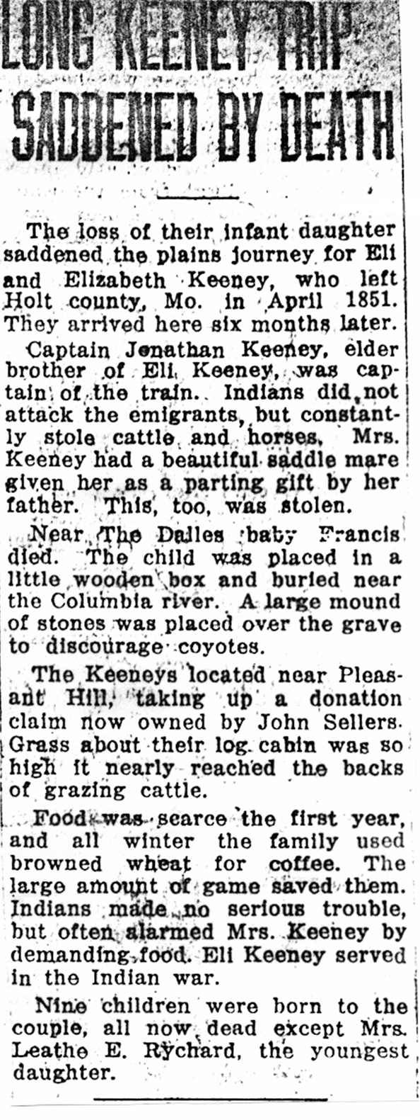
Frank Abner Keeney 1867 - 1958

The first time I heard about the Keeney Music Hall was on November 20, 2001 by way of Betty C. Richards at the time I tried looking it up online and didn't really find much on it. I then got busy doing other things and it slipped to the side of things to do.

Then in the 2009 issue of KFG I was asked if I knew anything about Frank Keeney who owned the Keeney Theater in Brooklyn, NY. I looked online again and found a little bit about the theater and it's owner. It got pushed aside yet again and then at the beginning of the summer 2014 I dug up quite a bit about Frank Keeney and his several theaters. As far as I can tell all were vaudeville theaters when established and then movie screens were eventually added and both types of entertainment were offered.

In attempting to research the Keeney Theaters it looks like that around 1926 Loews bought out 3 of the theaters that Frank had, as near as I can figure out the names appear to be this way.

1. | Keeney Music Hall (Keeney's Theater) 1915 - 1926 was located at  300 Livingston Street, Brooklyn, NY 11217 when sold 9 June 1926 it became Loews Livingston Theater then was renamed in 1928 to Loews Melba Theater which was demolished in 1954 and is now is a four level parking & commercial building.
2. | Keeney's Bay Ridge 1921 - 1926 was located at 7120 Third Avenue, Brooklyn, NY 11209 became Loews Bay Ridge Theater now it's a McDonald's and Rite Aid
3. | Keeney's Bedford Theater 1924 - 1926 was located at 1372 Bedford Avenue at Bergen Street Brooklyn, N.Y. 11216 became Loews Bedford Theater and is now a church.

I keep finding more theatres that he owned and will just add them to the PDF below. Newspaper advertisements from 1909 also found a Keeney's Theatre at 323 Wall Street, Kingston, New York that was built in 1918/19 I'm not sure why the date conflict is there but it is.

Mentions of Keeney Music Hall and Keeney theaters

- Barbra Streisand Archives
- Funny Girl (Fanny Brice)
- Photo's Loews Melba Theater managed by Frank Keeney
- Loews Bedford managed by Frank Keeney
- Keeney's Bay Ridge Theater
  - A seating chart found in a free ebook on Google
  - A PDF file with a collection of items relating to Frank and his theaters.

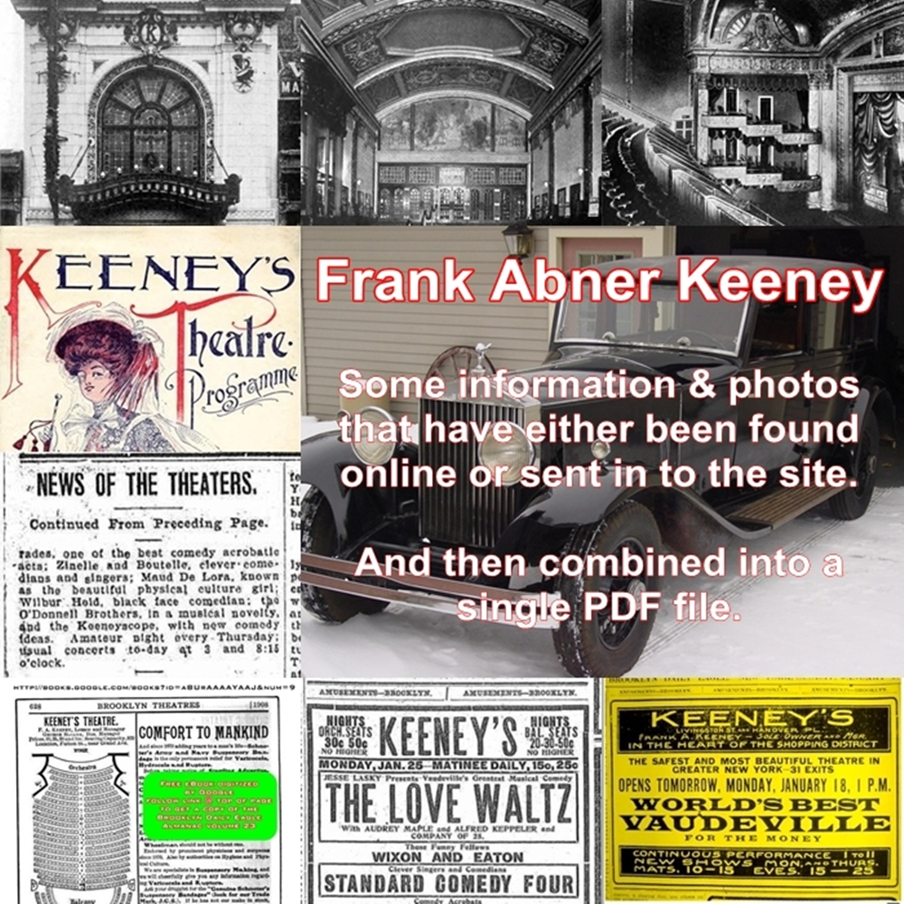

Daniell Lee Keeney
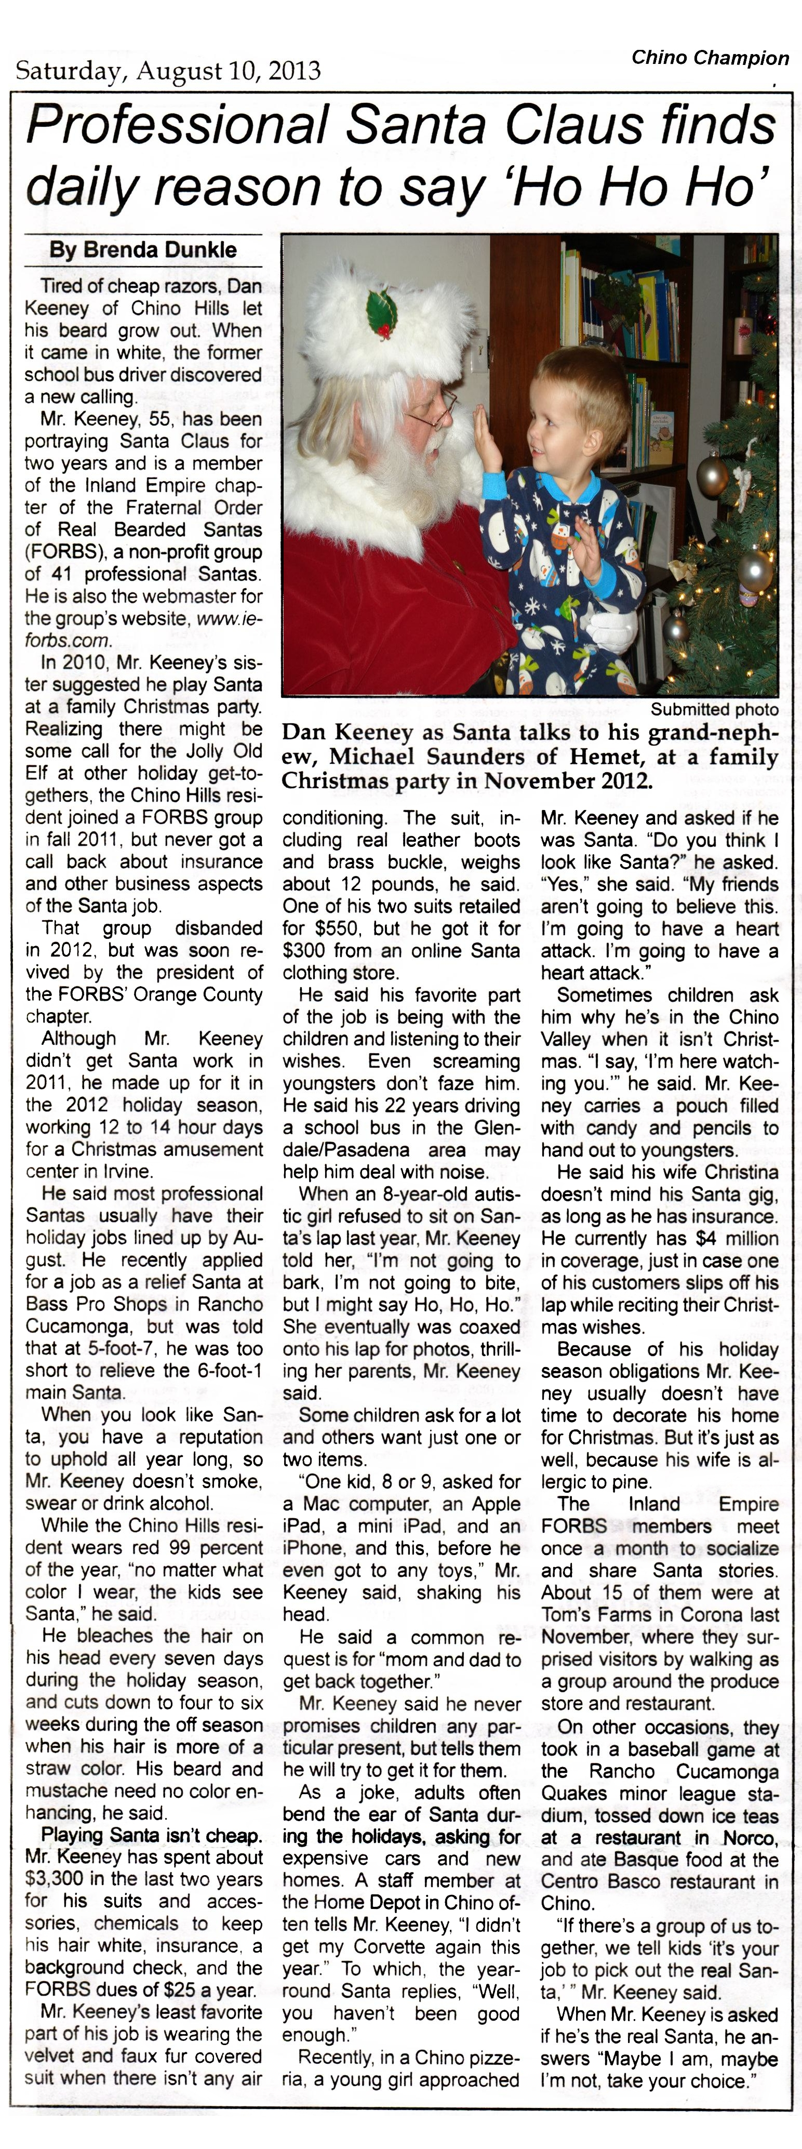
Here's a link to a larger image of this article. When the web page opens move your mouse over the image and it should change to a magnifying glass with a + plus sign then just click on the image for a full size view.

Note: the original article was published with the same photo in black & white. There are a couple of mistakes the biggest one being Chino Hills it should be just Chino the other being that I do not refer to children as being kids. I'll either say children or child

Keeney Obituary links
I found 91,400 links using Keeney Obituaries as a search term here are a few.
Durbin Keeney, Jr. 1948 - 2014
Marie J. Keeney 1959 - 2014
Whitney K. Keeney 1988 - 2010
John W. Keeney 1933 - 2013
James L. Keeney 1937 - 2014
Richard Keeney 1947 - 2014
Esta Mae Keeney 1917 - 2014
Danny L. Keeney 1941 - 2014
Mary J. Keeney 1925 - 2014
John E. Keeney 1971 - 2014
Larry E. Keeney 1955 - 2014
Walter K. Keeney 1926 - 2014
Allan L. Keeney 1941 - 2013
Dr. Bradford L. Keeney 1949 - 2014

I was looking for a photo of the John David Keeney family of Keokuk, Iowa for the March 1988 Keeney Update & I found this by accident it's a PDF on Captain Jonathan Keeney and it has some newspaper clippings & photos that I have not seen before in it. The file contains 16 pages.
http://www.oregonpioneers.com/bios/JonathanKeeney_1846.pdf

If anyone has access to old newspaper archives maybe they could send in a link for better copy of the following:
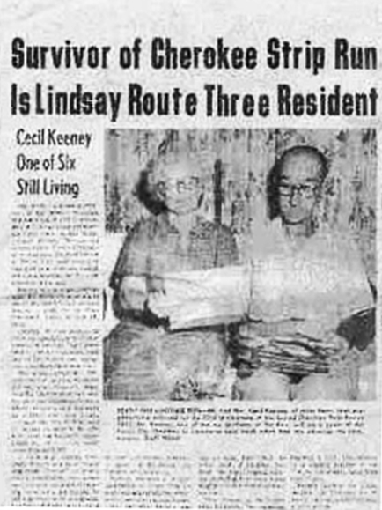

This may have come from Lindsay, Oklahoma but I am not sure of that or even when it was published.

As you can tell the only parts that are readable are the Headline & the sub-headline.

Submitted by: Mary Winner

Are We Correctly Identified?

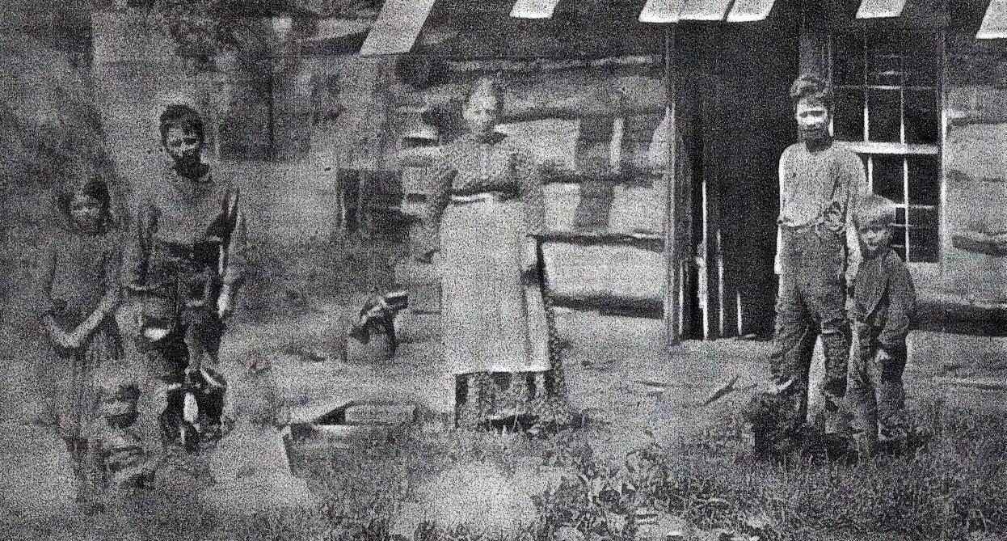
Larger image

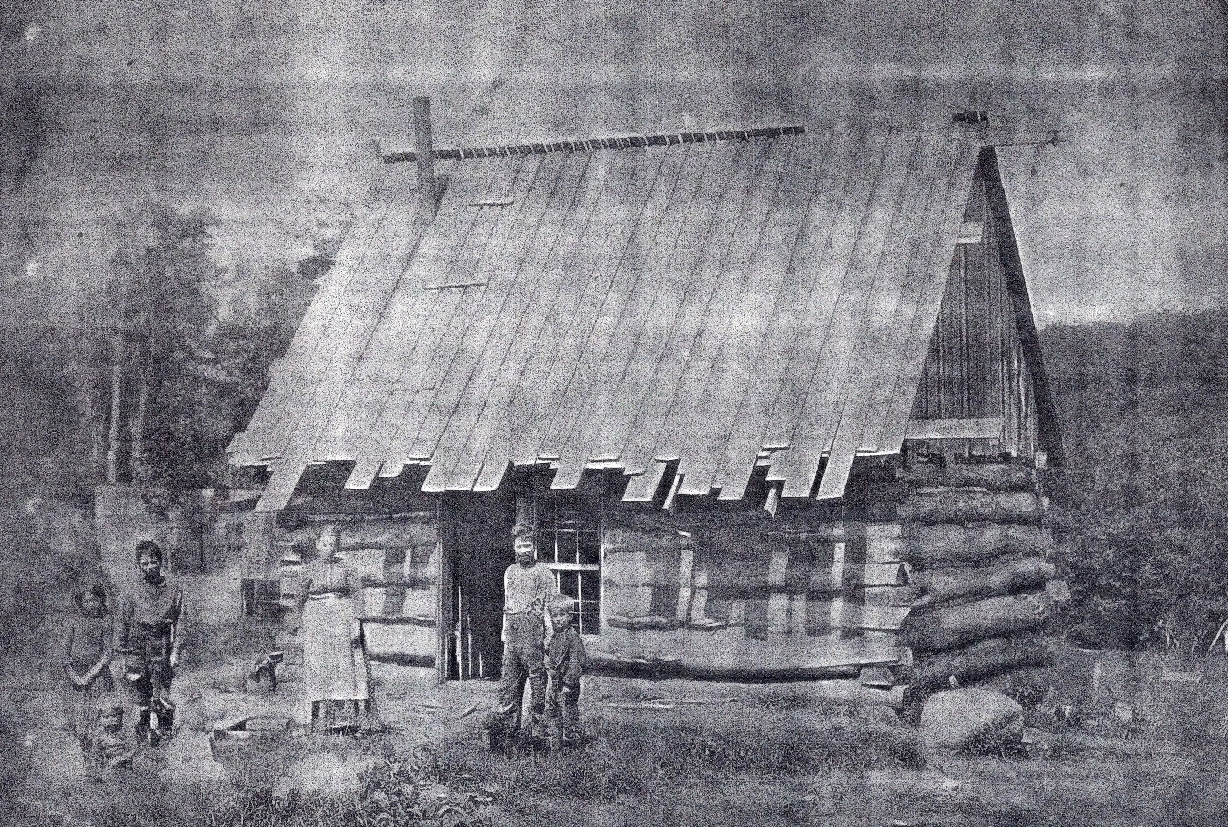
Larger image

This is the log cabin my great grandfather built in Osceola, Lewis, NY. The picture was taken around 1900 because the baby on the blanket is Harriet Abbey Keeney who was born in 1900. I was informed that the baby was Hattie, the boy closest to the door was Justus and the women was Hattie Abbey Keeney my great grandmother.

Right to left my best guess is Edna Keeney Mellen 1891-1967, Harriet Abbey Keeney Kinney 1900-1955, George Ellsworth Keeney 1886-1938, Harriet L Abbey Keeney 1858-1915, Justus Thayer Keeney 1884-1955 and Adelbert Keeney 1894-1962.

Maybe someone in the family will see this picture and let us know if I got them correct.

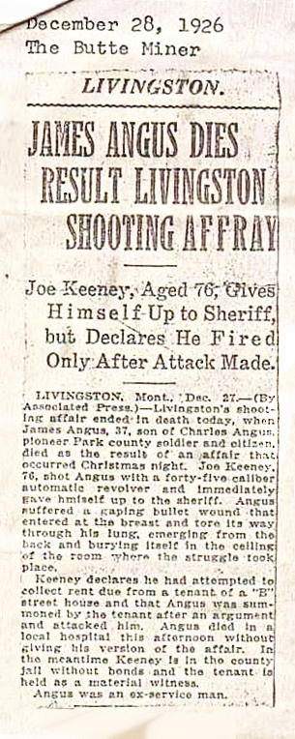
Another newspaper clipping of a Keeney involved shooting. This on Joseph Elias Keeney (1850 -1938) also a son of Captain Jonathan Keeney. This is the brother of Eli Keeney in the 1879 Headquarters saloon shooting in Bozeman, Montana above.

So this is the first issue put together with some submitted items, some from the site and some found online.

Let's make the next issue even better!!!

Send in items you have and we will get started on another issue, we are only committing our selfs to two issues a year to start with but if enough is sent in to make up at least an 8 page issue as printed from either the word document or the PDF we will put them out at the rate we receive enough items.

Don't forget by sending items in you maybe helping someone over a brick wall.

Send items to either
Dan Keeney or Mary Winner
using 'The Keeney Family Researcher' for the subject line.

Facebook Page

