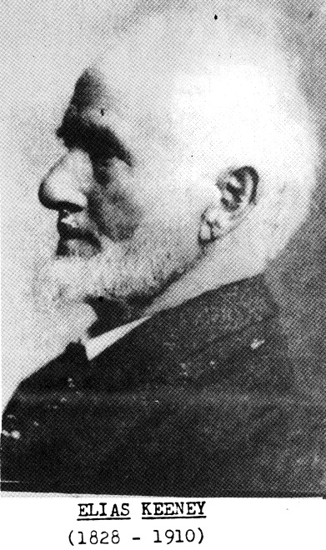
Keeney Update
VOL VI, Number 1 Roscoe C. Keeney, Jr. FEB 1989

Pioneer Keeney Family
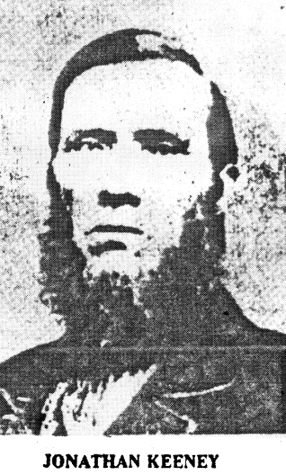
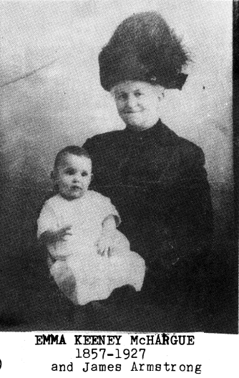

Father of Emma (Keeney) McHargue
The Times THURSDAY JUNE 17, 1976 OREGON
The history of Brownsville would not be complete without the story of the pioneer “Irish” Keeney family.
Jonathan and Elias Keeney came to Brownsville with Hugh Brown and his nephew, James Blakely, in the fall of 1846. Jonathan Keeney had been on the West coast as a fur trapper when a young man.
He had trapped with Jim Bridger, Sublette and others up and down the Continental divide. Jonathan returned to Missouri with the firm idea of coming to the Oregon country.
He sold his farm holdings in Holt County, Missouri and married. Son of John Jr. and Mary Ramsey Buckhalter Keeney
There were 2 young sons when he came to Oregon. It is not CAPTAIN JONATHAN KEENEY: Mountain Man with Jim
known for sure if Jonathan captained the wagon train to Bridger-Wagon Scout, Pioneer of Oregon Trail and Barlow
Oregon; but he was surely a good guide for the party, as he Road, Settler, Miner, Soldier, Inn and Ferry Proprietor
had traveled up and down the rivers and mountains with the fur traders. Elias Keeney, Jonathan’s younger brother came with the party.
In 1849 a number of Brownsville men went to the gold fields in California. Elias Keeney came back to Linn County with $15,000 in gold. He had in mind returning to Missouri, buy cattle, and drive them to Oregon where they were so badly needed.
Elias Keeney rode horseback to Holt County in three months-in 1850-no small feat in midwinter! Elias married soon after reaching Missouri; and the return trip to Oregon was his honeymoon.
In the spring of 1851 the long trip back to Oregon started. The party included Jonathan and Elias’s 68-year-old widowed mother, Mary; his twin brother, Eli and brothers James and Andrew Jackson Keeney/
The five Keeney brothers and 1 sister were the children of John Keeney and his wife, Mary Ramsey-Buckhalter. The family had lost 3 sons with T.B. within a five year period in the early 1840’s.
These young men were all married and left young children. Some were brought to Oregon to live among relatives.
Elias Keeney did purchase cattle in Missouri to bring to Oregon; but the Indians stampede the herd and many were lost.
The Calpooya Valley must have been a welcome sight in the fall of 1851, after the long hard trip across the plains.
My grandmother, Sarah Keeney, was 7 years old when she came with her family to Oregon.
In later years, she told me of the many trial and tribulations of the 6-months long trip. But, to her, the most frightening experience was after they reached Brownsville.
A short time after they had arrived in the Calapooya Valley, Indians-no respecter of any one’s privacy-entered the Keeney’s living quarters unannounced.
The children, having heard so many stories of Indian scalping parties, thought they were doomed.
They hid under mother’s very full skirts and thought they were safe. The Indians wanted tobacco. They were given the tobacco, grabbed food form the table and left.
The original Irish Keeneys came to America before the Revolutionary War; and migrated out to Virginia to East Tennessee.
They did not believe in slavery and left, n the early 1800’s for Fayette County, Indiana. All of the children of John and Mary Keeney were born in Indiana…except their twin sons, Eli and Elias, who were born, in 1828, in Ray County, Missouri.
The Keeneys were stock raisers; and as they pioneered new areas, they established ferry boats across the rivers and helped establish Hard-Shell Baptist Churches. There were a number of Baptist ministers in the family.
In Missouri, Mary, a daughter of Thomas Keeney, a Baptist minister, married Tolbert Kelley, the son of a Methodist minister. The Keeney family practically disowned her.
The young couple left Missouri and returned to Tolbert Kelley’s old home in Kentucky; but as the Civil War drew nearer, they were anxious to leave Kentucky.
The Missouri Keeneys forgave them, as they were wanting to see their Kelley grandchildren. Tolbert and Mary Kelley returned to Missouri with the intention of coming to Oregon. But Tobert died suddenly and the children had measles. These, and other problems, prevented Mary Kelley from starting to Oregon for several years. Mary finally arrived in Lane County and lived among Keeneys and Mulhollands, her relatives.
During the early Oregon Indian Wars several companies of volunteers were formed from Linn County. James Blakely and Jonathan Keeney both captained companies. Elias Keeney became noted as an excellent Indian fighter.
He fought in the Cayuse Indian uprisings; and was one to the party sent from Fort Vancouver to Walla Walls, Wash. To help run down the Indians who murdered the Whitmans.
Capt. Jonathan Keeney was in southern Oregon during the Indian disturbances of mid 1850’s. It was mostly guard duty, as the Indians were threatening to wipe out the settlers.
Shortly after 1870, Capt. Jonathan Keeney and part of his family left his beloved Calapooya Valley, moving to eastern Oregon.
Once again he had wide-open rangeland for his stock and a ferry on the Snake River. He died on his ranch on Willow Creek in Baker County.
Some members of the family followed him into that area; but many remained in Linn and Lane counties.
In Linn county many of the descendants ot the 5 pioneer Keeney brothers had inter married with other early pioneer families…to mention a few: Overtons, Warrens, Wigles, McHargues, Pearls, Michaels.
The Keeney cemetery on Coburg Road in Lane County, is the resting place of many descendants of Eli and Andrew Jackson Keeney.
By ELSIE BENNETT-BROWNING, a Great-Great Granddaughter of James Keeney and his wife, Catherine Stewart-Keeney

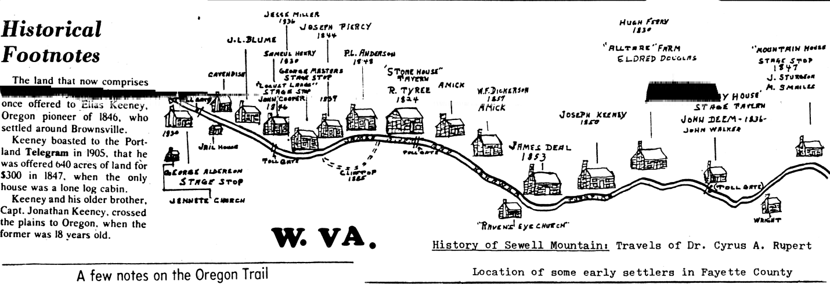

Editor: A pamphlet published and distributed by The Oregon State highway Department states as follows:
“The trail to Oregon from Independence, Missouri, after traversing the great plains to Fort Laramie, crosses the Continental Divide at South Pass, Wyoming. The main trail swings south by way of Fort Bridger and descends the Snake River system to Old Fort Boise. Thence over the rugged Blue Mountains to the Columbia River as far as Rowena Bluffs. Emigrant at this point were faced with the unhappy choice of surrendering most of their worldly possessions as payment for passage to the river men or making a winter crossing of the Cascade Range on the Barlow Toll Road.
Several early Indian Trails did lead through the Cascades into the Willamente Valley and were used by the early pioneers to drive cattle or pack animals or be traveled by foot. One of these trails was followed to a great extent and later improved and became known as the Barlow Road.
Another pamphlet published in 1943 by the Oregon Trail Centennial Commission contains an illustrated map clearly showing the Oregon Trail commencing at Council Bluffs, Iowa and Independence, Missouri and then ending at Seaside, Oregon. It lists the following as separate trails, or roads; Moron Trail, Applegate Trail, Naches Pass Trail and Barlow Road. The fact, or distinction as to the exact location of the Oregon Trail’s ending, brings forth the following questions of inquiry: What are we seeking; The end of The Oregon Trail or the end of The Oregon Wagon Road? If it is the latter, then it would seem that The Dalles, or more properly, Rowena Bluffs, could very well be designated as the end of the road, but not he trail. The first wagons upon reaching The Dalles, could travel no farther, so they were abandoned, or loaded onto rafts to be transported on down the river. Upon reaching the Cascade Rapids they were taken ashore, and again assembled to travel along another part of the trail, or road, and upon completion of this portage, were again loaded onto the rafts and taken by the water route on to Portland and the Willamette Valley.
If we are seeking the destination for the end of The Oregon Trail, not Wagon Road; then Seaside, or Oregon City may very well be the true end of the trail. Whatever particular spot that each individual pioneer considered to be the end of his own journey. For example: My ancestor, Uncle Jonathan Keeney, being an early pioneer to Oregon in 1946 and a settler of the Willamette Valley, near Brownsville went out on the trail to meet his old friend from Missouri, Wm. Templeton who in 1847 had followed Keeney to Oregon. Upon reaching the valley by way of The Barlow Road, Templeton had stopped in Howell Prairie near Salem because his oxen could go no farther and here he was cutting logs to build a shelter for the winter when Keeney arrived. Jonathan said, “Come on Billy, you haven’t reached

Oregon yet!” He brought them on to the Calapooya Valley, letting them live in a small cabin on his place and supplying them with fresh meat and flour to get them through the winter.
It has been stated that Ezra Meeker marked the trail in 1906, and started on his eastward journey in March of that year, erecting the first stone monument in The Dalles. He arrived here on the Bailey Gatzert with his wagon and oxen for his return trip across the plains. J.L. Kelley, mayor of The Dalles, allowed him to park his covered wagon on Liberty Street at Union park, preparatory to the dedication of a band stand and Old Oregon Trail monument, and on March 11, 1906 the monument bearing the legend End of the Oregon Trail-1843-1906, was dedicated by Ezra Meeker. The stone had previously been cut, lettering selected, and it had been engraved and set by a committee of citizens from The Dalles sometime before Meeker’s arrival. The weather was cold, and the attendance to the dedication was small. Meeker remarked; “The World will little note not long remember what we say here, but it can never forget what they did here.” (Lincoln)

Ralph R. Keeney
The Dalles
ABNER KEENEY OF MISSOURI
1. ABNER KEENEY, b. 8-30-1810 in Pulaski Co. KY; son of Moses (Ca. 1770-1847) and Catherine Pence Keeney (b.
1770-75, d. by 1835), married 12-13-1792 in Madison Co., KY; grandson of Peter Keeney, head of first Keeneys in
KY; d. 1-9-1895, Texas Co., MO; Prescott Cemetery; wife: Elizabeth (b. 3-4-1810 in KY, d. 8-18-1902; buried at
Arthur’s Creek Cemetery, Texas Co.
2. HENRY A. KEENEY, b. 12-1838 in Pulaski Co., KY; d. 7-23-1922 at Houston, Texas Co., MO m. Elizabeth Jane
Reagan (b.4-15-1839, died 8-20-1909) on 3-22-1863 at Rolla, Phelps Co.
3. JULIA KEENEY, b. 1858 (12 in 1870 census)
3. JOHN KEENEY, b. 1859 (11 in 1870 census)
3. MARION B. KEENEY, b. 6-1865, d 1956; wife: Nancy Ellen (b. 3-1877, d. 1943); children: Lennie (f), b. 9-
1895; Nellie, b. 8-1896; Pearlie, b. 10-1898
3. MARTIN KEENEY, b. 5-1866; Wife: Eliza (b. 3-1875); Children: James H. Keeney, b. 2-1896, d. 1944, wife:
Julia (b. 1898), bur. Boone Creek Cem.; Bertha Keeney, b. 6-1899
3. ISAAC M. KEENEY, b. 1868 wife: Eliza Ann (5-10-1875, 6- 25-1900, buried at Prescott Cemetery, Lynch
Township
3. MARY C. KEENEY, b. 1870
3. JAMES KEENEY, b. 1871
3. MAHALA KEENEY, b. 1873
3. HENRIETTA KEENEY, b. 1874
3. WILSON KEENEY, b. 7-23-1875, d. 12-1934 m. Vergolia Elizabeth Hassell (b. 4- 21-1884 at Licking, MO, d. 5-
20-1966), Hill Cemetery; m. Ehud Dollar after Wilson’s death (1939)
4. MILDRED KEENEY, m. (1) Frank Lahr; m. (2) Carlos Ogden
4. CALVIN KEENEY, wife Maude
4. JENNINGS S. KEENEY, m. Freda Dollar
4. HEBER OMER KEENEY, m. Virgie Dollar
4. ORVILLE REX KEENEY, m. Maxine Louella Brown (b. 1922) 5-2-1939
5. JANICE ELAINE KEENEY, b. 11-23-1941 m. Elmer Roy Maxey on 9-28-1960
5. PATRICIA ANN KEENEY, b. 9-30-1943 m. Michael Edward Kruse
5. MARY ELIZABETH KEENEY, b. 2-22-1945 m. Vernon Henry San Souci
5. ORVILLE RANDALL KEENEY, b. 6-8-1947, d. 1973 m. Carol Higgins
5. MARCIA LYNN KEENEY, b. 3-12-1954 m. D. Wayne Phelps, m.. Dan Ridolphy (2)
4. CLYDE ERIE KEENEY, b. 6-10-1918 m. Gladys Laverna Brown on 4-8-1939
5. CLYDE NEIL KEENEY, b. 9-30-1940 m. Janice Sue Martin 6-18-1966 at St. Louis
6. ANGELA JANICE KEENEY, b. 5-16-1970
6. DOUGLAS NEIL KEENEY, b. 10-12-1973
5. RONALD ERIC KEENEY, b. 12-8-1942 at Bourbon m. Mary Ann Valle 9-1-1962 Crawford County, MO
(b. 12-15-1941 at Bonne Terre, MO)
6. BRENDA SUE KEENEY, b. 5-27-1964 in MO
6. KAREN LEEANN KEENEY, b. 7-31-1966 in MO
6. KRISTIN LYNN KEENEY, b. 7-10-1968 at Ann Arbor, Washtenaw County, MI
5. JERRY DELANO KEENEY, B. 2-7-1944 m. Nancy Fay Bouse (b.1-18-44) 9-1-1963
6 TIMOTHY WILSON KEENEY, b. 7-18-1963 in LA
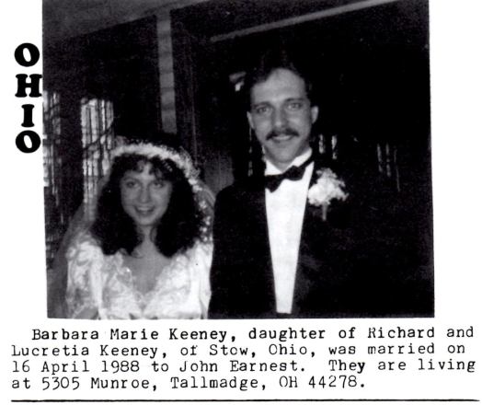
6 ERIC NATHAN KEENEY, b. 3-10-1972 in SC
5. SONJA JEAN KEENEY, b. 2-11-1948 at Bourbon
M. Theodore Kenneth Moore (b. 1948) 6-3-1966
6. TRICIA LYNN MOORE, b. 6-8-1967
6. KENNETH TODD MOORE, b. 9-10-1970
6. JASON WADE MOORE, b. 10-21-1976
5. PAMELA KAY KEENEY, b. 9-16-1952 at Bourbon
m. David Joseph Breen, m. Richard L Seide (2) 7-7-
1984 Bourbon, Crawford County, MO
6. CHRISTOPHER KEENEY SEIDE, b. 3-22-1986
4. MAXINE KEENEY, d. 1980, m. Robert Reigle
4. AFTON KEENEY, b. 8-28-1911, d. 9-5-1912
4. MARVIN WILSON KEENEY, b. 5-29-1916, d. 8-12-1916
4. EBER HOMER KEENEY, b. 4-19-1910, d. 6-14-1914
3. RHODA KEENEY, b. 1877, d. 1963 m. John Wiley Jones
3. ELIZABETH KEENEY, b. 1879
2. MAHALIA KEENEY, b. c. 1840 m. John Stockwell on 9-15-1858
2. WILLIAM C. KEENEY, b. 1842 in KY; age 28 in 1870 wife; Mary
Jane (b. 1844 in Kentucky)
3. SARAH KEENEY, b. 1864 in Missouri
3. LORENZA KEENEY, b. 1866 in Missouri
3. GEORGE KEENEY, b. 12-1867; wife: Susan
3. LOUISA KEENEY, b. 1869
3. FOUNTAIN KEENEY, b. 1871
3. ARAMINTA KEENEY, b. 1874
3. IDA KEENEY, b. 1875
3. JULIA KEENEY, b. 1877
(to be continued next issue)

Pennsylvania
continued from last issue from Catherine T. Pyle, Delray Beach, FL

THOMAS B. KEENEY, SR. Born in 1751, son of Alexander, married Mercy Lamb (10-12-1748-10-24-1839)
Thomas was a tall, large framed man, possessing inherited longevity and athletic strength, as his father,
Alexander, lived to the noble age of 106 years. Thomas D. January 10, 1840, page 88 years, 8 months.

The following information is from The Pioneer and patriot families of Bradford County., PA. (Heverly) 1700-1825.

Thomas Keeney, native of Litchfield, CT, first located at Wapwalopec, came to Wilmot, PA home seeking in 1787. He lived alone first season and a brush cabin. Next year he brought his family. He enlisted in the Army at East Hartford, CT and served 3 years of actual service during the Revolutionary War. Part of his service was under Capt. Bissell and Col. Pilkin. He was one of 15 or 18 persons concerned with the abduction of Col. Timothy Pickering, Prothonotary of Luzerne County Pennsylvania. One night in June, 1788, dressed and painted an Indian costume they abducted Col. Pickering from his residence in Wilkes-Barre, by forcible entry of his dwelling, by which they sought to hold him as hostage for the release of John Franklin, CT Title Agent for lands. Thomas was taken to Wilkes-Barre and kept in confinement all summer. In 1812, Thomas sold his land to John Gamble and moved to Chemong, New York. At age 81 (9-11-1832), Thomas applied for a Pension and it was granted. Thomas was called, “The Immigrant.” When the idea of railroads was first discussed, he thought (and said) it could not be done and that they had better build a new world; but he lived to see the cars running, and to ride on them. Thomas married Mercy Lamb, who was singularly good-looking French lady with black eyes, black curly hair and very fair-complexioned, which made her strikingly beautiful. She died in Chemung, New York 10-24-1839, age 91 years, 12 days. Thomas and Mercy and Thomas, Jr. and Eliza Keeney were all charter members of the church in Fabius, PA in 1803. Thomas died at Ruby and Richard Mitchell’s home near Tioga Village, PA but later his body was removed and he was buried beside his wife in Chemung, New York (10 miles below Elmira). Thomas and Mercy had eight children:

RUBY KEENEY b. 10-7-1771. In 1792 m. Richard Mitchell. Thomas died at their home.
MARY KEENEY m. Major Benjamin Bentley.
BETSY KEENEY m. a Mr. Sackett
LOUISA KEENEY m. a Mr. Weatherly and Mr. Howard
MERCY KEENEY m. Richard Keeney, distant cousin (first bride and groom of Wiilmot. Richard from Wyslusing.)
SUSANNAH KEENEY m. Asa Parshall of Chemung, New York
THOMAS KEENEY, JR. b. 1776 (9-8) m. Anna Parshall in 1797
JESSE KEENEY, b. 1778, M. Catherine Middaugh in 1799 in Litchfield, Connecticut

Jesse was the son who gave us our direct descendants and from whom our lineage comes. In 1788 Mercy Keeney, daughter of Thomas and Mercy Lamb Keeney married Richard Keeney, distant relatives and were Wilmot’s first bride and groom. She, like her mother, was a woman of great resolution. On one occasion a party of men had driven a panther up a tree at Rocky Forest. Mercy, age 16, volunteered to stand under the tree keep the panther up, while the men ran home to get the rifles, with which the animal was killed.

JESSE KEENEY, born at Litchfield, CT, youngest son of Thomas, Sr. and Mercy Lamb Keeney, 1778.
Jesse married Catherine Middaugh 12-29-1799 and moved to Cortland, New York in 1831. He located on a farm in Millcreek and lived there the rest of his life. Jesse d. 6-18-1834. His wife died 8-12-1848. Their children were:
ELIAS, b. In 1800, m. Ann Streeter, settled in Keeneyville, PA in 1838, named for him
SARAH K. m. George Daniels. Sarah d. 2-18-1889, b. In Keeneyville.
THOMAS M. Lived in Cortland, New York, had a son Seabury, also had a son, Frank. Both were Methodist
ministers.
PERMILLA m. Mr. Hill, son of Capt. Hill
JESSE settled in Tioga County, m. Miss. Fellows: 3 girls Anna m. Abijah Reynolds, who died in 1905,
leaving Anna with two sons, Abijah and Walter; Abijah lives in Tacoma, Washington and Walter in
Crete Nebraska; is Professor of Music in Doane college.
Abram settled in Tioga.
Kate Maloney m. Delinus Walker, c. were Albert, Sarah, Emma and Ruby. Emma m. Elliott Thorn
Mercy m. Mr. Brady, and had two sons.
Richard m. Adelia Wiles and had 8 children: George, Ira, Selden, Almira, Simon, Nettie, Herman, and Elmer.
George m. Marian Thorne, lived in Tioga. Their c. were Augie, Nettie and George. Ira m. Viola
Holiday, 1 c. Ira’s second wife was Margarette Cady of Ekland, 2 c., Richard and Cora.
Simon m. Zella Grover, had 6 c. Nettie and Herman deceased. Almyra m. George Dickinson-11-15-1868, 2 c. Anna & Burton
Ruby no info.
George D. b. Cortland 1825; moved to Keeneyville in 1848. He built a Saw Mill and engaged in lumbering.
He married Jane, daughter of John Drew, c. were: Florence, Agnes, Arthur (m. 3 ch..), Harry m. Mary Wheeler, 1 son, Wilbur, who died at Peekskill, N. Y. School 1919. Wilbur’s wife lives at Wellsboro… c. Ida, Burton (San Diego, CA), Eva and Myrtle. George D. Died 2-11-1896.
Elias, born in 1800, m. Ann Streeter. Their children were:
Roxanna m. Dr. Bunell
Jesse: m. Miranda Goddard, 3 c.: George, Alonzo & Ada. (Ann) died and Jesse m. and moved to Steep
Creek, Ryland, KY… Ada m. L. Spencer in Buffalo, NY moved to KY. Ada died Spencer remarried. He died 1-2-1880, left two children: James and Israel, a lawyer died in 1863.
Elias, Junior, no info
Israel P. Went south to teach school, was a brilliant lawyer, died KY in 1863.
EDWARD D. (Our direct ancestor) married Elizabeth Taylor and settled in KY.
Jerusha m. Wellington Newcomb, had 1 daughter, Bertha, who m. Elton Dates.
Henry m Ella Goddard, 1 son, Burton. Ella d. Henry m. Lura Goodwin
Jane m. Theron Tetelling, and lived a Losey Creek, near Keeneyville, PA

After death of Ann Streeter Keeney, Elias moved to KY and married Elizabeth Taylor’s sister
A Solomon Keeney was elected Commissioner in 1818.
A Clinton Keeney m Avey Tompkins b. 5-1-1815 d. 8-12-1874. C. Louisa, John, Mary & David

NOT OUR DIRECT DESCENDANTS, BUT RELATED:

Thomas Keeney, 111, the 7th child and 1st son of Thomas Keeney & Mercy Lamb Keeney was born 9-8-1776. He married Anna Parshall 1797. They lived in Chemung, then moved to Onondaga County, NY. Thomas was a soldier in the War of 1812.
In 1815, they moved to Middlebury, PA, cleared a large tract of land and turned it into a most fruitful farm, with the help of his sons. The family endured all of the privations of Pioneer Life.
They were members of the Baptist Church in Tioga. Their children were:
Merch, b. 1800
Isreal, b. 1804
Elija & Elisha, twins, b. 1-1806
Jessie, b. 1808 d. Michigan 4-19-1879, m. Sophronia McCarther in 1827.
Alvira, b. 1810
Ranson, b. 4-1812 at the Fabius Keeney Settlement in NY
Anna, b. 1816
Thomas, b. 1819
Thomas 111 wife, Anna d. 1827 at Chemung while attending her Father’s funeral.

Jessie Keeney, son of Thomas Keeney 111 and Anna Parshall Keeney, b. 1808 m. Sophronia McCarther 1827. All of their children were born at Holiday. They were:
Thomas B. lived and died in Michigan (1878)
Armenia m. d. in Hornellsville, NY
Luther m. lived in Kansas City
Julia m. Clayton Draft, lived in Nebraska, moved back to PA. Had 4 sons.

Harry Keeney Tells About Rendering Works

6-Star-Saver, Kewanee, IL, Tuesday, Oct. 30, 1984
by Betty Sullivan STAR COURIER CORRESPONDENT

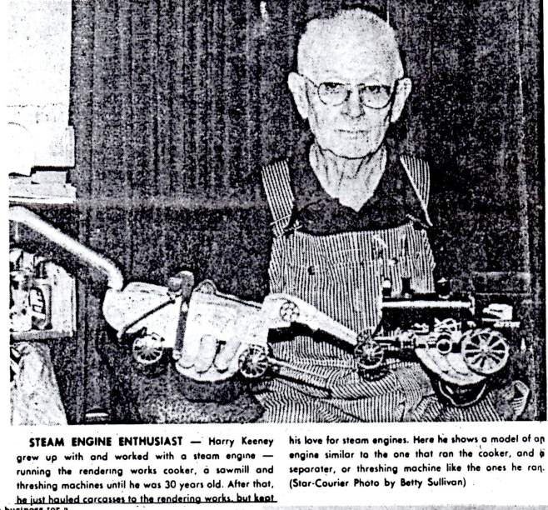
Harry Keeney, 1034 Kent St., was engaged in a very unusual-now very rare-occupation from 1921 to 1967.
Since the business was located in Neponset Township, right on the county line, the Neponset Township Historical Society president Ruth Gould visited Keeney last week, to get the story of the rendering works for their minimuseum
Keeney started helping his dad at the rendering works as a Skinner in ‘21 at the tender age of 12 years.
At the time, Keeney was still a student at the old Bowen school, located on R. 34 for about a mile east of the County Line Road, which passes Francis Park running north and south.
The rendering Works was located “way back in the field,” Keeney said.
That’s because the dead animals, collected from area farmers and elsewhere by the Keeney’s, gave off a horrible stench as they were boiled in a cooker, heated by a steam engine to 150°.
A farmer by the name of George Mocroft owns a farm where the works was located, and Jack Handebow owned the plant. Keeney reported that Mocroft was first area farmer to raise over 1000 hogs per year.
Eventually, Mocroft purchased the works, on condition that Keeney’s would come with it, and Keeney’s dad agreed to the deal.
In 1932, when young Keeney was 21 years old, Mocroft got out of the business altogether, and from then on it was called Keeney’s Rendering Works.
It was moved to the Keeney’s place, south of Route 34, the still on the County Line Road, on the Wiles and Tibbetts farm.
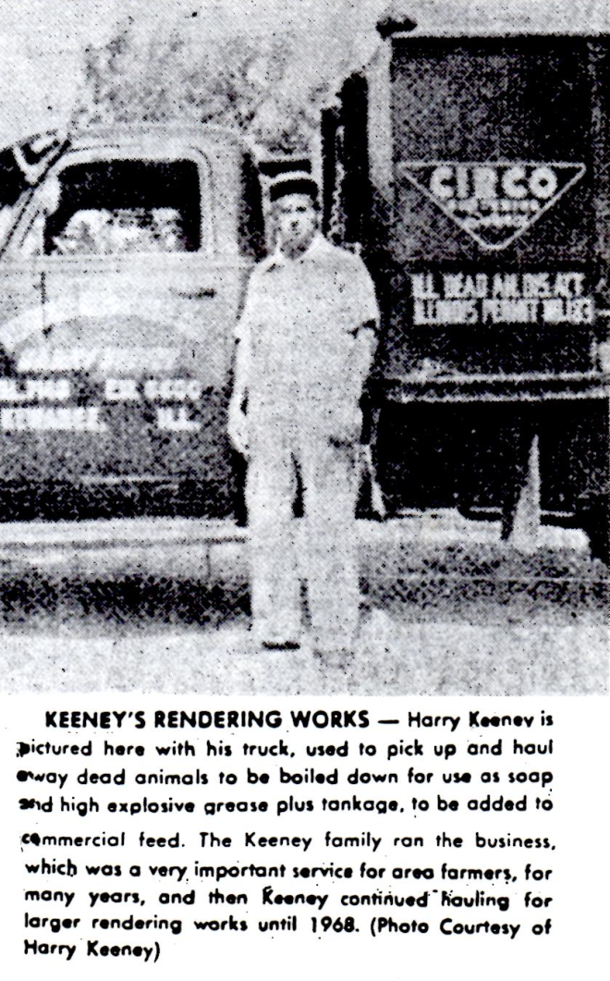
When his dad took sick, at age 42, young Keeney took over the works. His dad had had had bad heart trouble”, Keeney related, “but he used to ride along with me anyway,” until he died in his 50s.
Times got hard for small rendering works, especially after detergents, for the most part, replaced soap on the market.
Keeney said that after the carcasses were all boiled down, the grease was used to make soap and high explosives.
Tankage-ground-up bones, meat, and so on-is used in commercial feed. Keeney says it is a “high protein supplement.”
He eventually went in with Art Faber of the Central Illinois Rendering Company, Peoria, along with Albert Pease, Buda, and the Geneseo works.
From then on, all the rendering was done in Peoria. Keeney had a loading dock then (pictured), somewhat resembling a corn crib, but also having space between the floor slab so air can circulate around the carcasses and animals that stay in better condition while waiting to be hauled away.
Later on, Peoria decided they wanted delivery to Streator.
Keeney had moved to Kent Street in 1937, and since he couldn’t make a living hauling all the way to Streator, he quit the business for a few months and worked for Kewanee Schools.
Peoria then offered hauling to Galesburg, and since he still had his truck and loading dock, he started hauling again.
Keeney said he took this job in 1953 with the idea of quitting when he found another job, but he stayed with it for 14 more years.
Then, in 1967, a new plant was started up in Cambridge, so Keeney started hauling there.
However, Keeney said Cambridge instructed him to start charging the farmers $3 a carcass for pickup-it always been free service-because they’re going to have to lower their prices from a $1.25 per 100 weight to 65 cents.
This lasted about 2 to 3 months but as Keeney had predicted, the farmers only called they lost a large animal and he couldn’t make ends meet. He finally had to give up the business and went to work for the last eight years before his retirement at as forklift driver at Kewanee Manufacturing.
Eventually, Keeney related, Cambridge sold out to Darling and Co., Chicago. He isn’t sure whether or not they pick up animals anymore.
Keeney says he really enjoyed running the steam engine. He started out as a skinner, then graduated to running the cooker, and finally to running the engine.
More enjoyable jobs than rendering were also down steam engines in the 20s and 30s, so Keeney used to work with Pearlie Swearingen of Neponset, running threshing machines for area farmers; pulling out hedgerows, and running a sawmill.
Keeney was raised in a family with one brother, Tom, and two sisters, Mary and Pearl.
All four graduated from the Bowen school, and then went on to Neponset high school.
Keeney started high school in 1927, the year the new building which is still in use, was completed.
He married Marguerite Farren in 1960 at the age of 50, and she died just 10 years later, in 1970.
Keeney’s hobby now that he is retired, is collecting antique things, especially models of steam engines and other machines run by the engines.
He gave the minimuseum the pictures shown here and also a photo of the 14 children who were attending the Bowen school in 1924.
Keeney said the school was moved 1 ¾ miles north, when all Illinois one-room schools were closed, and was used as a tool shed on the old Kaiser farm.

OBITUARIES
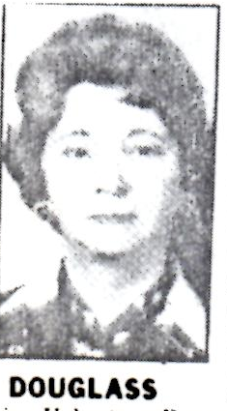
Lillian M. Douglass
Mrs. Lillian May Douglas, 78, of 1914 Orchard Ave., Belle, died Saturday, October 22, 1988, at home after a short illness.
She was a former schoolteacher in Roane and Kanawha counties. She was a member of Witcher Baptist Church where she sang in the choir and was a Sunday school teacher. She was a member of the Women’s Missionary Union and the Retired Senior Volunteer Program. She was a member of the West Virginia and National Education Association and the AARP.
Surviving: son, Robert E Jr. of Lilburn, Georgia; daughter, Phyllis C. Tumulty of Trumbull, Connecticut; brothers, Charles Keeney of Saluda, S C, Rev. Leroy Keeney of St. Albans; sisters, Frances Harmon of Indianatown, Florida, Maryetta Thom of Newark, Delaware, four grandchildren.
Service will be at 2 PM Wednesday and Witcher Baptist Church, Belle, with the Rev. Billy Wilburn and the Rev. Roscoe Keeney officiating. Burial will be in the Witcher Cemetery.
Friends may call after 6 p.m. today at the Fidler-Frame Funeral Home, Belle.

Luther S Weaver
Luther S Weaver, 88 of 385 Witcher Rd., Belle, died January 13, 1989, in Thomas Memorial Hospital after a long illness.
He was a retired power house operator for DuPont, Bell. He was a member of the Moose Lodge. He was a lifelong resident of Witcher.
Surviving: son, William A. of Lewisburg; daughters, Louise Priddy and Catherine Meadows, both of Witcher, Margaret Bishop of San Jose, California; five grandchildren; nine great-grandchildren.
Service will be 2 PM Sunday at Fiddler-Frame Funeral Home, Belle, with the Rev. Billy Wilburn officiating. Burial will be in the Witcher Cemetery. Friends may call after 6 PM today at the funeral home.

Harry T Knight
Harry T “Yoe” Knight, 58 of Cedar Grove, died December 30, 1988 at General Division, CAMC.
He was a native of Shrewsberry and a lifelong resident of Kanawa County. He was a former miner and was a Protestant.
Surviving: sons, Thomas Michael of Fallsview, Harry Lee and Robert Joseph, both of Elkhart, Indiana; daughter, Leanna Margaret Knight of Montgomery; mother, Mrs. Ruth E Keeney Knight of Cedar Grove; brother, Harold E of Cedar Grove; sisters, Mrs. Frances Riffle and Mrs. Linda Coleman, both of Cedar Grove, Mrs. Janet Tupis of Charleston, Mrs. Dolores Johnson of Lockwood, Mrs. Ramona Mullins of Elkhart, Indiana; four grandchildren.
Friends may call from 7 to 9 PM Sunday at Cook Funeral Home, Cedar Grove

Elizabeth R Keeney
August 23, 1888-December 2, 1988
Centralia, Washington-Elizabeth R. Keeney, 100, formerly of Corvallis, died Friday. She was born in Bevier, Missouri and graduated from Bevier High School in 1896. She worked as a typesetter and later headed the composing room of the newspaper in Brookfield, Missouri.
She studied nursing for three years on a scholarship at Chillicothe, Missouri normal school. She married James H Walker and moved to Primero, Colorado, where they filed for a homestead. She farmed and he worked in the mines until he died in a mining explosion in 1918.
After his death, she returned to Missouri for three years and then went to Wyoming to join her brothers. She was a cook in a mining camp and a hospital in Thermopolis, Wyoming.
In 1936 she was a representative for the Farm Bureau of Wyoming to Washington, DC, where she was the guest of President and Mrs. Roosevelt. She married George Keeney in 1929 and moved to Corvallis after World War II.
After her husband died in 1950, she returned to school in Corvallis to become a nurse. She worked in that field from the age of 65 until she was 85. After retiring she continued to visit people in nursing homes. She moved to Centralia to be near her daughter in Chehalis.
She was worthy matron of Cloud Peak Chapter of the Order of Eastern Star and was president of the University Dames.
Survivors include a son, Dick of Casper, Wyoming; and daughter Margaret Woods of Chehalis.
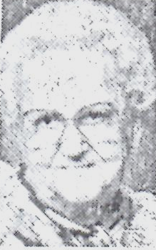
Services will begin at 11 AM today in McHenry mortuary, Corvallis. Vault interment will follow in Twin Oaks Memorial Gardens, Albany.
Contributions may be made to First Baptist Church, Corvallis in care of the mortuary.
S-J, 12/5/88

Molly Keeney
Orlando Florida-Molly Keeney, 70, died July 20.
A resident of Barber most of her life, she moved to Orlando, Florida 19 years ago. This is Keeney retired from Seiberling Tire and Rubber Company and was a member of the Barberton Senior Center.
Surviving are her husband, Raymond; son and daughter-in-law, Vernon and Linda Johnson of Sheffield Lake my: son, Ernest Johnson of Orlando, Florida; daughter and son-in-law Henda and Don Jones of Barberton; daughter, Rita Johnson of Orlando, Florida; grandchildren, Kathy Wisniewski of Orlando, Florida, Donnie Jones Jr. of Barberton, Kimberly Jones of Barberton, Pam Johnson, Kevin Johnson, Debbie Berenci, all of Sheffield Lake, Dawn Johnson of Albany, Georgia; six great-grandchildren; and a host of friends and relatives.
Funeral services Saturday, 10 AM, at Campfield-Hickman Funeral Home, Rev. Rodney Warstler officiating. Burial Greenlawn Cemetery. Visitation Friday, 2 to 4 and 7 to 9 PM
(Campfield-Hickman, 745-3161.)

Philip M Snyder Jr.
West Palm Beach, Florida-Philip M Snyder Junior, 78, of West Palm Beach, formerly of Mount Hope, West Virginia died Tuesday, December, 27, 1988, in West Palm Beach.
Surviving: son, Philip Kent of Coral Gables; daughter, Mary Kent Tuthill of Fayetteville, West Virginia; sisters, Mrs. Patrick C Graney and Mrs. Frank T Graff, of Mount Hope; one granddaughter
The body has been cremated.

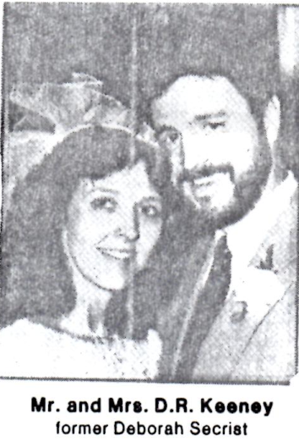
Keeney-Secrist
Deborah Irene Secrist, daughter of Mr. and Mrs. James E Pack of Ansted, and Daniel Ray Keeney, son of Mr. and Mrs. Billy W Keeney of Corliss were married Nov. 13 in the Anstad Baptist Church. The Rev. Robert Keeney officiated.
Clarris Skaggs was matron of honor and Jennifer Drennan and Trista Secrist for bridesmaids. Krista Seacrest was flower girl. Mike Keeney was best man. Ushers were Steve Keeney and Butch Pack. Brian Keeney was ring bearer.
Following a reception, the couple left for a wedding trip to Blackwater Falls State Park. They will live at Corliss.
She is a graduate of Anstad High School and is employed by Pyramid Home Products. He attended Fairmount State College and is employed by Hawk’s Nest Mining Company.

Minnesota
Glenwood, MN Herald
2-22-1907, page 3
Raymond Councilman and Rosetta Keeney were married at the home of Mr. and Mrs. D.J. Ruddick by Rev. George Porter Wednesday afternoon. The groom was assisted by Ed Witmer and the bride by Miss Florence Willst..
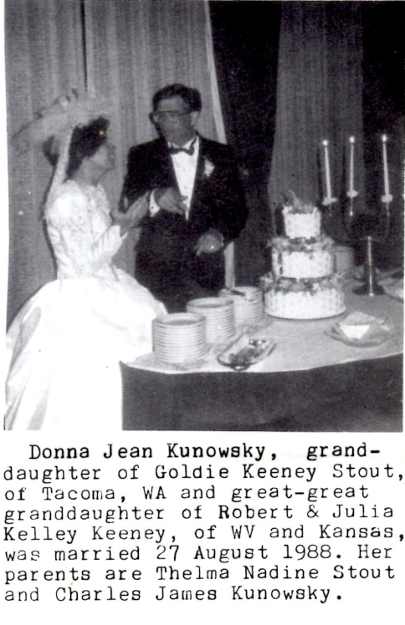
The contracting parties are well known in this village. The groom is the son of Mr. and Mrs. P.B. Councilman, who moved to Gentry, Arkansas a couple of years ago. The bride is the daughter of Mrs. A.M. Keeney of Minnewaska. The happy couple will leave for Canada in a few weeks, where they will make their home

SANFORD HERALD
Sanford, NC, 9-22-1986
The Rev. Floyd Harry Councilman, 75 a retired Christian minister, of Broadway, died September 20, 1986.
Born June 28, 1911 in Alberta, Canada, he was the son of Raymond Henry and Rosetta Keeney Councilman. He served churches in Indiana, Washington, North Carolina and Pennsylvania.
Survivors: wife, Caroline Halverson Councilman; two daughters, Anna M Messina (Butler, PA) and Thelma J Clark (Cheyenne, WY); sons Charles H. (Sierra Vista, AZ and Paul F. (Fayetteville, NC); brother, Lucian D, of Malten, Washington..
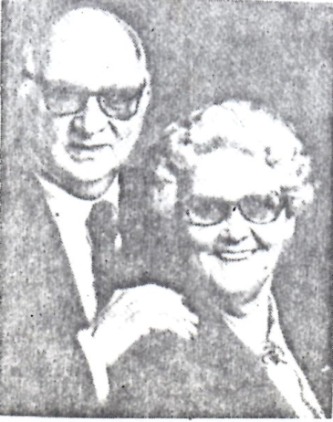

Keeney
Mr. and Mrs. Charles E Keeney of Eleanor celebrated her 50th wedding anniversary December 18 with reception given by their family at Wesley United Methodist Church. He is retired from Eleanor Auto Supply Inc. She is the former Lena Irons. They have a son, Charles I. of Charleston, and one grandchild.

Keeney book references:
Lillian Douglas, P. 105
Luther Weaver, P. 39
Harry Knight, P. 49
Charles E Keeney, P. 68
Billy W. Keeney family, P. 30
Philip M. Snyder-great-grandson of Francis Keeney Brawley, daughter of Moses Keeney
Molly Keeney-from Lawrence County OH branch
Elizabeth R. Keeney-identification needed

Insert stapled to the inside of Page 2 states the following:

relatives, patrons, friends:
You have not received Keeney update since September 88 and this one is a collection of material sent to me over past month, to be used as there was room. I’m sorry if some of it is difficult to read.
On November 15 I had a serious attack of double vision, later diagnosed as being caused by a paralyzed nerve. After 10 weeks there has been little progress toward recovery and I’m functioning (typing, reading, driving, preaching, even conducting weddings) with one eye covered-else I see two or more images of everything. Meanwhile, I have excellent medical advice and fully expect to recover. Meanwhile, I’m learning to live with a disability-although it takes much longer to accomplish things.
How can you help? Well, if you want KEENEY UPDATE during the recovery period, I’ll need material already prepared-biographical or family sketches, listings, pictures (preferably before 1900), obituaries, newspaper clippings. Type material must be single space and no wider than 45 letters and spaces. I have all kinds of material which has been sent double spaced, which I am unable at this time.
Those who have made no contribution toward printing costs for the past two or three years should do so. The same dozen or so people continue to foot the bills. Those on limited incomes might send information or clippings. Thanks to the following for contributions on this issue: Ida K. Mehlman, NJ; Blanche K. Roth, IN; Fran Hofstetter, OH; Robert B. Clark, UT; John D. Keeney, IA; Violet H Swartz, IL; Lester Keeney, FL; Mrs. W. T. Wilson, WY; Mrs. C. G. Summers, WV. Thanks to Ralph Keeney, OR; Catherine Pyle, FL; and Mary Ann Keeney, NC for volumes of material.
2-89 Roscoe Keeney, JR.

