Keeney Update
VOL V, Number 2 Roscoe C. Keeney, Jr. JUN 1988
KEENEYS, KEENEYS COAST TO COAST
Two nights ago a call from Newport News, VA from a Keeney relative who was leaving for England the next morning inquired about where to look for Keeney info in England. What would you have told her?
The mails continue to bring requests and the phone continues to ring weekly if not nightly, as Keeney kin continually seek to know where they fit in. Most get answers; requests for copies of materials are the simplest to fill and questions that include names and dates are sometimes easy to plug in to the information files; but many are complex and a few are never taken from the "things to do" file.
The letters I like are those that give information as well as request it. Such letters have come during the past two weeks from Texas, Michigan, Florida, California and Tennessee.
KEENEY UPDATE was revived three months ago after a six months lapse and, as a result, more printable material has come in and almost enough financial support to pay the total cost of printing and mailing that issue. So that calls for another issue - this one. Support should come from those who haven't written an UPDATE check for several years. If the material for publication, including pictures, is sent and support comes in to pay half the bills, I'll do the rest.
In April I took a genealogical journey into Cocks and Anderson Counties in Tennessee. The library in Clinton was especially helpful. I have established ties now with Keeneys still living in Anderson Co.
and expect to have much more information for future issues of the UPDATE. My goal has been to prove that the Greenbrier Co., WV Keeneys and the early Tennessee and Kentucky Keeneys came from the same family. Wish me luck.
1938 KEENEY ANNIVERSARY (50 years Ago)
Mrs. Hannah C Keeney who celebrated her 85th birthday anniversary Aug. 8 was honored at a basket dinner given last Sunday at the home of N. B Keeney at Belle.
More than 100 relatives and friends of Mrs. Keeney were present. A short talk was given by Rev. C. B. Jackson and music was a part of the day's entertainment.
Guests included Mr. and Mrs C. H. Kincaid, Mr. and Mrs. C. C. Hill, Mr. and Mrs. W. H. Keeney, Mr. and Mrs. E. O. Keeney,. Mr. and Mrs. Norman Harless, Mr. and Mrs. John Thom, Mr. and Mrs. R C. Keeney, Mr. and Mrs. R. T. Cline, Mr. and Mrs. J. C. Keeney, Jr.; Mr. and Mrs. Edward Wilson, Mr. and Mrs. L. W. Scruggs, Mr. and Mrs. Samuel Christy.
Mesdames Katie Trent, Julia Arthur. Ethel Wintz. John Foultz, Clifford White, C. E. Ellis, Mcdonald Keeney, W. C. White, Mary Cavender, Lora Young. Pattie Keeney, Robert Stewart, Dorothy Hardiman, Mabei Keeney, Wirt Harmon. the Misses Margaret H. Keeney, Margaret A. Keeney, Frances Hill, Helen May and Phyllis Jean Stewart, Barbara Ann and Doris Keeney, Jean, Carol and Linda Jo Harless, Mary Jane Harmon, Anna and Helen Hill, Mary Susie Keeney, Hannah, Dorothy, Mildred, Hellen, Rosa Lee, Lenora, Rachel, Gertrude and Alma Keeney.
The Misses Linda Wilson, Imogene Scruggs, Mildred Skeens, Geraldine Kincaid, Jean Ellis. Rev. C. B. Jackson, Rev. S. W Cavender, Buster, Floyd and Phillip Keeney, James Trent, John E.Hill, John, Charles, Billie, Calvin, Roscoe and Peter Keeney, James Skeens, George Stanley, Russell Warden, Paul Keeney, S. H. Johnson, Oliver Woodrum, G. T. Fizer, Rev T. K. Hudson, William and Thomas White. Clayton Fills, James Cavender, Wayne Douglass Cavender. Cameron Hill.
Carl Scruggs, Robert Hardiman, Thomas Oaks Keeney, Richard and Robert Keeney, T. G. Keeney, Robert Lee Cline, Lee Roy Keeney, Hugh Meadows and J. W. Meadows.

MICHIGAN KEENEY DESCENDENTS ISSUE INVITATION
The Erie, Michigan Keeneys trace their line back to Connecticut. Salmon Keeney came to Michigan in 1827 to look for land (the family still has his log of the trip).
Salomon's son, Andrew Jackson, became quite a writer in his late years, leaving about 25 diaries of the late 1800s and early 1900s.
Twenty Keeney descendants, including Salmon and his mother, Mary Gordon Keeney, are buried on the farm on a small sandy hill called the Keeney Cemetery.
A KEENEY-SAUNDERS reunion is held by family members on the first Saturday of July with a pot-luck dinner, business meeting, and a hay ride.
Any Keeney relative can get full information by calling Phyllis Keeney Smith (Mrs. William) at 313-848-4644 or write to 10212 Dixie Hwy., Erie, MI 48133.

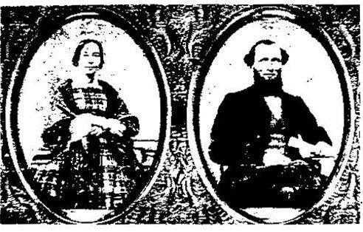
LEFT: Andrew Jackson Keeney, who migrated to Michigan in 1828 at the age of 9, with his wife Mary Corey Keeney; below is the Keeney Cemetery at Erie, Michigan, and the home of the family from 1889 to 1900 at Erie.

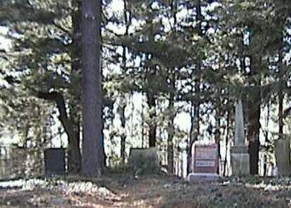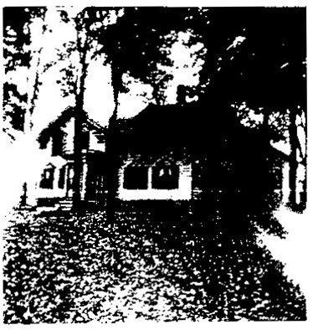

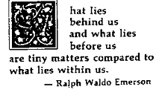
HARRY G. KEENEY, cashier and one of the directors of the Creswell Fruit Growers Bank of Creswell, is a bright young business man who is filling his present important position with credit to himself and satisfaction to the stockholders of the concern. He is one of Oregon's sons, having been born in Goshen, October 20, 1881, the son of James M.and Mary S. (Handsaker) Keeney, the former of whom was born in Missouri and the latter m Oregon. In this state they were married and have here resided for many years. For eighteen years the father served as postmaster of Jasper, Oregon, after which the family removed to Eugene, where they resided for a time and later engaged in farming near Dexter. Subsequently he returned to Eugene and here spent the remainder of his days, his death occurring in February, 1912. The mother, who has attained the age of fifty years, is still residing in Eugene. They were the parents of four children, of whom the subject of this review is second in order of birth, the other members of the family being Belle, Arthur L. and Clara H., all of whom reside at home.
Harry G. Keeney was reared in Oregon, here he attended born the common and high schools and later took a course in a business college at Seattle, Washington. After laying aside his text books he became a clerk in the Dexter Horton National Bank of Seattle, remaining there for two and one-half years. He then entered the employ of the Pacific Condensed Milk Company, with whom he continued for two and one-half years, when he went to Coburg, Oregon, as an employee of the Booth-Kelly Lumber Company, his connection with this firm being of short duration. He then become a clerk in the First National Bank of Eugene, filling this position until July 12, 1911, when he entered the Creswell Fruit Growers Bank of Creswell in the capacity of cashier, a position which he still retains.

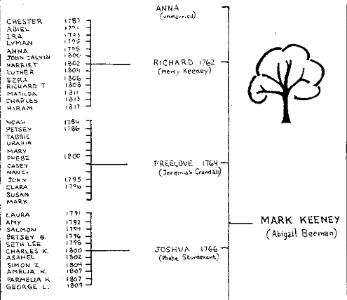
KENTUCKY KEENEYS
1810 Census:
James Keeney – Pulaski 156
Joseph Keeney – Clay 151
Moses Keeney – Pulaski 156
Peter Keeney – Pulaski 156
William Keeney* - Fleming 74
(moved to Lawrence Co., OH)

1820 Census:
James Keeney – Pulaski 047
Moses Keeney – Pulaski 058

1830 Census:
James Keeney – Caldwell 149
Henry Keeney- Pulaski 010
Michael Keeney – Pulaski 018
Moses Keeney – Pulaski 051

1840 Census:
James Keeney – Caldwell 039
Jonathan Keeney – Caldwell 039

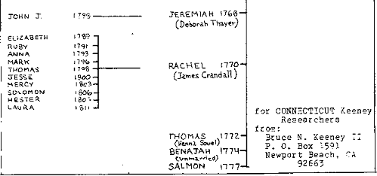
1850 Census:
Catherine Keeney – Pulaski 058*
Fielding Keeney - Campbell 035**
Henry Keeney – Pulaski 058*
Hiram Keeney – Pulaski 015*
John Keeney – Pulaski 025*
Moses Keeney – Pulaski 058*
James Keeney – Caldwell 289
Jefferson Keeney – Caldwell 367
Thomas Keeney – Caldwell 360
Thomas J. Keeney – Caldwell 360
*all Somerset **Newport

Ella Syble Keeney Family daughter of Charles Franklin & Lizzie Knight Keeney (1848-1925); sister of Frank Keeney, well-known labor leader and organizer
Ella Syble Keeney (born 25 Oct. 1876 Died; 19 Oct. 1927) married
Samuel Lewis Penrod (born, 16 Oct. 1871 died; April 1953)
1. Mary Elizabeth (born, 26 March 1897 Died; 20 Sept 1928) Married
Elmer Weaver (born; died; 8 June 1987)
A. Maurice Calvin Weaver (born; 4 May 1919 Married; Esther Marks
A1. Douglas Weaver (born; 12 Aug. 1950
A2. Daughter (born 1952)
B. Anna Lee Weaver (born 15 Dec. 1920) Never Married
C. Claude Logan Weaver (born 8 July 1925) Married has children.
2. Maye Hern (born; 4 June 1899 Died; 19 April 1984) Married
A. Leslie Arthur
3. Lester Franklin (b. 30 Oct. 1901, d. 1 May 1984) never married.
4. LEANDER BARBOUR b. 23 Oct, 1903 d. 14
Nov.1971) m. Mildred Jane Dunwiddle (b. 4 Apr. 1904)
- John Lynn Penrod b. 20 May 1928; wife: Mary Ann
A1 Rick
A2 Tim
A3 Jennie
- Phillip Dean Penrod (b 20 Apr 1934)
A1 June
A2 Roberta
A3 Barbara
WYOMING COUNTY, PA
1860 Census, Braintrim Township
Area # Name Age Sex
1648 Keeney, Angeline 5 F
Keeney, George G. 38 M
Keeney, Rachel 23 F

1661 Keeney, Abigail 69 F
Keeney, Chester 21 M
Keeney, Matilda M. 38 F
Keeney, Sabra E. 36 F

1665 Keeney, Jane ? F
Keeney, Lyman 64 M
Keeney, Maria 40 F
Keeney, Polly 48 F

1666 Keeney, Albert ? M
Keeney, Ann M. 50 F
Keeney, Dennis 25 M
Keeney, Jasper 20 M
Keeney, Richard 51 M

1667 Keeney, Almira 36 F
Keeney, Ezra 54 M
Keeney, Harriet 13 F
Keeney, Jane Ann 23 F Keeney, John W. 9 M Keeney, Lucretia ? F Keeney, Martin 21 M Keeney, Phebe 2 F Keeney, Richard 17 M

1684 Keeney, E.J. 33 M Keeney, Elizabeth 30 F Keeney, Eva 4 F

1737 Keeney, Angeline 45 F
Keeney, Angeline 27 F
Keeney, Charles 60 M
Keeney, Ruby 24 F
1739 Keeney, Beverly W. 24 F
Keeney, George 15 M
Keeney, Louisa 54 F
Keeney, Nelly M. 20 F
Keeney, S. Z. 55 M
Keeney, Sarah G. 19 F

- Robert Allan Penrod (b. 13 Sep 1935) m Thelma Ford
A1. Beth Ann
A2. Julia Kay
A3. Scott
Leander Barbour - second m. Bonnie Faye Moore (b.24 Nov.1924)
D. Barbara Ellen Penrod (b.8 Parch 1944) Braden
A1. Adam Hale Braden (b. 10 May 1971)
A2. Eben Patrick Braden (b.2 Feb. 1975)
5. DONALD LEWIS (b. 14 Sept. 1910) m. Marie Honley (b. 19 Apr. 1913)
A. Thomas A. Penrod (B.1 Dec. 1941) m. Judy
Carpenter
Al. Joan
A2. Jeffrey
5. HELEN RACHEL PENROD ( b.8 Sept. 1917) m. Rex Calvin Scott
m. Elmer Ray Rushton (b.3 Jan. 1909)
A. Glen Allen Scott (b. 18 Aug. 1940) m. Joyce Geiger (b. 24 Sept. 1940)
A1. Richard Allen Scott (b. 30 Sept. 1959) m. Sandra Dawn Sussex (b. 30 Sept. 1959)
A2. Jerry Keith Scott (b.17 Au g. 1961) m. Lori Lee Elsworth (be. 4 June 1963)
A3. Christopher Niichael Scott (b.6 June 1963)
A4. Michael Dewayne Scott (b.26 June 1967)
A5. Angela Deniese Scott (b.4 Feb. 1972)
B. SHAROLYN ALETA SCOTT (b.12 Jan. 1946) m
Ronald Vernon Yoder (b 6 Dec. 1941)
A1. Kimberly Kaye Yoder (b.25 Jan. 1971)
A2. Kelly Diane Yoder (b .8 Sept. 1973)
Most of family lives in Anderson, Alexandria and Indianoplolis, Ind.
All belong to Betheny Christian Church.
Information from Helen Rushton
R. 2 Box 142, Alexandria, Ind. 46001

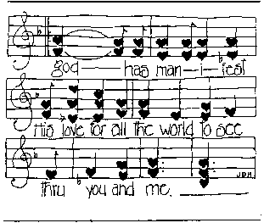
SCHOOL RECORDS 121 YEARS OLD
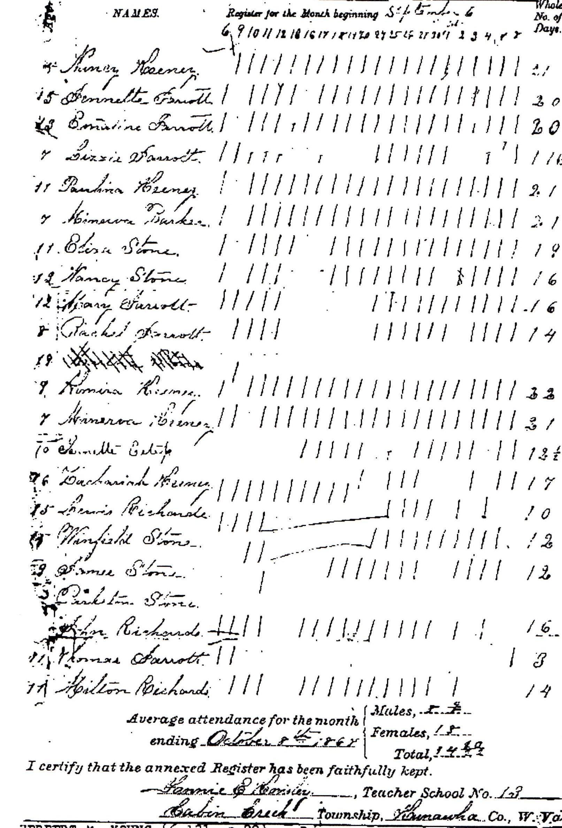
The one-room school on Cabin Creek, WV in 1867 had 20 students, almost all related.
Three sons of Moses & Frances Harris Keeney remained there, as indicated by class enrollment.
Nancy Keeney (1862-1928), who married Lucian L. Williams, and Zachariah Keeney (b.1850), who married Almira Elizabeth Jarrett, were children of William E. Keeney. Winfield Stone married Eliza Keeney, their younger sister.
The mother of Lewis, John and Milton Richards was Mary Keeney, daughter of David Keeney. Owen Richards was their father. Lewis (1853-1927) married Sally Farley, John David (1855-1928) married Martha Martin, and Milton (b. 1857) raised his family in Boone Co. WV.
Paulina Keeney (b.1856), Almira (Myra) (1858-1950, wife of Harry Johnson), and Minerva (b.1860) were children of William S. Keeney, son of Moses Walls Keeney. Minerva had at least two children, Sallie and Grover C. (Runt) Keeney.
Jennette Estep became the wife of Harrison Columbus Keeney (1841 - 1924) and lived in Clay County.
The Jarretts, who came to Cabin Creek from Greenbrier along with the Keeneys, were in-laws of David Keeney.

WEST VIRGINIA
SALLIE POWELL KEENEY 11-9-1899 5 -1- 1988 5. 223 in Keeney book (Stires J .family)

Mrs. Sallie Powell Keeney
Mrs. Sallie Powell Keeney, 80. of 1922 Orchard Ave., Belle, died May 1. 1988, at home after a short illness.
She was a member of Bethlehern Baptist Church.Witcher She was a lifelong resident of the Belle area.
Surviving: sons, Robert H. Jr of Sissonville, Thomas O. Sr, of Belle; daughter. Doris Hall of Belle; eight grandchildren; 13 great-grandchildren.
Service will be 11 a.m- Tuesday at Fidler-Frame Funeral Home. Belle. Burial will be in Witcher Cemetery. Friends may call after 6 p.m. today at we funeral home.

HERBERT M. YOUNG (6.121 , p28). grandson of Harrison C. Keeney
Herbert M. Young of 217 Quick Road, Elkview, died March 20, 1988, in St. Francis Hospital after a long illness.
He was retired from Purity Baking Co. with 38 years service. He was a Mason, a member of Scottish Rites Bodies and the Kedem Temple. He was a veteran of World War II.
Surviving: wife, Betty Whitlock Young; daughter, Judith Lynn Burdette of Elkview; sons, Ronald G. of Columbus, Ohio, Johnnie L. of Culloden; brothers, Harold of Charleston, Howard of Fort Myers, Fla.; sister, Mrs. Mabel Mullins of Clendenin; six grandchildren
Services will be 1 p.m. Wednesday at Stevens-Grass Funeral Home, Malden, with the Rev. Lawrence Slater officiating. Burial will be in Elk - Hills Memorial Park. Big Chimney,

William A. Stanley  William A. "Bill" Stanley, 64, of Cedar Grove was dead on arrival April 22, 1988, at Montgomery General Hospital after an apparent heart attack.  He was retired from Du Pont, Belle, with 40 years’ service. He was a Navy veteran of World War II and Korea. He was a lifelong resident of Kanawha County. He attended Sharon Church of God, Sharon.  Surviving: wife, Marjorie Maloney Stanley; daughters, Mrs. Chloe A. Bowen of Ceder Grove, Ms. Barbara J. Stanley of Parkersburg; mother, Mrs. Julieette Keeney Stanley of Ravenswood; sisters, Mrs. Lucille Davis of Ravenswood, Mrs. Eleanor Boggs of Murrysville; brother Jack C. of Charleston, S.C.; three grandchildren.  Friends may call from 2 to 4 p.m. Sunday at Cook Funeral Home, Ceder Grove. | Recent deaths in Michael & Elizabeth Gatewood Keeney family, listed in Vo1.IV, No.2
 | Mrs. Minnie Mae White  Mrs. Minnie Mae White, 98, of 107 Ferry St., Diamond, died May 11, 1988, at home after a long illness.  She was a charter member of Diamond Baptist Church and a lifelong resident of Kanawha County.  Surviving sons, Ralph and Hubert both of Diamond, Ray of Reed City, Mich.; daughters, Mrs. Cecil Jordan and Mrs. Carrie Gay, both of Diamond, Mrs. Myrtle Smith of Hurricane, Mrs. Edna Jordan of Milton, sister Mrs. Marie Bartley of Quincy; 24 grandchildren; 48 great-grandchildren; 12 great-great-grandchildren.  Service will be 1 p.m. Friday at Fidler-Frame Funeral Home, Belle, with Rev. Boyd Daubenspeck officiating. Burial will be in Montgomery Memorial Park. Friends may call after 7 p.m. today at the funeral home. | Earl Brockell  Earl Brockell, 73. of Miami, died April 16, 1988, at his home after a long illness.  He was a retired mine electrician formerly employed by Bethlehem Mine Co. He was a UMW member for 47 ½ years. He was a member of Miami Nazarene Church.  Surviving wife, Inez; daughters, Mrs. Mary Gallion of Giles, Mrs. Ethel Auricchio at home, Mrs. Linda Jefferey of Dry Creek; stepson, Paul Dunbar of Milam, Mich.; brothers, John of Dawes and Charles of Elkton, Md., seven grandchildren.  Service will be 11 a.m. Monday at Pryor Funeral Home, East Bank, with the Rev. Edward Midcap officiating. Burial will be in Montgomery Memorial Park, London. Friends may call 7 to 9 p.m. today at the funeral home.

2669 HOLLY BROOK DR. MOBILE, AL
ROBERT HENRY BRYD KEENEY was born in 1867 In Bedford City, Va. records show his immediate ancestors are not available, although long investigation by his grandson indicate that "Professor Keeney," as he was fondly known, was a descendant of David Asbury Keeney of Alderson, W. Va.
R.H B. Keeney was educated in Bedford (the word City was later dropped) and took his degree in English at the College of William & Mary. He had a penchant for travel, and his journeys took him to South Carolina and to the Spartanburg County public schools. In his later years, a Keeney Hall was named in his honor, although it later burned to the ground.
In 1892 he married Margaret Camellla Arthur of Union. S. C., Members of her family still reside in the Union and Boiling Springs area. Of that marriage, which was terminated by Margaret's untimely death in 1903, there were five children:
Arthur Gladstone Keeney, 1893-1955.
Diehl Vaughn Keeney. 1894-1972.
James Kirkland Keeney, 1898-1933.
Marvin Fowler Keeney, 1900-1970.
Margaret Keeney Dickson, 1902-1980.
Many of the children of the Keeneys listed above are still alive and continue to gather information about the Keeney family as it becomes available. Unofficial historian of the family is Arthur G. Keeney, Jr b. Spartanburg, S. C., in 1926. a retired television journalist now living in Mobile, Al. Arthur's address is 2669 Holly Brook Dr., Mobile, AL 36605. Arthur, now 62 and disabled, corresponds willingly and regularly with anyone who wishes to share information about Robert Henry Byrd Keeney or R. H.B.'s ancestors.
Arthur and his wife, the former Clydell Wiggins of Century, Fl., made the journey to Keeney's Mountain in 1985 and report it as being "one of the most beautiful sights we have ever seen."
Arthur's descendants (most of whom already have descendants) are as follows:
Jennifer Keeney Nelson, b. 1951.
Arthur Gladstone Keeney III, b. 1953 of Escondido, CA.
Christopher Kevin Keeney, b. 1954.
Richard Alan Keeney, b. 1956.
(All of the most recent generation except Arthur III live in Mobile.)
Sincerely,
ART
Art Keeney
(Arthur G. Keeney, Jr.)
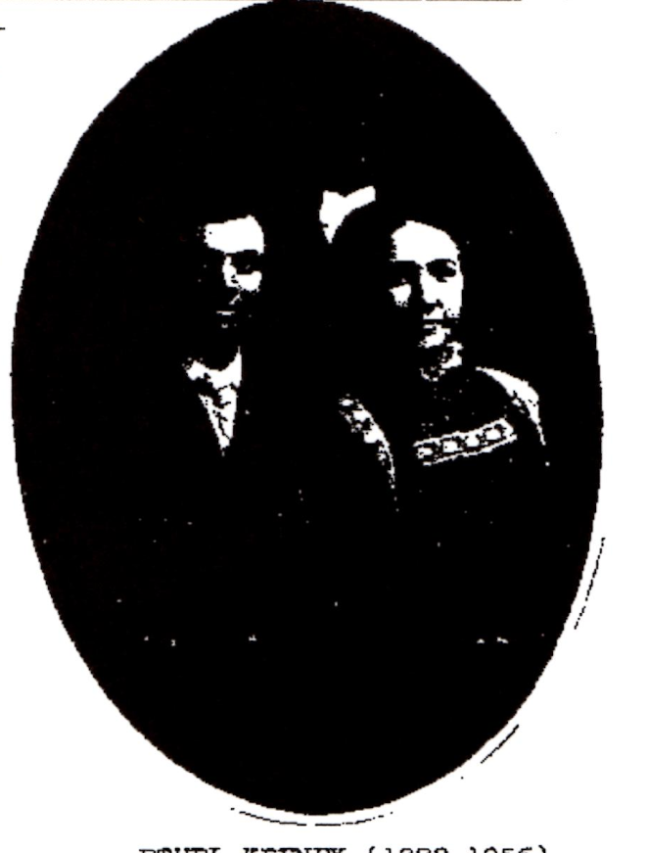
REPLY FROM THE EDITOR:
The dates following the names of the children of Robert H. B. Keeney do not correspond with other dates that I have. For instance, Marvin Fowler Keeney wrote me on 15 August 1977 from Daytona Beach, FL, stating:
"My father's name was Robert Henry Byrd Keeney. I believe he was born near Rocky Mount, VA in the year 1856. He died in 1928. He had five children. I am the youngest, born in 1902. All the others have passed on. To the best of my recollection my father's father was W. H. Keeney, who spent most of his life in the area around Rocky Mount.
According to Georgia Keeney, daughter of George Oscar Keeney, who was a brother to Robert Henry Byrd, the father of both was WILLIAM HAMILTON KEENEY (b.11-5-1829, d.1898) and the mother Sarah Person Vaughan. William Hamilton's father was (MOSES ASBURY KEENEY (c.1800, d.8-19-1840, married Phoebe Skeene 12-7-1825 in Greenbrier Co).

WEST VIRGINIA REUNION
The annual reunion of West Virginia Keeneys, sponsored by the descendants of John S. and Hannah Frazee Keeney, is scheduled for Saturday (note the change from Sunday), August 6, 1988, at Witcher, ten miles east of Charleston on Route 60.
Don Hall is president. Complete information can be received from Hannah Keeney, secretary, at 304-949-4579.
ETHEL KEENEY (1888-1955) and HENRY MOELLER (1882-1977)
Ethel Keeney was a rural school teacher in Jackson County, Iowa, for three years, prior to her marriage March 3, 1909 at Maquoketa, Iowa. She was a daughter of John Wesley & Addlaide Lona Keeney (Update Vo1.II, Number 4) and the grand-daughter of William S. Keeney (Update, Vol. I, Number 3), all members of the Michael Keeney/Catherine Lewis line.

Anniversaries
Howard and Helen Sehon
Howard and Helen Sehon of Portland, formerly of Salem, will celebrate their 50th wedding anniversary at an open house from 2 to 4 p.m. Sunday at home.
They request no gifts. Friends and relatives and invited. The hosts of the celebration will be their children.
Howard Sehon and Helen Hartman were married Feb. 6, 1938, in Carson, Wash.
Their family includes Mr.and Mrs.Richard Law and James Sehon, all of Portland, Janet Sehoa of Salem and five grandchildren.
Howard Sehon is a grandson of Robert Keeney of Kansas, who was the eldest in the Stires Keeney/Mildred Gatewood family.
Charles Snyder is a great great grandson of Frances Keeney Brawley, oldest of the children of Moses and Frances Harris Keeney.
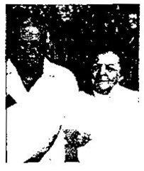

Mr. and Mrs. Charles W. Snyder of Clendenia will celebrate their 50th wedding anniversary Saturday with an open house given by their daughters at their home on Elk River Road from 2 to 4 p.m. He is retired from Union Carbide. She is the former Addie Jo Childress and is retired from Applachian Power Co. Their children are Renee Lepley of Clendenia and Charlene Procter of Moneta, Va. They have four grandchildren.
Snyder April 1988

Will of Jonathan H. Keeney (1824 - 1884)
Dated 28 August 1880, Filed 22 January 1884, Pendleton, Umatilla County, Oregon page 78
Know all men by these presents that I, Jonathan H. Keeney of Umatil County State of Oregon, being of sound and disposing mind, do make Publish and Declare this to be my last Will and Testament hereby revoking all former wills and testaments made by me.
1st: It is my will that my executor pay all my just debts and fune expenses out of my effects at the time of my death.
2nd: I give and bequeath to my beloved wife Mary A. Keeney the use of all my property both personal and real during her natural life.
3rd: I give and bequeath to my youngest son Charles Edward Keeney, after the death of my said wife Mary A. Keeney, the following described real estate to-wit: The Northwest quarter (N.W.?) of section Thirty Three (33) in Township one (1) South of Range Thirty Two (32) East of the Willamett Meridian in Umatilla County, State
of Oregon.
3rd: It is my will that at the death of my said wife Mary A. Keeney all my property both personal and real left and not consumed by my said wife in support of herself and the support and education of my said son Charles Edward Keeney, be divided equally between my children, John Henry Keeney, Joseph W. Keeney, M.S. Keeney, Thomas B. Keeney, Calista Hardesty, Sara C. Jones and Charles Edward Keen
4th: It is my will that in case any of my said children shall die leaving no heirs of their body living at the time of the death of my wife Mary A. Keeney, that such childs part of my estate shall be distributed with the rest of my property share and share alike with the survivors of my children.
5th: I appoint my two sons M.S. Keeney and Thomas B. Keeney execut of this my last will and testament without the necessity of giving any bonds.
In witness whereof, I have hereunto set my hand and seal this 23rd day of August in the year of our Lord one thousand eight hundred and eighty. Jonathan H. Keeney (Seal)
Witness: J.H. Turner, J.C. Leasure Filed: 22 January 1884 (J.P. Busbee) Clerk
Jonathan H. Keeney
Born - Feb. 4th 1824 Died - Jan. 17th 1884 at Pilot Rock, Oregon
Umatilla County
Married - April 18th 1844 to - Mary Adeline Lamb - Henry Co., Mo.
Children were: Jonathan, Adeline, John, Joseph, Marshal, Thomas, Calista, Sarah

