Keeney Update
VOL V, Number 1 Roscoe C. Keeney, Jr. MARCH 1988

Annotated 1850 Census, Kanawha County, (West) Virginia
1064-1071 | Keeney
(#2247) | Moses W. | 53 | VA | Farmer | $500
Notes | Mary (Huff) | 46 | VA
(#2246) | William | 22 | VA | Laborer
 | John | 20 | VA | “
(#2275) | Moses | 18 | VA | “ “
 | Joseph | 15 | VA | “ “
 | Washington | 12 | “
 | Harrison | 10 | “
 | Frances A | 8 | “ | (Fem)
 | Caroline V. | 4
1065-1072 | Keeney
(#2250) | William E | 41 | VA | Farmer | $500
Notes | Sally (Huff)  Sarah R. (m. 22 Jan 1835) | 33 | VA
 | Cornelius | 14 | VA
 | Foster | 11 | “
 | Samuel | 9 | “
 | Matilda | 6 | “
 | Alvira A. | 3 | “
 | William H. | 7/12 | VA
1066-1073 | Keeney
Notes | Foster H. | 38 | VA | Farmer | $500
 | Eliza J. (Huff)  (m. 17 Feb 1843) | 27 | VA
 | Evline | 16 | VA
 | Moses | 13 | “
 | Milton | 11 | “
 | Elizabeth | 7 | “
 | Neri (Male) | 3 | “ | (Nevi)
1069-1076 | Keeney
#2273 | Michael | 46 | VA | Farmer
Notes | Elizabeth (Gatewood)  (m. May 1831) | 41 | VA
(#2238) | Frances | 18 | VA | (Fem)
 | Mary J. | 15 | “
 | Robert | 13 | “
 | David | 11 | “
 | William | 9 | “
(#2337) | Lucinda | 7 | “
 | Woodford | 5 | “
 | Elizabeth A. | 3 | “
 | Michael | 2 | “
 | John | 7/12 | “
1070-1077 | Jarrett
 | Addison | 27 | VA | Farmer
 | Margaret (Keeney)  (m. 24 Aug 1848) | 19 | VA
 | Amanda | 7/12 | VA
1082-1089 | Keeney
(#2271) | Stiars J. (Jade)  (b. 1813, Greenbriar Co. d. 1896 | 44 | VA | Miller
Notes | Milly (Mildred P. Gatewood) (m. 25 Jan/Jun 1832; Milly b. 1813, d. July 1860; Stiers J. m. 2nd- 13 Jul 1865, Cynthia White) | 37 | VA
 | Robert | 16 | VA
(#2278) | McDonald | 12 | VA
 | (McDonald, 27, m. 21 Oct 1878, Amelia Alexander)
 | Nancy | 14 | VA
 | Michael | 10 | “
 | Moses | 9 | “
 | Madaline  (Adaline B., 18, m. 18 Apr 1863, Woodford White) | 6 | “
 | Macy | 4 | “
 | Frances | 2 | “ | Female
 | Crawford, Mahala | 27 | VA
1083-1090 | Mirrer/Murray
(#2274) | Thomas | 44 | VA | Laborer
 | Mary | 44 | “
(#2359) | Julia A.  (m. 13 Aug 1853, Rodham Spaulding, #1497) | 13 | “
(#2130) | Sally  (Sarah, 20, m. 21 Nov 1859, Andrew Foster, 23, #1010) | 11 | VA
 | Drusilla | 9 | VA
 | Hansome | 6 | “
 | Robert | 4 | “

John Keeney, Jr. Andrew Jackson Keeney
b. about 1780, VA (Now Jefferson Co. Tenn.) b. 7 Oct 1819, Fayette Co., Ind.
d. 6 Dec 1845 (of T.B.) Holt Co. MO d. 23 Sep 1895, Lane Co., OR buried:
o. Farmer, Blacksmith, Ferryman, Gunsmith Keeney Cemetery, Cloverdale Rd. Lane Co., Farmer
Md. 1805 Jefferson Co. Tenn Md. Elizabeth Mulholland 18 Nov 1841, Henry Co. MO
To: Mary Ramsey Buckhalter F. ? Mulholland
b. 1783, Edgefield Co., So. Carolina 2.Hannah Daniels Cooper, 3 Jun 1849, Lawrence Co.
d. 24 Jun 1872 Brownsville, OR Mo.
F. Daniels
3. Amanda Jane Morse Matthews
22 Dec 1861, Land Co. OR
F. Morse (or Morss)

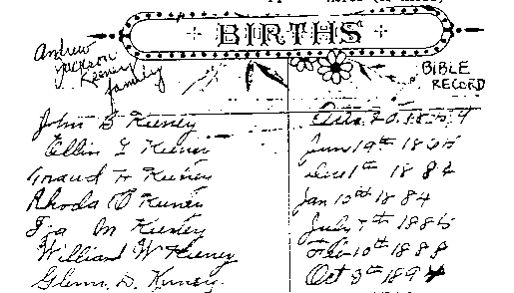
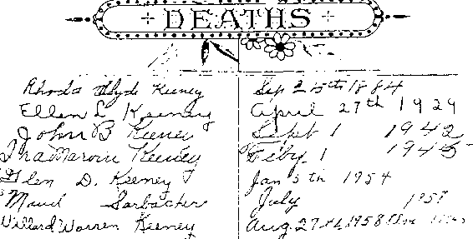
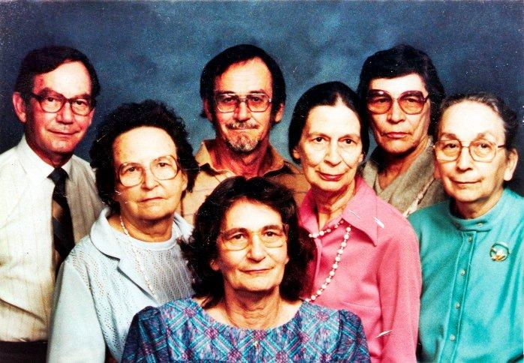
Keeney family all out for education
An interesting story of family endeavors in education is told by Lester and Marjorie Keeney, DeLand. Their daughter, Marinelle Davis, Marietta, Ga., a student at Kenesaw College, is included in the 1988 Directory of Who's Who in American Colleges and Universities. "Her solid academic record, along with her sincere commitment to community, make her an ideal selection," according to Betty Siegel, Kenesaw president. Davis' son, Christopher Davis, recently made the President's Honor
Roll at Kennesaw with a 4.0 grade point average. Mother son, LeRoy Davis III, is a senior at the University of Georgia. Marinelle Davis, 46, and a grandmother, married young (just out of high school), reared a family, but never gave up pursuing education for herself and her family.
The Keeneys also have another daughter in college. Elizabeth Milling, 35, is attending college is Merrimac N.H. She, with her husband and two children have recently returned to the United States after 6 ½ years in Europe. And that's not the end of the education story. The Keeneys have a granddaughter, Carolyn Slape, at Campbellsville Baptist College, Campbellsville, Ky., where she is a music major, graduating in May.
McDONALD & MAMIE STANLEY KEENEY family, grandchildren of John S. & Hannah Frazee Keeney and great-grandchildren of Stires & Mildred Gatewood Keeney, posed for this family portrait at Christmas time. Helen Pauline (Bennie) Metheny is in front; Maxine Harless, Hannah M. Keeney, and Dorothy Lee Gwin, second row; Albert McDonald (Bus) Keeney, George M. Keeney, and Mildred A. Keeney, back row. All the girls except Helen are retired teachers, Bus retired from DuPont, George from FMC, and Helen from business/secretary.

KEENEY UPDATE
KEENEY UPDATE was started in December 1983 as a quarterly publication to supplement the book, "2,597 KEENEY RELATIVES", published in 1978 and now out of print.
At first KEENEY UPDATE was sent to all those who had purchased a book, with a $2 donation to assist with postage. Then generous gifts from several "believers" made it possible to continue. After March 1987 both financial support and material for publication seemed to reach an abrupt end.
This issue is an attempt to put together information that has come from here and there over the last nine months. Future issues will depend on whether people are willing to share their family information, charts. and pictures of KEENEYS born before 1900. Requests for information are filled almost every week, but there is an unwillingness to share family information or else KEENEYS are the world's worst procrastinators.
If anyone has a copy of "2,597 KEENEY RELATIVES" that is no longer wanted, the editor will be glad to return the price you paid (records have been kept), plus cost of postage. Mail to Box A, Cedar Grove, WV 25039.

Missouri Marriages
James Keeny to Modest Keeny 19 March 1832 Jonathan Keeney to Catherine to Ragsdale 1/4/1848
Joseph Keeny to Winny Chesney 27 Dec 1837 in Osage County
Joseph Keeney to Susan Trowley 17 Jun 1836 Oliver H.P. Keeney to Mary T. Laughlin on
Above in Cooper, Jackson and Ray counties 11/17/1850 in Osage Co.
John H. Keeney to Narcisse Thompson 12/21/1847 Mary Keeny to Levi Snyder 16 Nov 1854 (Cass)
In Johnson County James R. Keeney to Anna Rostock 22 Mar 1860
Eli Keeney to Elizabeth Pierce 2/24/1848 (Holt) in Holt County
Elias Keeney to Margaret Hyet 10/1850 (Holt) Mary C. Keeny to George Townlin 18 Oct. 1855
Henry William Keeney to Martha J. Hodges on in Holt County
3-18-1849 in Franklin Co.
Jacob Keeney to Rebecca Vaughan 1/12/1842 (Mill)

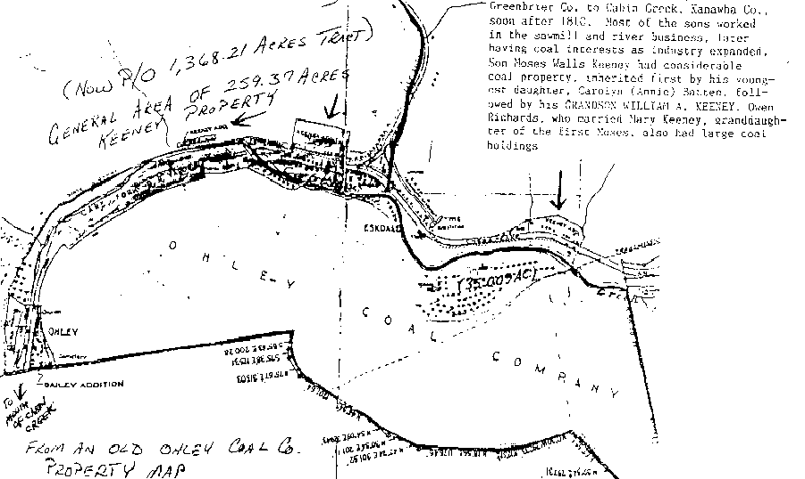

Moses & Frances Harris Keeney moved from Greenbrier Co. to Cabin Creek, Kanawha Co,. soon after 1810. Most of the sons worked in the sawmill and river business, later having coal interests as industry expanded. Son Moses Walls Keeney had considerable coal property, inherited first by his youngest daughter, Carolyn (Annie) Batten, followed by his GRANDSON WILLIAM A. KEENEY. Owen Richards, who married Mary Keeney, granddaughter of the first Moses, also had large coal holdings.

Obituaries
Thomas C. Knight
Thomas C. Knight, 81, of Cedar Grove, died Oct. 21. 1987 in Memorial Division, CAMC, after a short illness. He was a retired coal miner and was a lifelong resident of Kanawha County. He was a Protestant. Surviving: wife. Ruth E. Keeney Knight; sons. Harry and Harold, both of Cedar Grove, daughters, Frances Riffle and Linda Coleman, both of Cedar Grove, Janette Tupis of Charleston, Doris Johnson of Summersville, Remona Mullins of Elkhart, Ind.; sister. Louise Rider of Cedar Grove: 27 grandchildren; 26 great-grandchildren. Service will be 2 p.m. Monday at Cook Funeral Home. Cedar Grove, with the Rev. Philip Wolf officiating. Burial will be in Woodland Cemetery, Cedar Grove. Friends may call from 7 to 9 p.m. today at the funeral home.

Cledith N. Keeney
Cledith N. "Tookey" Keeney. 55, of Box 81. Dawes, died Feb. 7, 1988. at home after a long illness. He was a retired electrician for U.S. Steel. He attended Miami Nazarene Church and was an Army veteran of the Korean War. He was a member of UMW and was a former instructor at Carver Technical Center. Surviving wife, Delores Stewart Keeney; daughters. Mrs. Pamela McFann of Julian, Mrs. Mehsa Cassis of Charleston; brothers. Keith and Hewitt, both of the Wevaco area of Cabin Creek, Adrian of Beckley, Jack of Shelby, Ohio, Stacy of Chesapeake; sisters, Thelma Cantley of Crown Hill, Inez Brock: of Dawes, Julia Moore of Beckley, Madeline Hall of Newark. Ohio. Ruth Sadler of South Charleston, Ann Ream of New Haven. Ohio, three grandchildren. Service will be 1 p.m. Wednesday at Fidler-Frame Funeral Home. Belle, with the Rev Edward Midcap officiating. Entombment will be in Kanawha Valley Memorial Garden Mausolem. Friends may call from 7 to 8.30 p.m. today at the funeral home.
Mrs. Bessie M. Hunter
Mrs. Bessie M. Hunter. 78, of Box 10, 365 Rensford Star Route, died Oct. 20, 1987, at home, after a long illness. Surviving: daughter, Phyllis Elswick of Campbells Creek; son, Richard of Roanoke, Va.: stepson. Billy Franklin of Vinton, Ohio: seven grandchildren; four great-grandchildren; one great-great-grandchild. Service will be 11 a.m. Thursday at Witcher Baptist Church, Belle, with the Rev. Billy Wilburn officiating. Burial will be in Witcher Cemetery. Friends may call after 7 p.m. today at Stevens-Grass Funeral Home. Malden, and one hour prior to service at the church

Lewis M. Keeney
LEBANON, Va. - Lewis M. Keeney, 67, of Lebanon, formerly of Eskdale. W.Va.. died Oct. 8, 1987, in Bristol Memorial Hospital, Bristol, Tenn., after a long illness. He was a retired employee of Appalachian Power Co., Clinch River. He was a member of Good Shepherd Catholic Church, Lebanon, and a Navy veteran of World War II. Surviving: wife, Mrs. Dorothy Keeney; daughters, Mrs. Kay Everson of Manassas, Mrs. Rae Beaver of Pratt, W.Va.; sons, James Leach of Barberton, Ohio. Robert Leach of Wadsworth, Ohio; sisters, Mrs. Lucille Canterburry of Charlotte, NC Mrs. Elmo Scott of Dawes, W.Va., Mrs. Eilene Bass of Lebanon: brothers, Arthur of Chesapeake. W.Va., William of Marlinton, W.Va., Charles E. of Eleanor, W.Va., Lawrence of Eskdale; 17 grandchildren; 16 great-grandchildren. Mass of Christian burial will be 11 a.m. Saturday in Good Shepherd Catholic Church. Lebanon, with the Rev. Robert Rademacher officiating. Burial will be 3 p.m. Sunday in Hiverview Memorial Park. Charleston. SC. Friends may call from 1 to 9 p.m. today at Russell County Funeral Home, Lebanon.

Margaret Ann Stone
Margaret Ann Stone, 70, Gas port, N.Y., died Monday morning, Aug. 24, 1987 in the Llnited Church Colonv Nursing Home in Gasport. Born Dec. 15,1917, In Point Pleasant. she was the daughter of the late C.C. and Bessie Reynolds Stone. She was preceded in death by one brother, Robert. Surviving are one brother. Captain Charles Henry Stone. Point Pleasant: one sister. Mrs. Bess Evelyn Merrill, Lockport, N.Y. four nephews and two nieces. Graveside services will be conducted Friday at 11 a.m. at Lone Oak Cemetery with the Rev. Steven Dorsey officiating. Burial will follow in the cemetery. There will be no visitation. Arrangements are under the direction of the Crow-Hussell Funeral Home.

Lewis M. Keeney was a son of James T. & Edna Jacobs Keeney and grandson of Wm. H. & Sally Huff Keeney (p.67).
All others in the obituaries are members of the Michael R. & Elizabeth Gatewood Keeney family, listed in KEENEY UPDATE , March 1987 SUPPLEMENT in pages 9, 11, 14 and 8.
Readers are invited to send obituaries from other newspaper reports.

Lifesaver
Fairfax Police officer Stephen Keeney of Manassas helped save the life of a Herndon man who suffered an apparent heart attack during a meeting of a REACT group at the Fairfax County Governmental Center Aug. 4. Keeney assisted with cardio-pulmonary resuscitation until rescue units arrived.
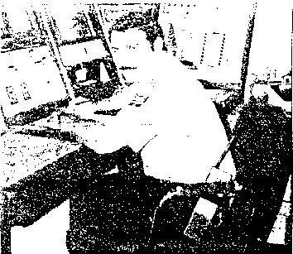
Manassas Man Saves Heart Attack Victim
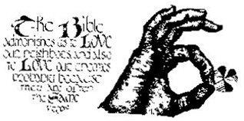
By ROCKY HOPCHAS JM Staff Writer
Stephen Keeney of Manassas, a Fairfax Police officer, was credited by members of the Herndon REACT team with helping save the life of a team member who suffered an apparent heart attack during a meeting of the group Aug. 4.
Keeney helped administer cardio-pulmonary respiration to WiIliam Anton of Herndon until rescue units arrived al the Fairfax County Governmental Center, where the meeting was being held, according to Robert Baird, public relations officer for the Herndon REACT team.
Anton was treated at Reston Hospital where a heart attack was confirmed, and is recuperating at home. Baird said.
During a break period at the group's bimonthly meeting, Anton and another member left a conference room and were walking toward an outside corridor near the Fairfax County Police reception desk when Anton suddenly collapsed onto the floor.
The team member accompanying Anton immediately sensed something was seriously wrong and quickly summoned Fairfax Police Officer Mark Eastman, who immediately called the Reston rescue squad for medical assistance, Baird said, then leaped over a counter to Anton's side.
Within seconds after the call for medical assistance, Eastman and Keeney evaluated the situation and began to make Anton comfortable. Baird said. A REACT team member noticed Anton had stopped breathing, and informed Keeney and Eastman, who immediately began cardio-pulmonary respiration.
Anton began breathing again in a matter of seconds. Baird said, but stopped again and CPR was again administered.
A Reston paramedic company was on the scene m a short time and transported Anton to Reston Hospital for further emergency treatment, Bated said.
"If it were not for the heroic efforts of both Fairfax County Police officers being on the scene and quickly administering first aid, Anton may not have been alive today." Baird said. He stated that the Herndon REACT unit was especially proud to have "such dedicated men assigned to the Fairfax County Police."
REACT is an acronym for Radio Emergency Associated Communications Teams. They monitor citizens band radio channel 9, the FCC designated emergency communications and traveler’s assistance channel, for every type of emergency transmission.
Page A6 The Journal Messenger Manassas Va. Wed. Aug. 26, 1987
WYOMING CO., PA. KEENEYS
Continued from December 1985
THOMAS KENNEY (Alexander 3)
4 | b 10 May 1751 East Hartford, CT d 10 Jan 1840 Tioga Co., PA, m 10 Jan 1769 Hartford Mercy Lamb b 12 Oct 1718 d ca 1840.
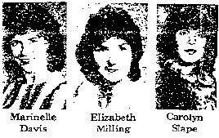
During the Revolutionary War, he volunteered for several brief tours of duty in the Connecticut Militia. He first enlisted in April 1775. Marching to Boston and was stationed there for 7 months discharged in Nov. While he was on this tour of duty, he saw the Bunker Hill Battle and said General Washington visited their station at Roxbury Hill, while he was there. He had several short enlistments of two months each in 1776. 1777 and 1778 as Private in the Connecticut Militia.
According to his application for a pension, he further stated in the year 1780, he removed his family to Wyoming County, PA, having been there six months earlier in the year. The frontier settlements were greatly annoyed by the Indians for a long time after the proclamation of the peace and that the settlers were constantly compelled to take turns on Garrison duty as Indian parties continued to plunder, burn and destroy, that he belonged to a company of young man on minute service whose duty it was to be ready to go at any and every call. He was under the command of a Col. Butler and Capt. Satterlee for eighteen months and were frequently in the pursuit of Indian parties and constantly slept with his arms in readiness to turn out at a moment’s warning, day or night.
He received his pension (Pension #S 9366) issued 8 Nov 1833. At the time of his application for pension, executed 11 Sept 1832, he was living in Fabius, Onondaga County. NY.
Thomas Kenney settled near Kenney's Ferry. PA (now Laceyville, Wyoming Co., PA). He built a temporary shanty on the southwest bank of the Susquehanna River (in Braintrim Township) and in the same year he built a comfortable log house on the opposite bank of the river, and in the following autumn (1786) moved his family into it, thus becoming the first settler in Braintrim Township, west of Skinner's Eddy. His wife and daughter, Mercy, were heroines in several courageous exploits.
Thomas Kenney and his wife returned to New York State in a few years, leaving the farm in possession of Richard Keeney (son of Mark Keeney, SEE THE BEEMAN CHAPTER) and his wife Mercy (dau. of Thomas Keeney-4). The Keeney family ran the Keeney's Ferry until a bridge was built at Laceyville.
Education
Keeneys have a granddaughter, Carolyn Slope, at Campbellsville Baptist College, Campbellsville, KY, where she is a music major, graduation in May.
ELIJAH d 1846 Chicago, IL m ca 1792 Cynthia Lee Forbes b CT
MERCY b 15 Feb 1770
RUBY b 14 Oct 1771 d 14 Aug 1842 m 6 Aug 1792 Richard Mitchell b 16 July 1768 d 7 Mar 1847
THOMAS, JR. b 8 Sept 1776 E. Hartford, CT d 1853 Middleberg, PA m 1797 Chenango NY Anna
Parshall d 1827 Chenango.
JESSE b 28 Sept 1778 E. Hartford m 29 Dec 1799 Catherine Middaugh b 13 Sept 1781 d 13 Aug 1848.
SUSANNAH m Asa (son of Isreal and Ruth (Howett) Parshall)
MARY B.
BETSY OR BETTY
LOUISA OR LEWENA
JONATHAN OR JOHN
MERCY KEENEY (Thomas - 4)
b 15 Feb 1770, probably East Hartford, CT d 14 Mar 1856 PA (Probably Wyoming Co.) m 18 Sept 1788, Wyoming Co. Richard Keeney (son of John Keeney h 17 June-1.762 d 11 June 1831, probably Wyoming Co., PA. They are undoubtedly cousins, but that is not proved.

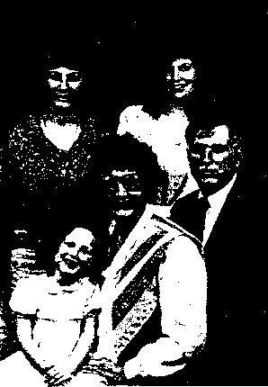
KEOKUK, IOWA KEENEYS
JOHN DAVID KEENEY is pictured with wife Rebecca and children Suzie, Heather and Shannon. John is in the MICHAEL KEENEY/CATHERINE LEWIS line, six generations down the line, hailing from Lawrence Co., Ohio, grandson of Fred B. and son of Charles.

IN MEMORY OF
JOHN E. KEENEY
BORN September 7, 1911 Prosperity. West Virginia
ENTERED INTO REST July 2, 1987 Kokomo, Indiana
SERVICES FROM Eikenberry-Eddy Funeral Home Monday, July B, 1987 - 10:00 A.M. CLERGYMAN OFFICIATING Dr. James Hardin
PLACE OF INTERMENT Fast Maplewood Cemetery Anderson, Indiana

Mrs. Frances M. Keeney COCHRAN, Ga. - Mrs. Frances M. Keeney, 66, of Cochran, died July 20, 1981, in a Cochran hospital, after a short illness. She was a retired teacher, a member of Trinity Episcopal Church, Cochran, and a member of the DAR.
Surviving: husband, Dr. James L. Keeney; son, Randall of Cochran; daughter, Ann Graves Keeney of Aspen, Colo.; brother, William H. Martin Jr. of Dry Fork, Va.
Graveside service will be 3 p.m. Thursday in Spring Hill Cemetery, Charleston, W.Va, with the Rev. Mack McCloud officiating. There will be no visitation. Barlow-Bonsall Funeral Home, Charleston, is in charge of arrangements.

