Keeney Update
VOL IV, Number 3 Roscoe C. Keeney, Jr. JUN 1987

Reminiscing . . .
After four years it's time for some reminiscing KEENEY UPDATE was started to keep those who obtained 2,597 KEENEY RELATIVES up to date, since the 500 copies almost evaporated, there were no more books and people kept Loading me down with information previously withheld... Then as word spread the mailing list increased to include Keeney relatives in 45 states; this presented a problem, since most of the new ''subscribers didn't have ''the book'' and most were interested in Keeneys from other lines and states.
Conclusion: It is impossible to put out a publication that will interest every Keeney line, unless one has a computer, money to travel widely, and lots of extra time, not to mention a secretary, none of which I have.
Enjoying the role of full-time pastor these last 19 months has taken my time and energies. . and I've been ''drafted'' as secretary of the ministerial group, treasurer of the food pantry for needy folks, and vice president/editor for the W. Va. Baptist Historical Society and still serve as executive director for the WV High School United Nations.
So why all the detail? I want to say to all that, while my obsession for the past decade has been genealogy, it isn't now. This issue of UPDATE is possible only because I was furnished good material by Pat Kaufman of Manson, IA; Iris Priddy of Bakersfield, CA; and Mrs. Monroe Kriegel of Stillwater, OK. I think it's a good issue, thanks to them.
Plans now are to publish an UPDATE in September to complete the fourth year - IF enough suitable material comes in - after that it will depend on you.
Christian Keeney, direct ancestor of Connecticut Keeneys and a Florida resident, was here recently "loaded with facts". His obsession with genealogy is worse than mine ever was!
How about some good profiles on Oscar Keeney… or listings of deaths and marriages of Keeneys in your state.. and old pictures are better if shared!
Roscoe

ESKDALE, WV TO GOWEN, OKLAHOMA TO LONGVIEW, WA
In Loving Memory of WALTER RUSSELL KEENEY
Mr. Walter Russell Keeney was born on October 24, 1909 in Whittler, West Virginia to the late Daniel Webster Keeney and Avada Myrtle George Keeney. The Keeney's moved in the I930's to Anderson, Indiana, where Mr. Walter Keeney attended Anderson College.
He met Lucy Doris Pucker of Mill Shoals, Illinois in Anderson, Indiana. They fell in love and married on December l7, 1938. They made their home in Anderson, Indiana and lived there until 1981. At that time they moved to Arcadia, California. In 1985 the Keeney's decided to relocate to Phoenix, Arizona.
Mr. Keeney worked for R.H. Kyle while in West Virginia. After moving to Indiana, he worked for Delco Remy where he retired after 24 and a half years of service in 1974. Mr. Keeney's passion was restoring classic and period furniture which he did until his death on April 21, 1987.
Mr. Keeney was active in his community in Anderson Indiana. He participated in the Soap Box Derby, Anderson Boys Club and the Fisher Body Guild. He will be greatly missed by his devoted family and friends in Indiana and California.
Mr. Walter Russell Keeney leaves to cherish his memory, his wife of 49 years, Lucy Doris Keeney; three sons, Glenn Russell of Anderson, Indiana, Charles Kettering of Arcadia, California, Edbert Otis Keeney of Phoenix, Arizona; two daughters, Anna Mae Pinter of Arcadia, California and Marjorie Mary Dolinski of Laverne, California; three brothers, John E. Keeney of Galveston, Indiana, William David Keeney of Marion, Indiana and Herman A. Keeney of Naselle, Washington; ten grandchildren, two great grandchildren and a host of other family and friends.
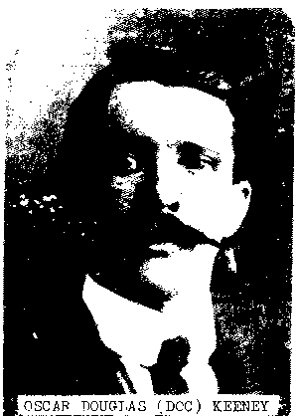
OSCAR DOUGLAS KEENEY (p. 70, KEENEY RELATIVES) was born November 5, l876 at Eskdale, WV, the oldest son of Samuel & Ruth Ferrell Keeney. His father died when he and several brothers and sisters were very young and his mother cared for the family the best she could. In 1903 she was married to J. C. Peters.
Soon after 1900 Oscar left the hills of West Virginia for Oklahoma, where he worked in the coal mines. There he married Minta Maude Griffith, who had come from Ohio and worked in the post office. Both were Baptists and they were married on Christmas 1910. When there were strikes in the mines, Oscar would go to Colorado and work as a timberman.
The Keeney backyard gardens were enormous and produced abundantly, while the neighbors seemed to produce plants that merely bloomed. A granddaughter remembers his telling them that if they
would use the almanac and plant in the correct signs, they would produce food. Scores of cans of fruit and vegetables were set aside for use in winter. Being also a skilled hunter, Oscar brought home turkeys, grouse, ducks and squirrels - and there were also bee hives and honey.
While his formal education was meager. Oscar was a self-educated man. He had a large bookcase of good books, many biblical. An example of his will to learn was an occasion when he ignored his cotton and yam crops, choosing to take the whole family on a picnic. As darkness fell along the stream where they ate, his surprise came: a complete eclipse of the sun. He then explained what had just happened.
Oscar Keeney was ahead of his time for sure. He organized a neighborhood baseball team and walked miles with the team to another town to play.
Then came the depression years; the family left Oklahoma and settled in Longview, Washington. He had experience in the timber business and, at the age of 54 or 55, found a job in the shipyards. "I put some color back in my hair and went to the shipyards,'' he quipped. All four of his sons were in the Navy in World War II.
He was never called Oscar; he was always "Doc" and he was good at dosing out the medicine. It was quinine for that malaria in Oklahoma and it was a solution of Iodine and glycerin diluted for sore throats. It was sassafras tea in the spring.
Life was never easy for this family, but "Doc" always had a twinkle in his bright blue eyes, a lot of common sense and a sense of humor. As he aged, his teenage grandchildren were amazed at him; he'd be listening to news or the radio and watching a baseball game on TV. They loved Grandpa, but learned that ''they were not to kill the snakes around the garden because they ate the insects''. He was a good father and a faithful husband.
Oscar Douglas Keeney developed a heart ailment and died June 5, 1959 at age 83 at Longview, Washington. He never got back to West Virginia-- raising the family in Oklahoma and 22 years on the West Coast made a full and a good life.
Iris C. Keeney Priddy 3-16-87
Family of Oscar D. & Minta Griffith Keeney:
IRIS CECIL KEENEY, b.2-5-1912 at Gowen, OK,
m, J. E. Priddy - Bakersfield, CA
RUTH ELIZABETH KEENEY, b.1-15-19l4
m. Monroe Barnes - Longview, WA
ELMO MURRY KEENEY - b.12-21-1917
lives at Kelso, Washington
WANDA LORENA KEENEY McMILLAN, b. 1-23-1919
DONOVAN ROSS KEENEY, b.6-13-1921 at Gowan,
OK, d. 5-29-1986; wife: Ruby; children:
Patricia, Robert, Terry - all Kelso, WA
LOYD NEIL KEENEY, b.12-6-1923, d.7-7-1977
wife Blanche lives in Longview, WA
OSCAR DOUGLAS KEENEY, JR., b. 7-7-1925;
Resides at Springfield, Oregon.

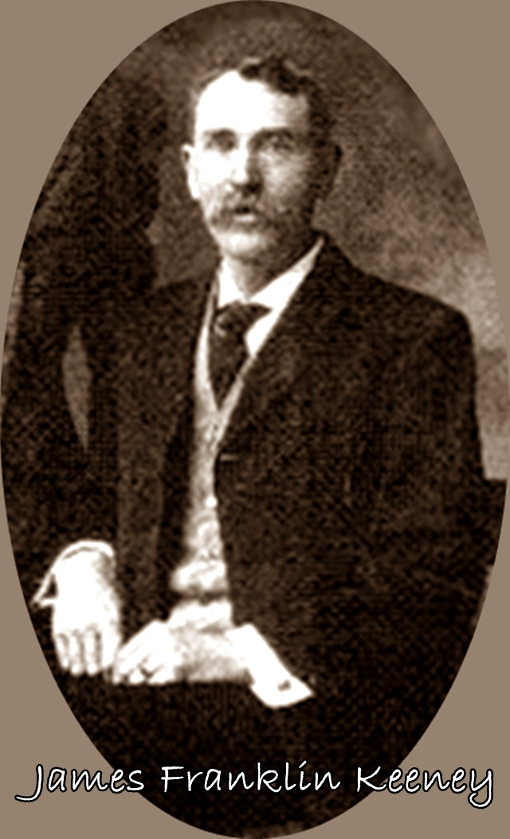
James Keeney - The Founder of WaKeeney
(April 30, l892) James Franklin Keeney, the founder of WaKeeney, Kansas was born in Crawfordsville, Indiana, on the 15th of September, l845. His father's name was Charles P. Keeney, and his mother's maiden name was Mary Beck, a cousin of Senator Beck of Kentucky. His mother was born in North Carolina and his father in Kentucky. They went to Iowa in 1850, and settled in Des Moines, where James F. Keeney lived with his parents until he was twenty years old. Part of this time he worked on his father's farm rear the city and going to school in the winter. When he was eighteen years old he was sufficiently advanced in his studies to teach school, which he did, at the same time he was pursuing the studies of higher mathematics, Greek and Latin under Prof. J. A. Nash, of Des Moines. So he was prepared to pass the examination and enter the University of Rochester, at Rochester, N. Y., where he took a four years collegiate course, graduating in l866 with high honors, having excelled in mathematics and in both Greek and Latin. He also studied law. He lived in Rochester, N. Y., until the fall of l868, when he removed to Chicago, where he has ever been an active and progressive Chicagoan. His first enterprise in Chicago was, in connection with some others, to buy up 240 Acres of land to lay out Ravenswood, which is today one of the finest suburbs of Chicago, being now in the city limits and only six miles from the business center.
His next enterprise was just before the big Chicago fire, the buying up of a large tract of land twelve miles north of the courthouse on the lake and laying out South Evanston. Here he built a fine railroad depot on the Chicago and Northwestern railroad, a fine business block and forty fine houses and established this place on such as solid basis that today it is the home of thousands of Chicago's most influential and best business men.
After the great panic in Chicago in l877, Mr. Keeney went west to Trego county, Kansas, and bought in all about five sections of land and founded WaKeeney.
The old settlers of Trego county are well acquainted with Mr. Keeney 's record in Kansas. Not only was he prominently identified with all of WaKeeney' s business interests, but he was well known in the state. The Keeney block, which bears his name, was built by him in 1880; our fine depot building, one of the finest on the line of the U. P. railroad we owe to him largely. Mr. Keeney was a member of the legislature from Trego county and was one of the leading members of that body. Upon him was conferred the high honor of president of the Western National Fair Association, was a member of the state Board of Agriculture, etc. He was also prominently mentioned by the press of Kansas for governor. It is needless to remark that if he had remained an Kansas he would have been one of the most prominent men in the state.
In l88l Mr. Keeney returned to Chicago, bought l60 acres near Humboldt Park and founded the village of Hermosa, which is a thriving place and is only five miles from the courthouse and to which the street cars now run. This place he also developed by building houses, sewers, and doing all the necessary things to make it a desirable home for the masses.
He built for himself on the southwest corner of Rush and Ohio streets last year a seven story brick apartment house, which covers a ground space of 100x125 feet, which is considered the finest building of the kind in Chicago, which brings in a rental of $45,000 per annum.

James Keeney (Western Kansas World, 30 April 1892, Page 7) He also built for himself a fine granite mansion of Michigan boulevard, where he now lives.
He bought recently 1,200 acres in Cook County, on the South Side, and has established there a manufacturing town, which he calls Columbia Heights. The Rice Henge Piano Co. employs 300 men; Steger Piano Co., 200 men; Standard Cloth Co., 150 men; Columbia Heights Piano Co., 100 men; Ornamental Terre Cotta Co., 50 men, and several other factories. It is Mr. Keeney's intention to make this the crowning work of his life, as he has already accumulated a fortune.
Research on this page supplied by Pat Kaufman, Manson, Iowa
Marriages, Polk Co., Iowa
Polk Co., Marriages, 1846-1866
(SOURCE: Marriages, Polk Co., Iowa; Pioneer Sons and Daughters Gen. Soc., Des Moines, Iowa)
May 2, 1829 | Keeney, William - Watts, Sara
Jan. 1, 1852 | Keeney, Jonathan -- Gooch, Melissa
May 23, 1852 | Keeney, William W. -- Hook, Me1vina
Nov. 7, 1852 | Keeney, Josiah -- Hook, Margaret A.
March 23, l854 | Gooch, Thomas J. -- Keeney, Nancy P.
Feb. 22, 1855 | Keeney, John 0. -- Keeney, Malissa
Dec. l0, 1855 | Krysher, Wesley -- Harrison, Mary R.
Feb. 8, 1859 | Keeney, William W. -- Fisher, Philinca
July 17, 1856 | McCay, Thomas W. -- Keeney, Elizabeth
May l5, 1857 | Manus, Sanford T. -- Keeney, Mary M
Dec. 27, 1860 | Pearson, Ephraim -- Keeney, Margaret
Oct. 11, 1862 | Lang, George W. -- Keeney, Sara Jane
June 29, 1864 | Case, William -- Keeney, Margaret E.

Marriages, 1867-1871
Sept. 25, 1867 | Keeney, William P. -- Keeney, Nancy E.

Marriages, l87l-l880
April 5, 1876 | Smith, Channing L. -- Keeney, Mary E.
Feb. 18, 1577 | Hayes, J. M. -- Keeney, Melissa F.
Jan. l4, 1880 | Cladwell, A. B. -- Keeney, Josie

Marriages, 1880-1884
Nov. 16, l880 | Keeney, C. F. (25) -- DeFord, Eliza (21)
Nov. 16, 1880 | Wilson, Ellery (29) -- Keeney, Malissa H.
Nov. 15, 1881 | Keeney, Jonathan (35) -- MyerHoff, Clara
Sept. 20, 1882 | Godfrey, John D. (28) -- Keeney, Maggie
June 8, 1884 | Keeney, Thorns E. -- Cullenbine, Mamie
(l885 - 1888 -- no Keeney listed)
Polk Co., Marriages, 1889-1892
Jan. 18, l891 | Beatty, David -- Keeney, Cassie M.
Aug. 3, 1890 | Dillingham, James -- Keeney, E. A.
Marriage Records, Warren Co., Iowa 1849-1899
(Source: Project of Carlisle School, Carlisle, Warren Co, Iowa.)
Nov. 1, 1857 | Hurd, William P. -- Keeney, Mary H.
Mar. 31, 1861 | Keeney, D. F. -- White, Rosana
Dec. 22, 1863 | Hopkins, James R. -- Keeney, Mary Jane
Feb. 15, 1865 | Keeney, Jonathan -- Keeney, Elizabeth A
Oct. 26, 1876 | Keeney William B. -- Foust, Jennie
Dec. 14, 1880 | Rogers, A. J. (38) -- Keeney, Sylvia (28)
Jan. 15, 1882 | Keeney, George (29) -- GoForth, Lydia (19)
Jan. 30, 1883 | Kelly, Thomas W. (29) -- Keeney, Clara (28)
May 17, 1883 | Keeney, Silas (24) -- Davis, Lizzie A. (19)
June 25, 1883 | Boatwright, George W. (25) -- Keeney, Nanna J. (19)
Sept. 2d, 1885 | Keeney, Nathaniel F. (24) -- Hendrickson, Phebe
Oct. 15, 1885 | Keeney, Joseph A. (27) -- Smith, Clara B.
March 9, 1886 | Keeney, Frank E. (20) -- Van Pelt, Mattie (17)
Oct. 20, 1886 | Keeney, Frank (22) -- Phelps, Alta (19)
May 18, 1887 | Hanna, Goerge A. (28) -- Keeney, Susan E. (17)
July 10, 1889 | Hollingworth, John W. (32) -- Keeney, Grace
Dec. 26, 1890 | Keeney, Elmer A. (22) -- Smith, Eliza S. (21)
Dec. 24, 1893 | Keeney, Eugene F. (23) -- Clarke, Eva (18)
Nov. 19, 1895 | Keeney, John (45) - Welch, Bridget (33)
Dec. 25, 1895 | Kline, John (24) - Keeney, Carrie D. (19)
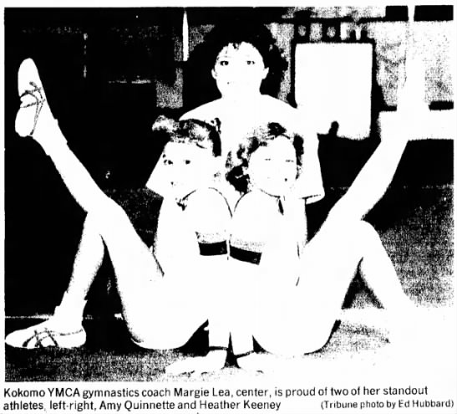
Local gymnasts hope to study at Soviet Gymnastics School
By Mark K. Lyons
Tribune Sportswriter
Like most American children their age, Amy Quinnette and Heather Keeney have spent the majority of the past year going to school, playing with friends and reading.
But lately, the pair of Kokomo YMCA Pirouettes gymnasts have been studying a foreign language in the hopes of visiting its native country for two weeks in late June and early July.
"We've checked out Russian books from the library." Quinnette said. "Before we can go to Russia to train, we have to learn how to say 'please', 'thank you and 'where's the bathroom?'"
The pair of Junior Elite National Team members and their coach, Margie Lea, hope to raise enough money to attend the 1987 Soviet Gymnastics School and Course June 24 to July 8.
They've made some progress already. They've applied, made their down payments and have been accepted to the school, which is scheduled to be in the ultra-modern gymnastics and lecture hall facilities located in Moscow's Olympic Centre Complex.
The trio has also established an account at Union Bank and Trust Co, in their names.
They've received some local sponsorship, too, as the ImageSmith took the passport photos for Quinnette and Lea. Once their passports are completed, they'll be sent to the Soviet Union, and they'll receive visas in return which will be good for that country and for China.
"The USAIGC (United States Association of Independent Gymnastics Clubs) is doing our Visas, because we're actually going on a study tour." Lea said. The association sanctions the Junior Elite program and is promoting the school in conjunction with Study Tours Internationale of Carmichael, Calif.
Keeney, 8, and Quinnette, 9, work nine to 12 hours a week under Lea's tutorage at the Kokomo Family WMCA in addition to taking ballet and dance instructions. "But that's nothing like what they'll encounter this summer." The coach said.
The school is designed to instruct the coach as well as the gymnasts. "I'll work with the girls for a good part of the course, but there'll be other times when just the coaches will take classroom studies with the Soviet coaches." Lea said. "We feel we're representing Kokomo and the YMCA, because the Y gives me a chance to work with the girls and gives me a full-time job.
"I don't have room for all the girls I teach now, yet they give me the gym to work with Amy and Heather when I need it."
The Soviet program has been especially designed to meet the needs and interests of American and Canadian male and female gymnasts, their coaches, parents, judges, club administrators and physical education teachers. It features what Lea called two solid weeks of training.
More than 30 of the Soviets' top coaches, sports medicine and applied gymnastics scientists, led by head men's coach Vladimir Popov, are expected to be at the school. Among the areas to be covered are choreography, acrobatics, trampoline, special physical fitness programs, exercise techniques and methods, psychological preparation, medical control and biomechanics, as well as the gymnastics events, uneven bars, tumbling, floor exercises, balance beam, rings, parallel bars and vault.
This is the second straight year for the school, and Gary Goodman, the USAIGC's national technical director, will again serve as the school's director.
It's important that we learn to speak at least some phrases in Russian, because Gary says the Soviets respect Americans' attempts to communicate with them in their language." Lea said. "I feel that sports is a medium through which we can communicate, too. If we can develop a camaraderie with them, then so much the better."
Keeney and Quinnette are the only girls from Indiana attending the school. When asked why she wanted to go to Moscow, Quinnette's answer was brief.
"I'm going to learn, "she said, before pausing, then added, "and bring back as much knowledge as I can."
About $2,500 is needed for each of the gymnasts and their coach. Half that amount is to be paid at the end of this month, with the rest due at the end of May, about three weeks before they depart to Canada en route to the Soviet Union.
Donations can be sent to Union Bank and Trust Co. in care of Russia '87, Post Office Box ??, Kokomo, Ind. 4??01.
Lea said the trip has been a year in planning, and Quinnette and Keeney are becoming more interested in the state of affairs between the Soviet and American governments.
"I think they're more aware now than they were before, and they're wondering why things are the way they are. But they have assured us that the girls are 100 percent protected while they are over there. From all I've seen, the Russians really want us over there, because they learn as much from us as we learn from them."
Keeney's favorite events are the floor exercise and the uneven parallel bars, while Quinnette's are the vault and balance beam. Quinnette wants to be a scientist after her gymnastics career is over, but Keeney's planned route through life is a bit different.
"Heather said she wants to be a top-level gymnast and to work at McDonald's, " Lea said.

KEENEY AMONG NATION'S BEST
Kokomo YMCA Pirouettes gymnast Heather Keeney has earned a spot on the Junior Elite National Team after passing tests conducted recently.
Keeney, 8, passed the physical ability test and the profile elements test. According to Margie Lea, Keeney's coach the past four years, the tests are extensive and very difficult. The tests began with physical strength, flexibility and speed trials and ended with advanced skills in Olympic events.
Gary Goodson, national director of the United States Association of Independent Gymnastics Clubs, said of 3,000 gymnasts who undergo the tests each year, only 100 to 150 pass. The program has been established to develop elite gymnasts, and to train and develop national elite coaches, based on studies of the leading gymnastics systems in the world. Much of the USAIGC program is based on the Soviet Union's system of developing elite gymnasts, Goodson said.
Keeney and Lea have qualified to attend the Junior Elite National training camp. At camp, each gymnast learns new skills which guides him being a world-class gymnast. Each one is also tested by psychologists and sports medicine doctors to give his coaches an idea of where he needs to improve, and what physical and mental adjustments he needs to make to withstand the lifestyle of an elite gymnast.
Another member of the Pirouettes, Amy Quinnette, also passed the physical ability test. However, she came five points shy of passing the profile elements test. Lea said since Quinnette was so close to passing, she has the opportunity to test again June 1 at Albany, N.Y.
Like Keeney, Quinnette has been under Lea's tutelage for the past four years.
___________________________________________________________________________________
BRIEFLY
A KEENEY Olympic champ?
That's possible. But right now Heather is in need of the $2,500 for the training trip to Russia which starts this month. Donations should be sent to Union Bank & Trust, c/o Russia '87, PO Box 748, Kokomo, IN 46901.

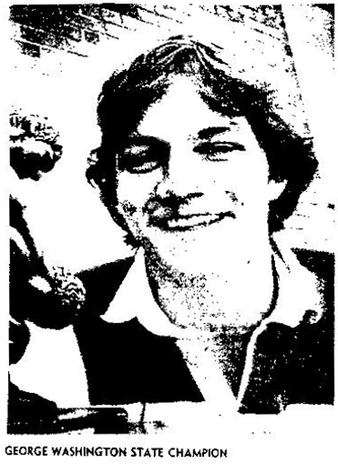
Greg Samples is the son of Rebecca Keeney Samples and husband Amon and the grandson of Albert M. Keeney, of Belle, WV (p.101 in KEENEY RELATIVES)
SAMPLES DOUBLE CHAMPION
By Don Hager
Daily Mail Sports Editor
There have been great high school athletes who were involved in state championships in more than one sport.
The usual combinations include basketball and high jumping, football and sprinting or football and shot-putting.
Greg Samples of Gorge Washington High School may have accomplished a first. He has state championships in the normally unrelated sports of wrestling and tennis.
He won the No. 6 singles tennis championship last spring and on Saturday captured the 155-pound wrestling title.
''Wrestling - by far.'' he answered when asked his favorite sport.
Samples has had great success on the mat, reaching the state tournament all three years on his high school career. He had a 17-13 record as a sophomore, 25-8 as a junior and 35-4 this year.
''Greg has helped this year by our much tougher schedule." Said GW wrestling coach Fritz Wisecup. "We went to New Jersey and wrestled the No. 1 team and they beat us badly, but the kids learned something. We went north (where West Virginia's high school wrestlers powers reside) and wrestled North Marion and Parkersburg. We're going to the Brooke County Classic next year.
"Our schedule hurt Samples' record. He lost a couple of close matches early to strong opponents, but I don't think he was on his back once in 39 matches."
Wisecup praised Samples' strength, especially in his forearms and hands.
Samples, who attended wrestling camps at Clemson University the last two summers, credited his success to the Patriots' hard work.
"We started in the cold fieldhouse in the winter. It was just constant work.'' he said. ''It helped to have better people to wrestle.'' George Washington has an outstanding sophomore class of wrestlers.
GW finished sixth in the state tournament and won its first tourney ever, taking the West Side Invitational. We'll be in the thick of things next year.'' Said Wisecup.
When Samples reached the state finals, he found an old adversary waiting: Jay Martin of Herbert Hoover.
"We wrestled five times - four times during the season and once in the states." Said Samples, who pinned his Kanawha Valley opponent. Samples had three pins and a 14-5 victory in the state tourney.
''Jay is a good wrestler.'' Samples said. ''He goes all out all the time. He's nonstop.''
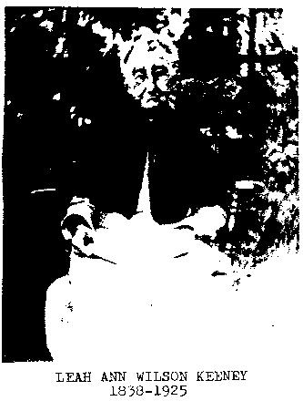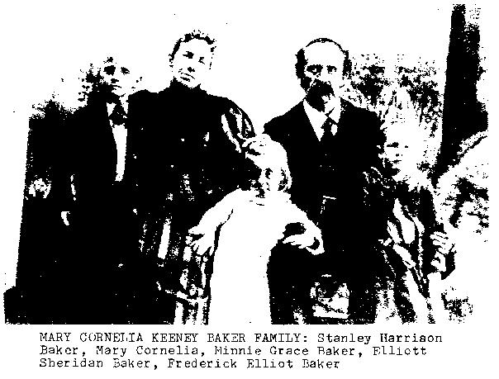
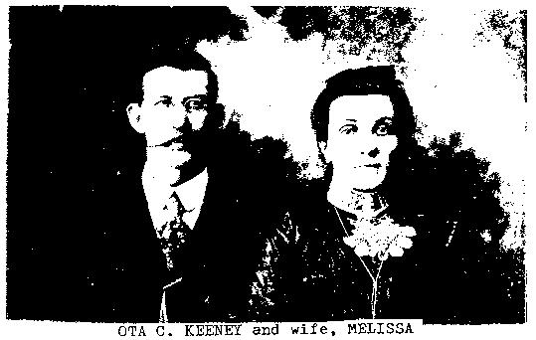
LORENZO MILTON KEENEY / LEAH ANN WI LSON FAMI LY
LORENZO MILTQN KEENEY, b.8-1836 in Greenbrier Co., WV (then VA) was a son of David A. Keeney (6-2-1796, 6-30-1862, buried at Blaker's Mill, near Alderson, WV) and Jane Hunter Keeney (3-24-1804, 3-4-1878), who were married in Monroe Co., WV 4-20-1826. His grandparents were David Keeney (c.1765- 1846, baptized 9-24-1820 at Old Greenbrier Baptist Church by John Alderson) and Peninah Bailes, who were married 4-24-1788 in Greenbrier County (Greenbrier court records)
LORENZO MILTON KEENEY married Leah Ann Wilson, daughter of William & Mary Wilson of Monroe Co. on 12-14-1859 in Greenbrier County. She was born in 1838 and died in 1925 at Chesapeake, Lawrence Co., Ohio. Lorenzo died April 4, 1911 at Chesapeake and is buried beside his wife at Spring Hill Cemetery, Huntington, WV.
There were seven children in this family:
WILLIAM EDGAR KEENEY, b.1860 in Greenbrier Co., d.l-3-l939 at Waterloo, Lawrence Co., 0.
m. Sarah Elizabeth Goff, b.8-5-1859 at Waterloo, d.4-17-1937
EDITH KEENEY MCCLELLAN (daughter)
JOSEPH NEWMAN KEENEY, b.2-5-1862 in Greenbrier, d.12-8-1943 at Vacaville, Solano Co., CA,
m. Gertrude M. Chapman (b.1872 in Monroe Co.), married 12-24-1898 in Monroe Co., WV.
MARY CORNELIA KEENEY, b.3-8-1865 at Waterloo, O., d.2-19-1953 at St. Albans, Kanawha Co., WV;
married 4-11-1888 at her home at Alderson, WV, m. Elliot Sheridan Baker (b.10-7-1865 at Gallipolis, O.,d.8-18-1939 at St. Albans.
Children:
STANLEY HARRISON BAKER (b.1-2-1889, d.6-21-1967) m. Maysel Forrest Eads
PHYLLIS BAKER, m. Monroe Krieger (at) Stillwater, OK.
FREDERICK ELLIOT BAKER (b.3-27-l891, d.3-30-l936) m. Virginia Withrow
MINNIE GRACE BAKER (b.l0-3-l893, d.5-12-l963) m. Vernon Albert Miller
Children:
Mrs. G. Conrad Harris (Staunton, VA),
Grace Miller Keeney, wife of Marvin Keeney, (of) Graves, TX;
Mrs. William P. Waite of Rocky Mount, NC;
Vernon Miller
OTA CLARK KEENEY (b.1867, d. at Bluefield, WV) wife: Melissa -daughter: Mary Nell
JOHN MATTISON KEENEY, b.1-24-1871 in Gallia Co., d.12-18-1951 at Chesapeake, Lawrence Co., O.
m. Myrtle Ann McDaniel, dau. of Wesley & Mary Wiseman McDaniel (b.4-21-1875, d.7-8-1956)
Children:
Leah Grace Keeney, b.l2-l2-l899, died 11-17-1957
Maurice Melville Keeney, b.4-30-l901, d.5-13-l912
Byron I. Keeney, b.12-8-1902, d.10-7-1939
Olive May Keeney, b.9-30-l906
ANNIE BELLE KEENEY, b.2-5-1874 at Symmes Township, O., d.7-31-1964 at Huntington, WV m. Martin Adams 6-16-1920; no children
MYRTLE ROSE KEENEY, b.3-20-1883 at Symmes T'ship, d.7-29-1955 in Huntington, WV m. Harry Gardner Haynes
Daughters: Clyde Carol and Faye Haynes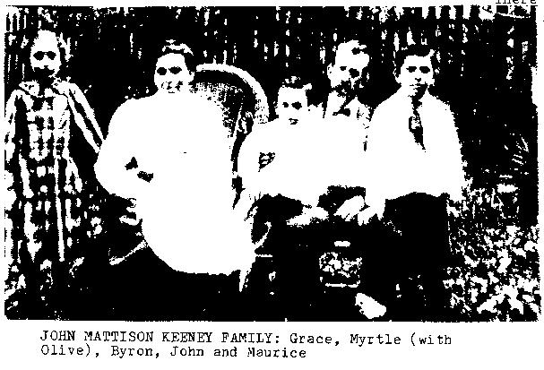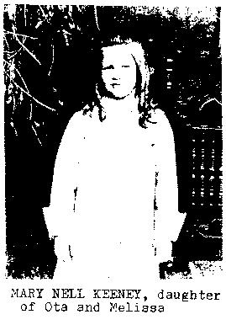
A HISTORY OF RAVENSWOOD AND JACKSON COUNTY
Sectionalism Continues
The year 1847 was a difficult one for some Jackson Countians. With their growing population, a large group of people decided to form another county and succeeded in getting permission to break off a piece of Jackson County. The new county was called Wirt. Other events of that year included the building of a steam sawmill at Murraysville and the arrival in Ravenswood of George W. Long who would later operate the Alpine Hotel. The year of 1847 also saw the formal organizing of the Presbyterian Church in Ravenswood with such families as Koontz, Rice, Wardner, Alexander, Blackmore, and King as members; the first minister to be Installed by the new congregation was the Reverend William Nealy.
Another village was laid out in 1847. Led by Nathan Ong the village of Angerona was put on the map. In a few years it would have a couple of store, a post office, a sawmill, gristmill, a tannery, and a blacksmith shop. Much later it would receive national publicity when silver was discovered there.
With the growing riverboat activity, local businessmen in Ravenswood began to take advantage of the situation by selling food and accommodations. Perhaps most significant and enduring was the Ravenswood House which was constructed at the top of the river bank in 1848 by A. J. Keeney. After Keeney it was operated by John Counts, a son-in-law named Shanks, and W. C. McConnell. Almost overnight the word spread along the river that Ravenswood was a good place to stop on a steamer, if for no other reason than to eat and stay overnight at the Ravenswood House. Later it would receive additional charm when the room numbers from the Emma Graham steamer wrecked in Millwood would be placed above the room entrances. It would achieve an international reputation as a "splendid place to get away from the jittery world'' when it was recommended by Duncan Hines. Other national travel services would also recommend it.
Edgar L. Keeney 6.300 p77
Edgar L. "Bado" Keeney, 79, of East Bank, died April 3, 1987, at home after a short illness.
He was a lifelong resident of East Bank and was a former police chief. He was a disabled army veteran and a former employee of State Road Weight and Measurement Department and Carbon Fuel Co. He was a retired employee of the Buildings Commission.
Surviving: wife, Erma E. Keeney; daughters, Deanie Hicks of Gaithersburg, Md., Lois Shaw of Arlington, VA., Linda Ellis of Chesapeake; son, William E. of East Bank; stepmother, Mrs. Ruby Keeney of Chesapeake; sister, Reba Mooney and Alma Adkins, both of Chesapeake; brother. James of Florida; 10 grandchildren; six great-grandchildren.
Miss Clarice Hutsenpiller
PEARISBURG, Va. - Miss. Clarice L. Hutsenpiller, 75, of Pearisburg, formerly of Grassy Meadows, W Va., died April 21, 1987, at Gales Memorial Hospital, Pearisburg, after a short illness.
She was retired from Celanese Corp. of America at Narrows, Va., with 32 years service.
Surviving: brothers, Fred C. Hutsenpiller of Meadow Bridge, W Va., Ray Hutsenpiller of South Charleston, WV., Clayton Hutsenpiller of Smoot, W Va., Gene Hutsenpiller of Hendersonville, Tenn.; sisters, Verena Douglas of Charleston, W Va., Erma Surbaugh of Grassy Meadows.
Service will be 2: p.m. Friday at McCraw Funeral Home, Lewisburg, W Va., with the Rev. Leroy Crane and the Rev. Stewart McMurray officiating. Burial will be in End of The Trail Cemetery, Clintonville, W Va. Friends may call from 2 to 4 p.m. and 7 to 9 p.m. today at the funeral home.
6.478, p.127
David Jackson Keeney (1818-1888), builder of Ravenswood House, was a son of John D. & Rachel Burnett Keeney, who were married 11-30-1812 in Monroe Co., WV (then VA). His wife was Catherine Naomi Counts.
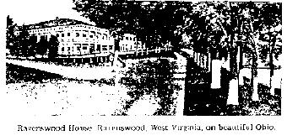
Patrick K. Keeney
NORTHFIELD. Ohio - Patrick K. Keeney, 55, of Northfield, died Sunday in Boone Memorial Hospital, Madison, W Va., after a short illness.
He was an employee of W. E. Plechaty Co. in Cleveland. Ohio. He was a Protestant and a veteran of the Korean War.
Surviving sons, Kelly of Northfield Village, Ohio, Tony of Northfield; sisters, Mrs. Hazel McCormick and Mrs. Grethel Bowe of Prenter, W Va., Mrs. Roxie Curnutte of Cleveland, Mrs. Mary Ann Sutphin of Albuquerque, N M., brothers, Clarence of Racine, W Va., Charles of Carlsbad, N M., Billy and Ronald of Prenter.
Services will be 1:30 p.m. Wednesday in Freewill Baptist Church, Prenter, with the Rev. Troy Howerton officiating. Burial will be in Williams Mountain Cemetery, Williams Mountain, W Va.
Friends may call from 7 to 9 p.m. today at Armstrong Funeral Home, Whitesville, W Va., and one hour prior to service at the church.
7.125 - d.4-1?-87

Montgomery Co., Indiana Marriages*
Book I
Sept. 16, 1828 Hiram Keeney -- Martha Brown
Oct. 7, 1832 Henry Keeney -- Molly H. Hughs
Sept. 18, 1834 Elizabeth Keeney -- Absalom Harrison
Apr. 19, 1836 Jane Keeney -- Jacob Roaminger
Book II
Nov. 27, 1839 Susan Keeney -- Naeman Rominger
Jan. 30, 1840 Nancy A. Keeney -- Samuel McCoy
Sept. 24, 1845 Mary Keeney -- Jacob V. Brown
Nov. 13, 1845 Susan Keeney -- Richard McCafferty
Book III
Feb. 2, l848 Samuel T. Keeney -- Elizabeth Kessler
Feb. 3, 1850 Hiram Keeney -- Bridget Ryan
Sept. 27, 1852 William Keeney -- Mary Penrod
*(source: Montgomery Co., Indiana, Marriages; copied and published by Mrs. Mabe1 Shanklin. Printed by Heritage House, Danville, Illinois.)
Elias Keeney of Willamette Valley
ELIAS KEENEY. May 10, 1846, Elias Keeney left Holt County, Mo., with ox-teams, and, after crossing the plains in about the average time, arrived at his destination three miles east of Brownsville, September 14, of the same year. This early pioneer, who represents the prosperous and successful agriculturist of the west, came to this state with almost no money, his worldly possessions consisting of the clothes he wore. An impression of his life and of his use of opportunity among strangers among whom he came without resources, is best gained by visiting his well equipped and modern farm three miles west of Brownsville. This property became his home a year after coming to Oregon, in 1849, and consists of six hundred and forty acres. Many changes have taken place during these fifty-six years of residence, and from a wilderness in the woods Mr. Keeney has developed a paying and valuable property, and one which has been a source of great satisfaction to its enterprising owner.
A native of Ray County, Mo., Mr. Keeney was born December 18, 1828. His father, John and his mother, Mary Ramsey (Buckhaulter) Keeney, being natives of Tennessee. The parents were early settlers in Ray County, where the father engaged in farming and stock-raising in pre-empted land, and there reared his eight sons and one daughter. He removed to Holt County, Mo., in 1842, but did not long survive his change of location, for his death occurred on his farm in 1845. He was survived by his wife, who came to Oregon on the second trip made by her son, in 1851, and died near Brownsville at the age of eighty-nine years. Among her children were twins, Elias and Ely, who began life upon very unequal footings, for Elias was unusually small - while Ely weighed eleven pounds. As time went on Elias showed the better and stronger constitution, and at the present time is not only much the heavier, but is the largest and strongest in the family.
Owing to the extremely wild conditions in Holt County, Mo., Elias received a limited education, for the schoolhouse was remote and the home duties arduous. To his quiet neighborhood came the cheering news of gold and fertile lands in the west, and though crossing the plains in 1846 was as yet a most hazardous and unusual undertaking, he cheerfully confronted the undertaking, although he had practically nothing with which to start life in the far west. Once established upon the farm which he now owns, he returned to Missouri in 1850, and there married Margaret Jane Hyatt, who died in Oregon in 1861, leaving four children. Of these, Ely is a resident of Phoenix, Ariz.; Rebecca is deceased; Emma is the wife of James McHargue; and John.
The year of his marriage Mr. Keeney again started over the plains, bringing with him his wife, his mother, and all of the children with the exception of one brother and two sisters. Settling on his claim, he lived there until 1891, and then moved into Eugene to educate his children. In 1900, he went back to the farm, and in 1901 located in Brownsville, purchasing a little property on the south side, where he has erected a comfortable home. Some time after the death of his wife he had Lucinda Van Winkle, who was born in Tennessee, and who died in Oregon. Nine children were born of this union, the order of their birth being as follows: George W., deceased; Rhoda, the wife of James Vaugh, a farmer of Halsey, Ore.; James M., of east Oregon; Edward Elias, deceased; Homer J., of Portland; Clarky, deceased; Roy J.; Ilena J., an educator in Shaniko, Wasco county; and one child, who died in infancy. The third marriage of Mr. Keeney, which occurred in 1887, was with Mrs. Matilda Noffsinger, who was born in Missouri, as was also her father, Hiram Lee, a native of Cape Girardeau County. Mr. Noffsinger farmed for many years in Missouri, and crossed the plains in 1863, locating near Cottage Grove, Lane County, where he bought land, and where he died in 1883, at the age of eighty-seven years. Four of his children are 1iving: Martin H.; W.N. of Montana; Thomas H., of Los Angeles, Cal.; and Ida M., an educator of Eugene, Ore. Mr. Keeney is a member of the Methodist Episcopal Church, in which he is an officer, and towards the support of which he is a liberal contributor. He is unquestionably the friend of education, and during his residence on the farm served for many years as school director. He has also served the Republican Party but has never sought official positions or worked for other interests than those of his friends. He has been an interested spectator of the development of his section from a wilderness to the present agricultural and commercial prestige, and has contributed his share towards its larger and better growth. In the early days he had many experiences of a more or less unpleasant nature with the Indians, and in the war of 1848 enlisted in Company C. Fourth Regiment, as a private, under command of Captain Maxon.
Mrs. Grace M. Keeney
Mrs. Grace M. Keeney, 84, of 204 Rensford Star Route, died Oct 25, 1986, in General Division, CAMC, after a short illness.
She was a lifelong resident of Charleston and a member of Perryville Baptist Church, Campbells
Creek.
Surviving: daughter, Mrs, Mary G. Shinn of Charleston; sister, Mrs. Ida Ulbrich of Charleston; four grandchildren; six great-grandchildren
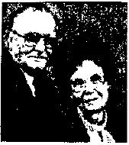
Keeney b. 76, p.19, son of C.F. & Esta Keeney
(Picture Missing)
Mr. And Mrs. Clyde Keeney of Mitchell Heights will celebrate their 50th wedding anniversary with an open house given by their children from 2 to 4 p.m. May 17 in Calvary Baptist Church in Chapmanville. He is retired from Guyan Service. She is the former Alta Thomas. Their children are Gloria Stultz of Mitchell Heights and Tommy of Chapmanville. They have three grandchildren
The Unmentioned
My ancestor, William, had children
All named, and with birth dates and places.
But his wife is not even mentioned;
Of her there are not even traces.
Surely she must have existed,
Was born, was a child and had dreams;
Grew up and learned hot to keep house,
Was a person - but nameless, it seems.
She had parents and, someplace, a home.
Her brothers are listed, no doubt.
But she was only a girl
So not really worth telling about.
She was half of my ancestor's heritage;
Without her he wouldn't have life.
His genes are half hers, but I find
She was only his father's wife.
Once a girl was first "dau", then wife.
She belonged to her father, 'til married,
And then she belonged to her husband,
And beside him, unnamed, she was buried.
How awful to think MY descendants
Might search for a name for me,
Be unable to find my identity,
And wonder just who I might be.
(This poem was authored by Dr. Dorothy Branson, 797 S. James Rd., Apt 14, Columbus, OH 43227)
Printed in "The Second Boat" November 1983)

