Keeney Update

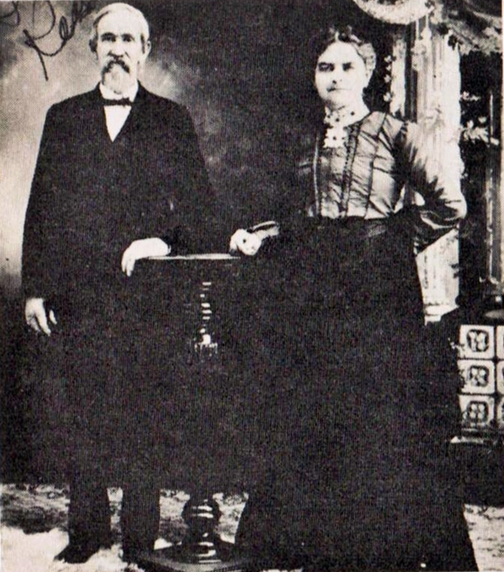VOL II, Number 1 Roscoe C. Keeney, Jr. Dec 1984

Robert H. KEENEY. In noting the practical farmers of Mill Creek Township, the name of Mr. Keeney can by no means be omitted from the list. He is the owner of 120 acres of land, forty of which lie in Nemaha County. His homestead is on section 3, where lie has brought the soil to a good state of cultivation and made the usual improvements suggested to the mind of the thrifty and intelligent farmer. The land is well watered from living springs, and more than ordinarily fertile. It came into possession of the present proprietor soon after his arrival in Kansas, in 1876. He landed here poor in purse from his native State of West Virginia, he having been born in Kanawha County, March 1, 1834.  
 The father of our subject was S. J. Keeney, likewise a native of West Virginia. and who spent his entire life in Kanawha County, engaged as a farmer and lumberman. He died when sixty-there years old. He was an honest, hardworking man, upright in all his transactions, and a consistent believer in the doctrines of the Baptist Church. The mother bore the maiden name of Amelia Gate- wood. She, likewise, was a native of Kanawha County, and died of consumption about 1854, when probably fifty years of age. She was a member of the Methodist Episcopal Church.  
 The subject of this sketch was the eldest child of his parents, whose family included six sons and four daughters. With one exception all lived to mature years, and all but one were married. Eight are still living. Robert H., remained with his father until reaching man's estate, and became interested in the coal mines of his native county, in which he officiated as overseer. Later he was for a time on a section of the Chesapeake & Ohio Railroad. He was careful and conscientious in the discharge of his duties, as well as being a skilled mechanic, and commanded the best of wages. He remained there in the employ of different companies until coming to Kansas, and then turned his attention to agricultural pursuits.  
 Emigrating from his native county to Ohio, Mr. Keeney was married in that State to Miss Julia Kelley. Mrs. Keeney was a native of the same county in West Virginia as her husband and was born in 1839. She is descended from a good family, being the daughter of Jacob M. Kelley, a well-to-do farmer, who came to Kansas in 1873 and acquired 900 acres of land in Mill Creek Township, Pottawatomie County. He died there at his home in 1886, at the age of seventy-six years. He was a man of good business abilities and for some years in his native State was Superintendent of a coal mine. In religious belief he was a Baptist, a good and conscientious man, who sought to fulfill faithfully all life's duties. Mrs. Keeney's mother was, in her girlhood, Miss Elizabeth Carr. She was still living, making her home with her son William, in Mill Creek Township, and is now sixty-six years old. Her life has been such as to draw around her many friends, and she has been for years a consistent member of the Baptist Church.  
 After his marriage Mr. Keeney remained a resident of his native county until the death of his wife, which occurred in January, 1876, at the age of thirty-six year. She was a member of the Baptist Church and the mother of eleven children, two of whom, Elizabeth and Jacob, are deceased. Jacob died when five years old. Elizabeth was married to Albert Rebone, who died leaving four little daughters. Edward married Mrs. Molly Burdette, and they live on a farm in Nemaha County, this State. George and Mack, twins remain at home with their parents. Mellie is the wife of F. H. Bonjour, and they live on n farm in Mill Creek Township. Charles H., Stires J., Sally, Reuben and Lewis are at home with their father. Mr. Keeney, since the death of his wife, has exercised great care in the training and education of his children, to whom he has been a good father. Politically, his sympathies are with the Democratic party. Socially, he belongs to Subordinate Lodge, No. 234, I. O. O. F., in which he has filled all the chairs and Rebecca Lodge, No. 81. Mr. Keeney is a skilled mechanic, and for years was a pilot on the Kanawha and Ohio Rivers.

ROBERT H. KEENEY

with Sarah Guffy Keeney (second wife)

The eldest son of both Michael and Stires J. Keeney was named Robert.  
Michael's.son, Robert, known as "Bull Bob", stayed in Kanawha Valley and is the ancestor of many Keeneys, Whites, Montagues, Baughans and others.  
 Stire's son, Robert H., went to Kansas as a young husband of Julia Kelly, but returned to West Virginia. After Julia's death he again joined the Kelly kin in Pottawatomie County, Kansas. One of his sons later returned to West Virginia, one set out for Colorado and then Oregon and the others stayed in Kansas.  
 The article below was printed 99 years ago in 1885, in a book of Portraits and Biographies of the Governors of Kansas and other well-known Kansans.  
 This should make a lot of Keeneys proud - all the way from Connecticut to Oregon.

**WARREN McDONALD KEENEY** (1862-1932) son of Robert H., with wife, Minnie McLaughlin Keeney in 1928; lived in Colorado 1901-21, Oregon 1921-32 (Picture missing)

**GRACE KEENEY SEHON** (b.1892), **GOLDIE KEENEY** (b.1904, living in Tacoma, WA.), and **MABEL PANSY KEENEY BARTON** (b.1896, living in Salem, OR.) daughters of Warren and Minnie McLaughlin Keeney (1952 picture) (Picture missing)

**JETTA & JACOB KEENEY** born April 19, 1980 are the children of Warren McDonald Keeney III. They are pictured here with their grandfather, Warren McDonald Keeney, Jr., born April 19, 1908 in Bristol, Colorado (Picture missing)  
The first Warren McDonald Keeney was a twin of George T. Keeney (1862-1940), who married Carolyn E. Bias (1862-1940) and is buried at Onaga, Kansas.

SUPPORTERS  
 KEENEY UPDATE friends have sent in $98 since the September issue to keep the UPDATE alive. This pays all the bills for this issue, with a few dollars left over.

***(Supporter names removed per request of R. Keeney)*** KEENEY UPDATE needs wider circulation. Maybe the theme for 1985 should be "Each one find one."  
Limited numbers of back issues are available. These can be mailed out to other Keeney kin. A small donation for postage would be helpful.

# CHRISTMAS CARD LIST

(middle initial K is for Keeney)

|  |  |  |  |
| --- | --- | --- | --- |
| Blanche K. Stotts 85 1605 Elm #216 Marysville, KS 66508 | Elizabeth K. Harmon 78, 904 S. DuPont Ave. Belle, WV 25015 | W. Russell Keeney 75 44O 1/2 W. Palm Drive Arcadia, CA 91006 | Letha K. Bupp 92 905 W. 2nd St. Charleston, WV 25302 |
| Raymond B. Keeney 76 633 Cottonwood Richlands, WA 99352 | Frances K. Kilburn 75 172 Taylor Ave. Vandercook Lake Jackson, MI 49203 | Gertrude B. Keeney 88 1213 Chrysler Drive Wamego, Ks 66547 | Lucille K. Canterbury 78 4804 Fire Creek Rd. Charleston, WV 25313 |
| Sallie B. Keeney 85 1922 Orchard Ave. Belle, WV 25015 | Earl Keeney 79 112 E. 8th St. Onaga, KS 66521 | Helen K. Cline 77 509 Washington Nitro, WV 25143 | Ethel K. Quemon 76 212 Leewood Drive Lexington, KY 40502 |
| Pattie K. Langdon 82 649 Barber St. Paw Paw, MI 49079 | Edgar L. Keeney 76 East Bank, WV 25067 | Ross C. Keeney 89 101 18th St., E. Belle, WV 25015 |  |
| Syble K. Phillips 79 3807 Stratford Pk Dr. Roanoke, VA 24018 | M. B. & Linda Keeney Rt. 5, Box 178 Rolla Missouri 65401 | Ruth K. Knight 77 Cedar Grove, WV 25039 |  |

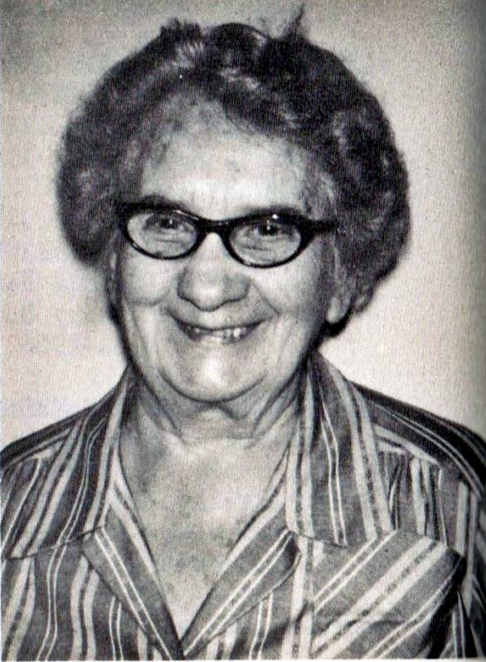5.114 LETHA MAE KEENEY b.4-26-1892; Lives in Charleston  
m. Austin S. Bupp b. 8-31-1880, on 8-11-1912, d. 9-7-1965, wholesale candy salesman for 64 years. Buried Spring Hill Cemetery Charleston.  
6.214 Bernard Keeney Bupp b. 7-27-1914 m. Anita Louise Weaver b. 2-9-1914 on 3-11-1933 - Divorced  
2-60. m. Esther Katherine Greene b. 10-26-1925 on 8-27-1963  
 7.256 Beverly Ann Bupp b. 9-4-1935 m. James W. Eddins

b. 9-13-1933 on 12-16-1955 - Divorced  
 m. Ron Tyree on 7-30-77 - Divorced 1981  
 8.267 Victoria Louise Eddins b. 12-17-1961  
 8.268 Rebecca Lynn Eddins b. 7-13-1963  
 8.269 Katherine Anita Eddins  
 8.270 Melissa Elaine Eddins Triplets born  
 8.271 Jesse Stuart Eddins 4-15-1967 (Eddins Triplets

LETHA MAE KEENEY BUPP

born April 20, 1892, is the last surviving child of the Rev. Thomas T. (Uncle Tom) Keeney and Eliza Ann White Keeney. She is shown here with her husband, Austin Syldester Bupp (1880-1965) at their 50th wedding anniversary is 1962 (Picture missing). The latest picture was taken on Christmas Day 1973.

born in Sarasota, Florida)  
 7.257 Bernard Keeney Bupp, Jr. b. 3-31-1937 m. Nancy

Lee Stone b. 7-20-1942 on 9-1961  
 8.272 Kelley Keeney Bupp b. 2-16-1962  
 8.273 Austin Lee Rupp b. 7-6-1964  
 6.215 Mary Louise Bupp b. 7-8-1921 m. Edward G. Goff b

12-31-1918 on 1-23-1945  
 7.258 Wayne Galin Goff b. 9-21-1946 m. Susan Mopps b. 6-28-1947 on 6-16-1973  
 8.273 A. Sean K. Goff b. 3-10-1969 Adopted  
 8.23 B Leslie Ann Goff b. 9-5-1978  
 6.216 James Prince Bupp b. 5-15-1926 m. June L. Bupp b. 4-29-1926 on 2-7-1947  
 7.259 Stephen Prince Bupp b. 2-2-1949 m. Julia Ellen Larson b. 1-1-1953 on 5-22-1976  
 8.273C Ellen Rachel Bupp b. 2-7-1979  
 8.273D Joanna Taylor Bupp b. 10-22-1980  
 7.260 Hasty Kay Bupp b. 2-2-1952 m. David C. Flinner b. 9-20-1948 on 3-23-1973 Divorced 10-81  
 7.261 Susan Diane Bupp b. 4-3-1955 m. Guy Elliott Gage III b. 4-17-1954 on 6-17-1978  
 8.273E Julie Anne Gage b. 6-30-82

REUNION TIME  
 Several grandchildren of Foster Keeney (1838-1909) and Eliza Gatewood Keeney (1855-1882) met at the 1984 Keeney reunion at Witcher, W.V. All were raised at Cabin Creek, original settlement for the Keeneys.  
Standing is Norman & Ilene Keeney Bass, Lawrence H. Keeney and Joanne Canterbury Braden. Seated are Lucille Keeney Canterbury, Audrey Stanley (Mrs. Lawrence) Keeney, Ethel Keeney Quenon and Elmo Keeney Scott (who was almost left out). Ilene, Lawrence, Lucille and Elmo are children of James T. & Edna Jacobs Keeney. Ethel is a daughter of Theodore & Daisy E. Brewer Keeney.

GREENBRIER , WV

Customers of the Mathews Trading Post - by Harry E. Handley, from Vol. 1, #1, August 1963 issue of the Journal of the Greenbrier Historical Society.  
Continued from August  
List covers period of time of 8 April 1771 to 26 Jan 1773.  
HUFF, Samuel  
HUGARD, James(cr. by 45"genseng)  
HUMPHREYS, James  
HUSTEN, Answid  
HUSTEN, James (Huston)- wool hat - Dec 72/Jan 73  
JARRET, David (Gerrit)(powder, lead, paper of pins)  
JARRETT, James (Gerrit,Jerrit)  
JOHNSON, Francis (1 padlock)  
JOHNSON, James (for John Frazer)  
JOHNSON, William (Antho Cr.) ( 2 pr, men's shoes)  
JOHNSRON, William  
JOANES, William (Jones) (3 1/2 yds. shirten linen)  
JURDEN, James (Jorden) (by 1 cask butter)  
KEENEY, John, Jr. (linen, rum, "shoe bucke")  
KEENEY , John Sr . - by 14 grey deerskins)  
KEENEY, Michael )(10 yds. linen, 1 gill rum)  
KEENEY, Thomas (son to John  
KEENESON, John (powder & Lead, by John Flinn)  
KELLY, Walt.(Walter) - (Almanak; pr. leggins)  
KINCAID, Samuel  
LEWIS B. (Benja) - (by cash butter)  
LEWIS George - (to 1200 nails; 3 pr. sleeve butts)  
LEWIS John, Col. (& wife)(leggons for ''servant man.")

A Few Words…

MAIL BAG  
 The mail bag since September has included interesting tidbits, information and suggestions.  
A letter from Charles R. (Dick) Keeney (son of Flem D., Jr. and Mabel Meadows Keeney), #7.529 in book, includes updates:

**CHARLES R. KEENEY, JR**., b. 2-9-1957, married Nancy Bolin on 7-5-1980; parents of Benjamin Arthur Keeney, b. 4-8-1984  
**LYN CHRISTINE KEENEY**, b. 2-2-1956, married Mark Christian Hostert (b.7-19-1953) an 1-2-1983  
**THOMAS ROBERT KEENEY**, b.11-25-1962 is unmarried and lives in Hermosa Beach, California.  
Lyn lives in Redondo Beach, CA and Chuck in Hanover Park, IL.  
**BEN KEENEY**  
Ethel Quenon writes about a visit from Ben Keeney and his wife Lillian, from Elgin, OK, to her Lexington, KY home. He had moved from Tennessee to Arkansas to Oklahoma. He has Keeney's Mobile Home Park, Route 1, Box 193J, Elgin, OK 73538. Maybe someone can help fit them in with the rest of the family.  
**NEW PROJECTS**: The editor is currently working an exhaustive history of the Ransom Gatewood family, which includes the Michael & Stires Keeney, as well as Foster Keeney families - plus the Murrays, Spauldings, Kellys et al.. helps and hints will be greatly appreciated

Upside-down structure comes down  
 CASCADIA (AP) – Jim Keeney had two choices: Spend $8,000 to comply with county sewer, building and zoning standards, or tear down his "upside-down" cabin along the South Santiam River near Cascadia State Park.  
 He took the sledge hammer option Thursday and his son, Kerry, started knocking the building apart.

C:\Users\David\AppData\Local\Microsoft\Windows\Temporary Internet Files\Content.IE5\I0JFGCCT\MC900104422[1].wmf Keeney, a Cascadia resident who built most of the seven homes county officials say don't comply with building and zoning ordinances, said he may tear down at least one more rather than try to meet the standards.  
 Linn County officials have said they would sue cabin owners who refuse to bring their homes into compliance by the end of August.  
 Keeney said county officials wanted the upside-down house moved away from the river, and told him it needed a more secure foundation and a sewage system. He said those were expensive alterations considering he spent less than $1,000 to build it.  
 Keeney designed and built the upside-down house in an effort to squeeze by county rules requiring a building permit for structures with a certain number of square feet on the ground. The house doesn't have enough ground-floor area to require a permit, according to Keeney, but the second floor flares outward and covers much more area.  
 Letters to property owners from District Attorney Jackson Frost note that "it may be difficult or impractical to correct some or all the violations without removing the structure. However, they (the violations) must be corrected."  
AP photo  
(picture missing) Kerry Keeney, son of owner and builder Jim Keeney tears siding off an illegally built home near Cascadia on Thursday. Keeney bowed to Linn County officials' demands he bring the build to sanitary codes and decided to tear the structure down.

Christmas is the birthday of our Lord. It is the

Hope He brings to us today. It is the time to

Rejoice and the time to be glad.

It is the time for happy memories of friends – and to

Share our blessings with those we hold dear. It is

The time to remember that first holy night when the

Magi followed the star. It is the time for

Angels to sing and shepherds to watch for today a

Saviour was born for all mankind.

God bless you everyone!

Roscoe

BOOK ADDITIONS  
8.215 (page 46) GWENDOLYN JEANNETTE SADLY, m. David Allen Farley (b.4-14-1959) on 6-20-1980; daughter Jennifer Lynn Farley, b.7-5-81  
8.226 (page 47) CHARLES TIMOTHY KEENEY, m. Debbie Graham (b.7-20-51); JONATHAN MATTHEW KEENEY, b.4-27-84  
8.233 (page 47) CHARLIE RAY KEENEY m. Patricia Ann Walker (b.6-1-59, d.5-12-1979 in motorcycle wreck; buried Hoops Memorial Park, Madison  
8.336 (page 62 ) CAMERON STEWART SMITH  
9.124a ZACHARY STEWART SMITH born 1-11-1977 at Parkersburg  
9.124b RUTHIE IRENE SMITH, 6-22-78  
5.35 (page 19) ESTA STOWERS KEENEY, died 1-14-1981; sons: Clyde E., of Logan; Fred and Russell, St. Albans ;  
7.200 (page 44) EDNA WHITE married Willard Jordan as 1-21-1930  
7.635 (page 129) CLYDE W. KEENEY, , d. 2-16-1982 is Huntington; buried at Highland Gardens S.Point, 0H  
9.22 (page 31) DANA EDWARD KEENEY, m. Vera Etta Washington 8-11-1977 at Whitesville, WV