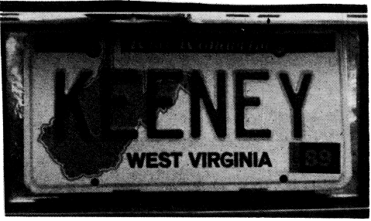
Keeney Update
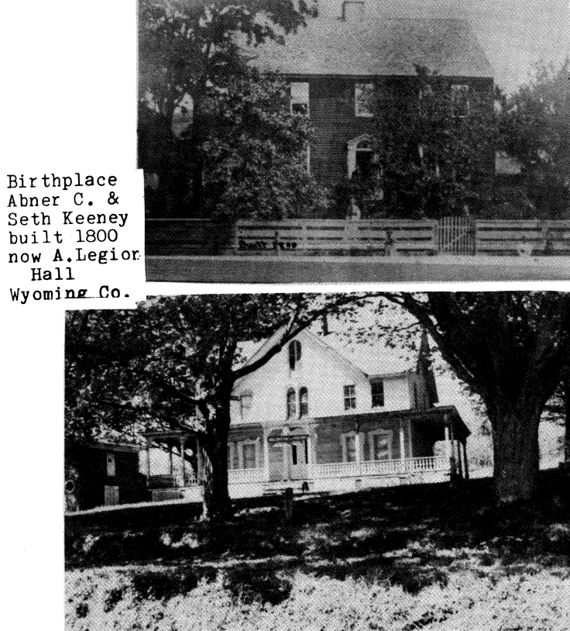
VOL VI, Number 4 Roscoe C. Keeney, Jr. DEC 1989

PENNSYLVANIA
WYOMING CO., PA, KEENEYS
Submitted by Patricia B. Austin

Abner C. Keeney and Seth L. Keeney are among the interesting Keeneys from this area. Their grandfather, Joshua Keeney, came from Connecticut before 1800 to settle in Braintrim Township in what was then Luzerne Co. (now Wyoming Co.). Abner and Seth kept close ties to their family here (see following obits). The house in which they were born is still standing, used as an American Legion Hall. The first picture shows the original house; the second one is what it looks like today after Abner remodeled it. The pictures of the Keeney tombstones were taken in Greenwood Cemetery, Brooklyn, New York in 1983.
(Abner C married Susan Ashby, not Ashley, as his obituary states.)
Abner C. Keeney-CONTRACTOR,
MILLIONAIRE
OBITUARY
Died in Black Walnut, Wyoming County, PA, August 13, 1884, Abner C. Keeney of apoplexy, of Brooklyn, NY aged 58 years. He was the son of Charles and Margaret Overfield Keeney, and grandson of Paul 2nd and Hannah Depew Overfield, and died on the farm where he was born.
His paternal grandfather, Joshua Keeney, was one of the early Connecticut settlers of Wyoming Valley; an acquired title to his land in the Township of Braintrim, one of the seventeen Connecticut towns awarded to actual settlers under the Compromise Acts between the Pennamites and Yankees of 1800. He held the office of Justice of the peace for a long time. It was then a life office, and appointed by the Governor of the State. His house was one of the oldest frame houses between Pittston and Tioga Point, now Athens. It bears the figures “1800” on the side of the top of the chimney. Here he reared his numerous family, and at his death his farm came to the ownership of 2 sons, Simon and Charles, the latter, Abner’s father. Charles Keeney was one of the active, solid men of Braintrim Township, was foremost in all the enterprises of the day, especially such as building churches and schoolhouses. He was an active member of the Methodist Episcopal Church, and his house was always open for the entertainment of preachers and friends. His good wife, a sister of the late Judge Nicholas Overfield, was a helpmeet indeed. Charles Keeney took great interest in advancing the common schools of the neighborhood; he gave his children the best education the times would admit of at home, finishing up at Wyoming Seminary. He died a number of years ago, leaving surviving him two sons, Abner and Seth, and two daughters - Angeline and Ruby.
Abner C., the eldest was born September 2, 1826. His boyhood was spent with his father, at farm work in the summer and attending school during the winter. As soon as he was old enough, he was a teacher in the common schools. Naturally, he had a faculty for governing and controlling men, hence early in his life he became a public contractor. His first work of importance was with his cousin, the late Judge John Passmore of Rome, Bradford County, in work on the Sunbury & Erie Railroad, and in finishing up the North Branch Canal. In 1852-3-4 he was a contractor with his brother Seth in building six miles of the Delaware, Lackawanna & Western Railroad, through the Delaware Water Gap. In 1855-6, he and Seth graded ten miles of the Lackawanna & Bloomsburg Railroad from Kingston to Nanticoke.
From there, they went to Brooklyn, NY, where they engaged in numerous contracts under the City Government, such as constructing water works, water mains, sewers, etc. He was engaged with others in building the Prospect Park Reservoir, the first water work enjoyed by the City of Brooklyn. He was also engaged in mercantile pursuits during the Rebellion. His mercantile firm in New York, of which his brother Seth was a partner, had a large store in Washington, DC, consisting of supplies and suttlers’ stores.
After the close of the Civil War, Mr. Keeney returned to Brooklyn, and with his early friend, William C Kingsley, Esq., engaged in constructing public works. Their first great contract was called the Walabout Improvement, a work that probably cost $1,000,000. They also constructed and built the Hempstead Reservoir, to aid in the supply water for Brooklyn. This work probably cost $1,500,000 and yet the rapid growth of Brooklyn compelled them to seek other sources for water supply.
He was engaged in many of the enterprises of the day he was an original stockholder and director in the Great Brooklyn Bridge that spans East River, connecting New York and Brooklyn, the longest single span bridge in the world, the span being 1600 feet. He was a large stockholder and director in the Brooklyn Eagle, leading paper published in Brooklyn City. He was interested in the Fulton Bank of Brooklyn; Metropolitan Gas Light Co.; a large stockholder and director in the Prudential Insurance Company of Newark, NJ; and many other public institutions. He was one third owner of the Brooklyn Theater, built on the site of the ruins of the one burned down a few years ago, and a member of the New York Corn Exchange.
Mr. and Mrs. Keeney came to Black Walnut, August 8, at their custom each summer to spend the heated term at his farm. Feeling a family pride in owning the old homestead, he had fitted it up in magnificent style, preserving its old-time fashion as far as possible; and spent a few weeks with his sister, Mrs. Ruby Watkins and other esteemed friends of his youth, free from the bustle and care of city life. The Monday following their arrival, his brother Seth paid him a visit; and invited him and his wife to join him the next day for an excursion at Lake Carey. Tuesday, Seth was at the depot at the lake to meet them, when a telegram was placed his hand informing him that Abner, his brother was dead. He was cut down suddenly in the prime of life by apoplexy.
He was of a social disposition, and enjoyed the company of friends. In 1863, he married Miss Susie Ashley [sic] of Jamaica, Long Island, a lady of great personal charms and accomplishments, who with 2 sons and a daughter mourn his irreparable loss.
The funeral services at his residence in Brooklyn, NY on Saturday, Aug. 16, 1884, or witnessed by a large circle of friends and acquaintances present to pay the last sad rites to an esteemed friend. The ceremonies were conducted by the Rev. Spencer S. Roche of St. Mark’s Episcopal Church. His remains were deposited in Greenwood Cemetery, the beautiful city of the dead.
Peter M. Osterhout
Tunkhannock, PA

SETH LEE KEENEY-CONTRACTOR,
MULTIMILLIONAIRE
OBITUARY
Seth L. Keeney, who was born May 26, 1831 at Black Walnut, PA, died at his home 221 Clermont Avenue, Brooklyn, NY, on Thursday, March 13, 1913, nearly 82 years. Mr. Keeney had been ill for two or three months. Two weeks ago, he underwent an operation, and a few days previous to his death was very low. An attack of asthma from which he suffered was complicated by other ailments.
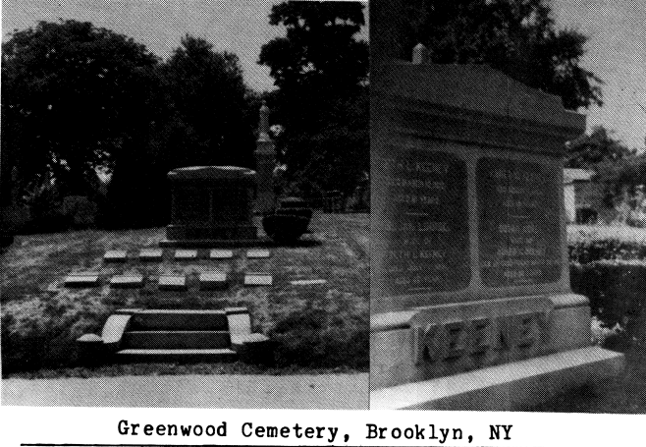
Mr. Keeney was the third son of Charles and Margaret Overfield Keeney of Black Walnut, Wyoming County PA. He had the advantages of a common school; and finished at Wyoming Seminary. When about 21 years of age, he was appointed to the superintendency of a section of the North Branch Canal, which no doubt was the foundation for his remarkable life work in which he amassed a fortune-contracting. His first job, in partnership with his older brother Abner, was building six miles of the Delaware, Lackawanna and Western Railroad through the Delaware Water Gap.
In 1856, he found himself settled in Brooklyn, New York, having gone to that city nearly 60 years ago; and there are many big engineering improvements in that city which he built, among them are; Fifty-ninth Street sewer in Manhattan; Prospect Park Reservoir; a big section of the great sewer system of Brooklyn; a portion of the Brighton Beach Steam Railroad; the Fulton Street and Coney Island Elevated Railroad; and dozens of other important improvements in Brooklyn city.
The years have been many since Mr. Keeney retired from active and personal participation of contract work; but he has been the capitalist behind some large contracting firms. In his active life he had accumulated a fortune, rated at large figures by those acquainted with his affairs. And because of his investments, he had been connected with a large number of financial institutions, as director or trustee.
He was married to Susan Osterhout of Tunkhannock in 1866, who died early, leaving two children: Frank A. Keeney, who has a daughter Ruby -14 years old – Mar., 1913; and Ruby Louise Keeney, who died on her 22nd birthday September 29, 1896. Mrs. Joseph G. Pearson of Black Walnut, who lives on the place where he was born is a niece of the deceased. He was a member of the Simpson Methodist Church.
The remains were laid to rest Sunday afternoon in Greenwood Cemetery at Brooklyn, which preceded the largely attended services at his late home.
Brooklyn Daily Eagle

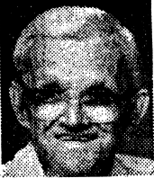
Raymond Keeney
Orlando, Fla. - Raymond Keeney, 75, died September 29, 1989
A resident of Barberton most of his life, he moved to Orlando, Fla. 19 years ago. He retired from PPG Chemical Mines, and was a member of Barberton Senior center.
Preceded in his death by his wife, Mollie, he is survived by son, and daughter-in-law, Vernon and Linda Johnson of Sheffield Lake; son, Ernest Johnson of Orlando, Fla.; daughter and son-in-law, Henda and Don Jones of Barberton; daughter, Rita Johnson; brothers Bob and Alvie; sisters, Doris Keeney and Margaret Huff, all of Chesapeake; numerous friends and relatives.

OH KY WV
JOHN C. KEENEY FAMILY
SOURCES: Information listed here comes from more than ten years of personal research and travel, complicated by the overwhelming number of persons named JOHN KEENEY. Court records and genealogical libraries have been searched in Greenup and Boyd counties, in KY; Scioto, Lawrence, Athens and Hocking counties, in OH, and Fayette and Kanawha counties, WV. Special contributions of information have been made by some Keeney descendants, whose names appear in the following genealogy: Mary Keeney Carey, Carey, OH; Harper N. Price, Milan, IL; Naomi Keeney Pollock, Wellsboro, WV; Dorothy Keeney Higgins, Lancaster, OH; and Carmen Keeney Lyons, Vandalia, OH.
(This corrects and expands pages 14-15 in 2597 KEENEY RELATIVES published in 1978)

7. JOHN C. KEENEY, b. 1793 in Greenbrier Co., VA; son of Moses Keeney (1766-1840) and Francis Harris;
brother of Francis Keeney Brawley, David A. Keeney, Moses Walls Keeney, Michael R. Keeney, William E
Keeney, Foster H Keeney, and Stiers J Keeney; moved to Kanawha County with family about 1810 and spent
his life in the lumbering, barge and river business along the Ohio and Kanawha rivers; listed in 1830 census in
Kanawha Co. and in the 1850 and 1870 censuses at Vernon Township, Scioto Co., Ohio; known as legendary
story teller, a river man with a peg leg
m. Sarah Elizabeth Farney (Fourney), born 1805 in WV, age 45 in Scioto Co. in 1850, 74 in 1880 Boyd
County, KY census, living at Coalton with son, John C., Jr.

CHILDREN: Francis E. Keeney Mortondail, b. 1827
Moses Keeney, b. 1828
John C. Keeney, Jr. b. 1830
Irena Keeney, b. 1832
Catherine Keeney Price, b. 1834
Lucy H. Keeney, b. 1836
William Keeney, b. 1837
George W. Keeney, b. 1839
David Keeney, b. 1845
Alfred Keeney, b. 1849

8. FRANCIS E. KEENEY. b. 1827 in Kanawha Co.
m. James Mortondail 12-17-1846 in Lawrence Co., Ohio
8. MOSES KEENEY, b. 1828 in Kanawha Co., WV; Civil War vet, member of Co. F, 91st Regt., Ohio Vol.
Infantry, with his brother George; buried in Howard Furnace Cemetery, Vernon Township, Scioto Co., OH
m. Rebecca Donahoe on 4-1-1866 in Scioto Co.
8. JOHN C. KEENEY, Jr., b. 2-1830; age 20 in 1850 and 28 in 1860 Scioto Co. censuses, 51 in 1880 in Boyd Co., Ky.; died in 1909 at 77
m. Mary Ann Arthur on 8-7-1853 in Scioto County; 41 in 1880, Boyd Co.; 62 in 1900, Athens, OH
9. SARAH E KEENEY, b. 1855 in Scioto Co.
m. Nathaniel Salyers in 1879 at Trace, Boyd Co., KY
9. JOHN C. KEENEY III, b. 2-1858; moved from Boyd
County, KY to Buchtel, Athens Co. OH after 1880
census; died in Athens Co.
m. Josie Fox (b. 2-1856 in KY) on 5-20-1882
10. EDWARD KEENEY, b. 2-1887 in Athens Co.
10. MYRTLE KEENEY, b. 2-1890 in Athens Co.
9. GRANVILLE KEENEY, b. 8-1861; age 48 in Ward
Township, Hocking Co., Ohio, census
m. Mary J. (Molly) Hardy (b. In WV, both parents born
in England) no children; raised 2 of Ida Keeton’s children
9. MOSES KEENEY, b. 7-1863 in Ohio; d. 5-3-8 1946 at
age 82-9-20 in Athens Co.; buried at Whitmore
Cemetery, Buchtel, Ohio
m. Francis Hammond (b. 7-1868, d. 9-14-1939)
10. NORA MAY KEENEY, b. 5-27-1887, d. 5-2-1951
m. Lewis Wetsel on 6-27-1903
10. AGNES KEENEY SWAIN, b. 9-1888; lived in
Canton, OH; daughter, Ila, worked as a model in
California
10. JERRY KEENEY, daughter, b. 9-1891
10. FREDERICK L. KEENEY, b. 5-9-1893 in Athens
Co. OH; d. 5-9-1964; buried at London, WV
m. Olive Elkins (b. 1899 in Boone Co., WV, d. 9-20-
1985 in Charleston) on 11-17-1922
11. ARTHUR E. KEENEY, b. 3-19-1923 and Buchtel,
OH, b. 9-24-1975 Smithers, WV; no immediate
survivors listed; buried beside his father at London
m. Irene Austin
12. CHARLES L. KEENEY, b. 1942 in Fayette
12. PHYLLIS ANN KEENEY, b. 10-29-1949
11. BETTY KEENEY, died 6-18-1940, b. 1938
11. ROBERT EARL KEENEY, b. 1927 in Fayette Co.
m. Feye Perry (b. 1924) on 10-21-1961
11. HAROLD KEENEY-served in the US Air Force
in England; lives Ft. Walton Beach, FL
11. JOHN DEE KEENEY-lives at Gatewood, WV
11. RICHARD MOSE KEENEY, b. 1-18-1933 at
Longacre, Fayette Co., WV
11. PHYLLIS JOANNE KEENEY, b. 1935; lives in
Cleveland, Ohio
m. Howard Bassen Mills (2nd m.) (b. 1927)
m. Melvin Edward Seacrist 7-27-1950 (1st)
12. CYNTHIA ANN MILLS, b. 12-15-1956
11. ROSE MARIE KEENEY, b. 9-29-1940
m. Herbert Clinton Hudnell (b. 1936) on 4-6-1962 at
Fayetteville; lives in Utah
10. DONALD WILLIAM KEENEY, b. 3-25-1900, died
8-6-1972
m. Lily Wright in 1921; one child: Opal
m. Dallie Elkins, sister of Fred’s wife; one child: Virgie
m. Bessie Alice Wright Wade (b. 3-22-1904, the sister of
his 1st wife; six children
11. OPAL IVENA KEENEY, b. 9-14-1921
m. Elmer Willard Edgell 8-30-1940 in Logan, Ohio; he died 7-16-1966
12. LOLA MAE EDGELL, b. 3-22-1941
m. Gilbert Hornyak 12-15-1961; children: Stanley
V., Laura M. (dec.), Brian G.
12. BRUCE VINCENT EDGELL, b. 11-19-1942
m. Bonnie Westbrook in 1965; children: Bruce V. Jr.,
Jennifer
m. (2) Jane Dickerson 7-3-1977; son: Justin Adam
12. MELINDA RUTH EDGELL, b. 8-1-1951
m. Wayne Paul Clagget 11-14-1970; children:
Thomas W., Crystal C.
11. Virgie Keeney-daughter of Donald and Dallie Elkins Keeney
11. DOROTHY JUNE KEENEY, first child of Donald & Bessie Alice Wright Wade, b. 9-20-1931
m. Homer Frederick Clark (b. 12-15-1931) on 5-6-1950, divorced 1965
m. Leroy Grant Rathburn (b. 6-15-40) to-14-1966
m. Howard Higgins (b. 5-26-1921) on 8-9-1983
12. MARY KATHRYN CLARK, b. 6-13-1951
m. Donald Weaver 6-21-1974 (US Army 1966 to
1986, Mary K. in Army 1969-74); children: Jeffrey
A., Sean Thomas
12. HOMER FREDERICK CLARK, JR., b. 6-16-
1953
m. Linda Linehan on 7-12-1974; daughter, Elizabeth
Ann, b. 8-28-1982
12. THOMAS JOSEPH CLARK, b. 2-28-1956
m. Anna Lou Whittington 8-21-1975; children:
Joseph M. (1976), Joshua Joseph (1980)
12. LORA LEE CLARK, b. 4-8-1962; Air Force E5
since 1981; m. John Richard Ryan, Jr. on 10-24-
1981; children: Jon P., Robert J.
12. DAVID HENRY RATHBURN, b. 6-5-1967
11. DONALD JUNIOR KEENEY, b. 9-20-1931 (twin)
m. Shirley Horn on 7-24-1955; 2 children
m. Mary Alice Stevens on 5-1-1982; 2 children
12. VINCE ALLEN KEENEY, b. 8-1956
m. Ruth Metcalf; children: Dianna R., Deedra
12. DONALD ARTHUR KEENEY, b. 3-25-1958
11. CHARLOTTE ANNE KEENEY, b. 1-23-1936
m. Donald Junior Pickett 2-21-1955 in Indiana
12. JERI LYNN PICKETT, b. 5-17-1956
m. James Lincoln on 6-28-1975; children: James W.
(1978), Brian C. (1981)
(Jeri Lynn m. Charles Martin on 4-4-1988)
12. CRYSTAL DAWN PICKETT, b. 2-24-1968
m. Stephen Alwyn Griffin on 11-15-1986
11. WILLIAM HAROLD KEENEY, b. 11-13-1938, d.
7-29-89
m. Carol Smathers on 9-14-1956
m. Betty J. Murphy on 11-17-1961 (b. 4-4-1939)
12. SHERRY LYNN KEENEY, b. 3-31-1957
m. Charles F. VanCuren; children: Richard O.
(1974), Tamra K. (1976), Charles W.H. (1981)
11. FRANK DERWOOD KEENEY, b. 11-6-1940
m. Linda Joyce Stalling (b. 6-7-44) on 4-1-1960
12. PAMELA LOUISE KEENEY, b. 8-22-1961
m. Michael Randy Simms 8-25-1978; children:
Mandy Marie (1982), Nicole (1982)
12. FRANKLIN WAYNE KEENEY, b. 7-10-1963
12. ROBERT LEROY KEENEY, b. 1-12-1965
12. SHERRY LYNN KEENEY, b. 5-5-73, d. 8-9-73
12. SUSAN RAE KEENEY, b. 7-21-1975
11. ROBERT EDWARD KEENEY, b. 2-16-1951;
lives in FL
m. Mary Frances Johnson (b. 6-3-51) on 3-6-1973
10. OLIVE MARGARET KEENEY, b. 9-13-1904, died
1978; buried at St. John’s Cemetery
m. James Jones; 3 children
m. Dewey Withrow (b. 7-3-1898, d. 3-7-1967)
11. WANDA MARIE JONES, b. 4-21-1924
Married name: Provence; lived in PA
11. EDRA JONES,, b. 11-8-1927, d. 4-4-1972
m. William Focer Reitter (b. 11-8-22, d. 3-25-79)
12. WILLIAM CHRISTOPHER REITTER, b. 9-7-
1946
m. Carolyn Geiger (b. 3-21-1950), 2 children
m. Shirley Larkey (b. 7-15-1942), 1 child
children: Carol Christine (1969), Melissa Jo (1970),
Christine Marie (1978)
12. EDRA ELLAMAE REITTER, b. 11-25-1947
m. Frank Scott Young (b. 2-14-1944), children:
Jeffrey Scott (1966), Melanie Dawn (1973)
12. RICHARD JAMES REITTER, b. 6-29-1949
m. Tina Marie Snyder (b. 8-8-1958), daughter: Molly
Lynne (b. 2-14-1988)
12. GARY LEE REITTER, b. 7-17-1952
m. Katherine Leavitt (b. 11-15-1955)
12. ROBIN ELAINE REITTER, b. 7-8-1955 twin
m. Benjamin Atlilo DiFabbio (b. 8-21-1950)
12. ROBERT ERIC REITTER, b. 7-8-1955 twin
m. Leanne Marie Martin (b. 6-27-1960)
12. PAUL RASKO REITTER, b. 11-24-1967
m. Patricia Ann Calhoun (b. 5-13-1969)
daughter: Edra Marie, b. 8-18-1988
10. WILMA KEENEY, b. 1907 at Buchtel, Athens Co.;
buried at Forest Rose Cemetery, Lancaster, OH; married to
a Valentine, then to a Wright
10. RUTH L. KEENEY, b. 1910 at Buchtel, Ohio
9. IDA KEENEY KEETON, b. 1866; age 14 in 1880 Boyd Co., KY census; mother of several children, including GRACE, b. 1897 in Ohio
9. BENJAMIN FRANKLIN (Frank) KEENEY, b. 1872 in Boyd Co., KY; age 37 in 1910 census, Athens Co., Ohio; died in 1952
m. Margaret Ellen (Ella) Snyder (b. 1868) on 11-3-1897 in Athens Co. (county records)
10. AUGUSTA MAE KEENEY, m. Harry Andrews; lived
in Detroit and Baton Rouge and went to Arizona and
California after husband’s death
11. ALVIN LEE ANDREWS, married and father of
Gary and Denny Andrews
10. EFFIE BLANCH KEENEY, m. Carl Hall; lived in Nelsonville and Athens, OH, then moved to Aqualla, Arizona
11. PAULINE HALL COPE PENNEY-lives in Nevada;
2 daughters from Cope marriage, one son from Penney
marriage
11. CARL HALL, JR.-died at age 16
11. MADONNA HALL, m. Earl Davis; 3 children
10. EVERETT WILFORD KEENEY, b. 1900; moved to
Wellsburg, WV in his youth; lives at McKinleysville,
WV; m. Mary Wilson
11. JAMES KEENEY-lives in Florida
m. Gusta McDaniels
12. JANIE KEENEY 12. CINDY KEENEY
11. DORIS J. KEENEY, m. Richard Fox
12. RICKY FOX 12. BONNIE FOX
10. FREDA KEENEY-died at birth
10. LEONA KEENEY-died at age 1
10. CLIFFORD ELLIS KEENEY, b. 1903
m. Ann Richards; divorced, no children
10. HUBERT KEENEY, b. 1906, d. 1922 at age 16
10. FLOYD KEENEY, b. 9-13-1907; moved from Buchtel, OH to Wellsburg, WV at age 15 to work 48 yrs. for Eagle Mfg. Co.
m. Mae Elizabeth Cumberland (b. 12-22-1909, d. 3-19-1984)
11. NAOMI MARIE KEENEY, b. 9-11-1928
m. Walter F Pollack on 5-6-1949
12. FAYE ELIZABETH POLLOCK
m. Alvin D. Long; CHILDREN: Richard, Raeann,
Bridgett
12. CHERYL LYNN POLLOCK, b. 1952, d. 1966
12. WALTER WILLIAM POLLOCK-adopted in 1968 at
age 7
11. VIRGINIA MARDELL KEENEY, b. 7-9-1930
m. James Kotch
12. DEBRA KOTCH, m. Mark Cippoletti
12. PAMELA KOTCH, m. James Stewart; daughter:
Shannon Mae Stewart
12. KIMBERLY KOTCH
11. FLORENCE MAY KEENEY, b. 9-7-1935; lives at
San Dimas, CA; m. Robert Gallagher
Family: Duke, died age of 2 mos; Doug M, one son;
Shawn, 2 daughters; Tonya Gallagher Lepre-no children
10. EDITH GENEVIEVE KEENEY, b. 1909, d. 1984
m. Jake Wolfe; moved from Wellsboro, WV to Bell Gardens, CA
11. WILLIAM WOLFE, wife: Joan; reside in Weirton,
WV; children: Bill, David, Tim
11. DONNA WOLFE, m. Frank Godina, five children,
divorced; lives at Vernal, UT
11. SHIRLEY WOLFE, m. Charles Bloom; lives in
California
11. RUSSELL WOLFE, m. Marlene Sayre; lives at
Wellsburg, WV
10. MELVIN FRANKLIN KEENEY, b. 1912; lives at Wellsburg, WV; m. Mary Miller
11. FRANK KEENEY; lives in FL after 20 years in the
U.S. Navy
11. CATHERINE RUTH KEENEY BOOTH; 1 child
10. RUTH MYRTLE KEENEY AMOS, b. 1917
11. LOLA JEAN KEENEY, m. James McDaniels
12. DENNY MCDANIELS 12. WENDY MCDANIELS
8. MARY IRENA KEENEY, b. 1832 in Kanawha Co. WV; age 76 in 1910 census, unmarried, living with David and Minerva Keeney in Athens Co., Ohio
8. CATHERINE KEENEY, b. 2-14-1834 in Kanawha Co., d. 9-2-1917 AT Buchtel, OH; buried at Buchtel
m. Stephen S. Price (b. 10-1-1822 in Lawrence Co., KY, d. 9-19-1873), married 10-2-1851 inn Lawrence Co., Ohio-11 children
m. (2) Alexpander Williams-1 child
9. SARAH LOUISA PRICE, b. 9-1-1852 at Argillite, KY,
d. 3-17-1855 in Scioto Co., OH
9. MARTHA JANE PRICE, b. 8-17-1854 in Scioto Co.,
d. 2-9-1940 in Hocking Co., OH
m. Simon Lovett
9. ALICE PRICE, b. 6-4-1857 in Scioto Co. m. Thomas
Gosney
9. ISADORA PRICE, b. 2-19-1859 in Lawrence Co., OH
m. Bernard Smith
9. JOHN RICHARD PRICE, b. 11-4-1860 in Jackson Co.,
OH, d. 5-27-1904 and Vivian, McDowell Co., WV
m. Jenny Latimer on 8-14-1885 in Hocking Co.
9. MARY CATHERINE PRICE, b. 12-23-1862 in Scioto
Co., d. 8-17-1926 at Logan, Hocking Co., Ohio
m. Robert Stewart 8-25-1880 in Hocking Co.
9. ANN ELIZA PRICE, b. 4-1-1865 Scioto Co.
m. Norman Stewart on 4-16-1885
9. ALPHARETTA PRICE, b. 11-16-1867, d. 10-23-1888
m. James Conway on 6-19-1884
9. STEPHEN ROBERT PRICE, b. 11-18-1868 in Scioto,
d. 9-16-1882 in Hocking Co., OH
9. GEORGE HARVEY PRICE, b. 3-28-1871 and Scioto
Co., d. 12-18-1945 at Mansfield, Richland Co. OH
m. Addie M. Zimmerman 1-30-1895 at Athens, OH
9. JAMES HOOD PRICE, b. 3-to-1873, d. 3-to-1873 at
Estill, KY
9. MAUDE WILLIAMS VERMARTEN, b. 5-20-1876,
died 9-21-1943 at Athens, OH; widowed at age 32; 2
children
8. LUCY A. KEENEY, b. 1836 in Kanawha Co., WV; age 14 in 1850 Scioto Co. census; may be the Ruth Ann Keeney, who m. Milton Patton 1-14-1854 (in Scioto Co. marriage records)
8. WILLIAM H. KEENEY, b. 1-1-1840 in Kanwha Co., WV, d. 3-11-1923 in New Boston, OH; buried at Wheelersburg, OH; parents, John Keeney and Elizabeth Farney, list on death certificate issued by Scioto Co.; Greenup Co., KY in 1880
m. Mary Ann Cunningham (b. 5-27-1840 in PA, died 2-27-1885; buried in Greenup Co.), married on 3-11-1863 in Greenup Co., John F. Rate, surety
m. Samantha Pruett (b. 5-12-1861 at Clay Lick, KY; d. 5-26-1929), at home of Henry Pruitt 6-11-1882
9. GEORGE KEENEY, b. 1865-15 in 1880 census of
Greenup Co., living with William and Mary
9. JAMES H. KEENEY, b. 10-1867 in Ohio; 12 in 1880
m. Eliza E. Greene (b. 1880) 12-24-1894 at home of his
uncle, Alfred Keeney; she d. 8-5-1901 and was buried in
Greenup Co., KY
10. CLARK KEENEY, b. 3-24-1896, d. 9-27-1898
10. JEANNE IRENE KEENEY, b. 8-1899 in Boyd Co.
m. Nora Green (1st m.) (b. 6-19-1871, died on 12-16-
1893) son: HUGHEY, b. 4-1892, d. 10-1893
9. WILLIAM S. KEENEY, b. 1874 in KY, 6 in 1880; died at age 92 in Ross Co., OH near Chillicothe
m. Lucy McKenna Wright Defoe (b. 1868) 11-6-1905
9. JOHN R KEENEY, b. 1883 in KY, d. 10-8-1912
m. Pearl Knapp (b. 1887) on 12-28-1904 at Fairmont, WV
9. HENRY HARRISON KEENEY, b. 6-1-1893 at Argillite, KY, d. 4-6-1967
m. Nellie Mae Douglas 6-24-1915 (b. 1897 at Waitland, KY, daughter of Marion and Doris Evans Douglass
10. LESTER EUGENE KEENEY, b. 11-2-1915 at Wolf
Pen, KY; lives in Deland, FL
m. Marjorie Lillian Hardy (b. 1-26-1920) on 11-2-1936 at
Ironton, OH, daughter of Frederick E. & and Emma
Middleton Hardy
11. CARMEN EMMA KEENEY, b. 12-17-1938 New
Boston, Ohio
m. James Aloysius Lyons on 7-4-1957
12. DEBRA LYNN LYONS, b. 3-25-1958
12. LESLIE JEAN LYONS, b. 4-6-1959
12. JAMES ALOYSIUS LYONS III, b. 6-27-1960
11. MARINELL RUTH KEENEY, b. 10-28-1941
m. LeeRoy Davis, Jr. 7-31-1959 in Atlanta
11. BARBARA IRENE KEENEY, b. 8-24-1943
m. Donald Slape 2-22-1963 and Braggs, OK
11. JAMES HARRISON KEENEY, b. 8-6-1947
m. Sheryl Siegler 6-26-65; (2) Linda Loper 6-12-68; (3)
Pauline Smith 11-79; (4) Jesse McPeeke 5-8-82
11. ELIZABETH ANN KEENEY, b. 8-17-1952
m. Robert W. Milling, Jr. (b. Colorado)
10. LLOYD BERWIN KEENEY, b. 9-28-1917 in
Ashland, OH; d. 11-17-1978 at Portsmouth; St. Peter’s
Cemetery, Wheelersburg, OH
m. Marcella Emmett
11. JERALD KEENEY, b. 4-18-1944 at New Boston
married in 1969; wife: Marge
11. MARY ANN KEENEY, b. 4-5-1948
11. MICHAEL KEENEY, b. 4-13-1949
11. RITA KEENEY, b. 11-18-1951 at New Boston
11. JOHN KEENEY, b. 1-2-1953 at New Boston
11. MARK KEENEY, b. 9-7-1954 at New Boston, OH
10. EVELYN MARJORIE (Marge) KEENEY, born on
10-18-1920 at Ironton, OH; d. 12-12-1984 at Columbus;
Forest Lawn Cem., Columbus, OH
m. Gene J Wintersole (died 7-4-1976)
11. GENE ALLEN WINTERSOLE, b. 6-28-1942
m. Brenda Cox on 4-25-1964
11. JANE ULDINE WINTERSOLE, b. 9-25-1947
m. David Winkle on 7-22-1972
10. MABEL RUTH KEENEY, b. 8-10-1922
m. (1) Richard Gaffey; (2) Lowell Pyle (3) Orville
Bratcher (4) Roger Preest
11. JANE CORNELL GAFFEY, b. 11-24-1945
m. Robert Lass in June, 1964
11. TOM DEAN PYLE, b. 6-21-1950; unmarried
11. CHARLES BRATCHER, b. 2-29-1952
m. Renee Williamson in June, 1976
11. ROGER PRIEST, b. 6-7-1955
m. Karen Waldren in 10-1974
10. GEORGE HENRY KEENEY, b. 7-22-1924
m. Darlene Admunson (divorced)
11. TIMOTHY ALLEN KEENEY, b. 6-14-1958
11. DALE DOUGLAS KEENEY, b. 11-7-1960
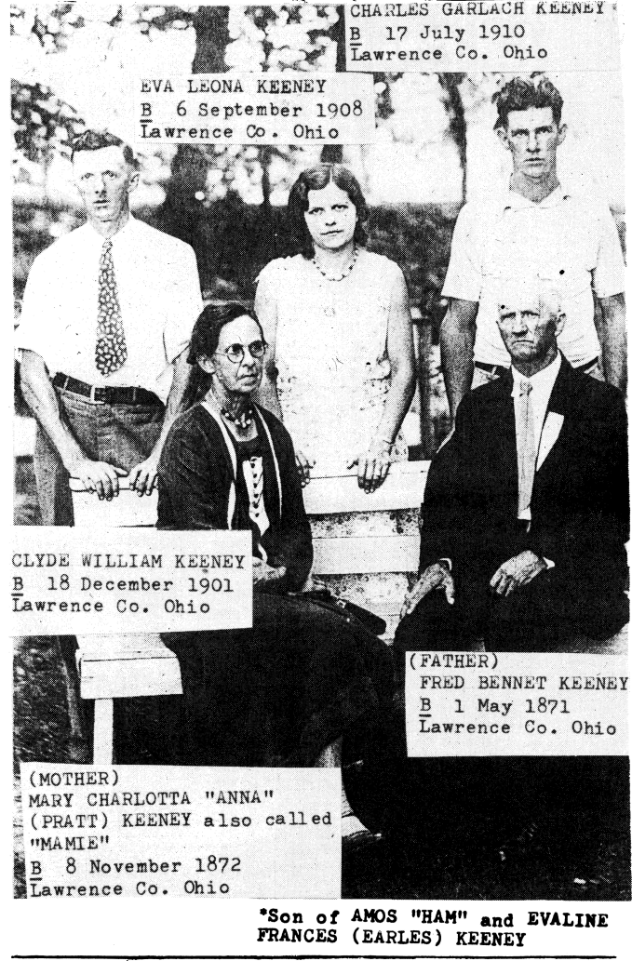
11. LINDA BARTINE KEENEY, b. 5-4-1963
10. DOROTHY JEAN KEENEY, b. 1-12-1933
m. Paul D. Dreaden 11-5-1951 in Indiana
11. PAULA JEAN DREADEN, b. 12-3-1952 in
Baltimore, M.D.; m. Michael Kelley (b. GA) on 3-27-
1969
11. CAROL LEILANI DREADEN, b. 7-1-1954 in
Hawaii; m. Albert Fullmore 3-30-1970
9. EVA KEENEY, b. 7-7-1898 in Greenup Co., KY
m. Warner Adkins (b. 1895 in Elliott Co., KY) on 9-13-
1919 in Boyd Co., KY
9. CHARLES KEENEY, b. 6-21-1902; 7 in 1910 Greenup
Co. census, son of Wm. & Samantha
8. GEORGE W KEENEY, b. c. 1839 in WV; age 11 in Scioto Co., OH census; member of Co. F, 91st Regt., Ohio Vol. Infantry, Civil War; buried in Howard Furnace Cemetery, Vernon Township
m. Romana Burnett on 3-10-1867 in Scioto Co.
8. DAVID KEENEY, b. 1-1845 in Scioto Co., Ohio, first member of the family after leaving WV; age 9 in Scioto 1850 census, 35 in 1880 Boyd Co., KY census, 55 in 1900 Hocking Co., OH census
m. Minerva E. Baker (b. 9-1844 in Greenup Co. KY) on 1-8-1871 in Greenup Co.
9. IRENE F. KEENEY, b. 3-1873 in Boyd Co. KY
9. SARAH E. KEENEY, b. 12-1874 in Boyd Co.
9. JOHN ERVING KEENEY, b. 8-1876 in Boyd Co.
wife: Mary (b. 8-1879 in KY); lived with Erving’s parents
and family, Buchtel, OH in 1910; coal miner
10. ALICE M. KEENEY, b. 5-1899
10. CYNTHIA E., B. 1901
10. MILLIE M. KEENEY, b. 1903
10. MIRIAM S. KEENEY, b. 1905
10. THEODORE D. KEENEY, b. 1906
9. GEORGE A. KEENEY, b. 1880; 2 mos., 1880 census
8. ALFRED KEENEY, b. 10-1849 Scioto Co., d. 1920 in Ashland, Boyd Co., KY; Dixon Cemetery
m. Sarah Alice Imes (b. 10-1855 in Greenup Co. KY, daughter of George Ines; d. 5-2-1931 at age 76 in Lawrence Co., OH
9. LUTETIA KEENEY, m. Charles Chinn
9. MOLLY KEENEY
9. GEORGE W. KEENEY, b. 3-1-1876 at Coallight, KY,
d. 7-6-1949 at Cole Grove, OH; buried at Ashland
Cemetery, Ashland, KY
m. Della Ruth Barber; (b. 10-1880 in Ohio) on 3-16-1899
in Lawrence Co., OH
10. ADAM KEENEY, b. 5-21-1908 at Burnwell, WV, a
mining town; d. 11-1964; Ashland Cemetery
m. Georganna Neville 3-5-1927 in Boyd Co., KY
father: Isaac Neville; 3 children
m. Nellie Conroy-2 children
11. RALPH ADAM KEENEY, b. 1-17-1926 at Ironton,
OH; lives in Columbus
m. Mary Ann Willis (b. 1927) 4-17-1948 at Greenup,
KY; p-Clayton & Dorothy Willis
11. MARY FRANCIS KEENEY MEYERS-Ironton,
OH
11. FRANKLIN D. KEENEY-Ironton, OH
m. Melinda C. Broughton 6-26-1981
11. KAREN ELAINE KEENEY, b. 3-26-1947
11. GEORGE WILLIAM KEENEY, b. 9-1954
10. EVE KEENEY, b. 9-8-1913 at Burnwell, WV
m. (1 )James Turpin; (2) George Fillinger
10. NAOMI RUTH KEENEY, b. 1-27-1917 at Ashland,
KY; d. 5-1-1976 at Columbus, OH; buried beside second
husband at Sunset Cem., W. Jefferson, OH
m. Clifford H. Elkins (b. 1914) on 6-6-1938 in Boyd Co.,
KY; m. (2) Ralph Borland
10. MARY MAGDALENA KEENEY, b. 4-6-1921 at
Ashland, KY
m. Lilford Carey (b. 1916 in Lawrence Co., OH) in 1937
in Boyd Co., KY
11. PATRICK L. CAREY, b. 3-27-1946; lives in
Marion, OH

Convey Your Family Heritage Without Leaving Your Doorstep

Ceda Murdoch
(Ceda Murdoch is the pen name for Marcella Fuller, of Nashville, TN, whose Keeney ancestry traces back to Lawrence Co., OH and old Greenbrier, WV;)

Will your grandchildren know who your grandparents were? Will they ever find the old family cemetery near the clearing where that first cabin stood? Who will tell them?
Great Aunt Lavisa says her great-nieces and nephews will take the old family shoe last was bought at a yard sale. She says she ought to tell someone the importance of family memorabilia.
Many men and women are willing to hand on their family recollections. And many younger relatives express genuine interest in learning about their ancestors.
You may convey the essence of your family heritage without leaving your doorstep. Let’s consider six main features (plus a variety of others).
Record the lineage, of course. Identify the old family photographs. Point out the old homestead, or if it no longer exists, provide a picture or draw a floor plan (or both). Identify family heirlooms and memorabilia. Direct youonger relatives to locate the old family cemetery. And so they will understand how they are all kin, do clarify family relationships.
First the people. Record your family lineage, going back as many generations as you know. Do not be surprised if your information uneven. Sometimes one family line is filled in for five generations (or more), and another shows only two generations.
Give full names whenever you know them, with dates and places of birth, marriage, and death (include place of burial). Indicate an approximate date (around 1894) when that is your best information. Give essential nicknames too. Otherwise, some relatives will never be recognized.
Whether you are typing or writing, consider your first copy a working copy, so you’re free to add a footnote that “Great-grandfather Abe joined the California gold rush, sailing south around the Cape.”
Genealogical charts for recording family lineage are widely available today. Most common is the four-generation chart, beginning with yourself, and tracing back to four sets of great-grandparents. This seems simple enough. Yet often the maiden name of the great-grandmother is unknown. And where was Great-grandfather Abe born? And when?
Throughout this project, as you record your family heritage, you will be seeking a suitable format for your information. Whether you choose to create one ultimate file or a dozen, someone will undoubtedly need further copies. So make your best copy of your lineage (whether typed or written) in black ink on white paper to guarantee clearer photocopies.
Whether your lineage is written on a fan-shaped chart or typed on the block-form genealogical sheets, do remember that your family is relying on you for clarity of information. Make accuracy your primary goal.
Next, search for photographs, setting aside old family pictures that need to be identified. Allow ample time and plenty of space to spread the pictures. You may want to divide these photographs and work first on those you know well.
Write the names on the back of the pictures. A fragile picture may require an envelope, with the names listed on the envelope. Or you may want to arrange your photographs in a family album, with identification clearly marked beside each photo.
Do your school pictures date back to group shots taken in front of a one-room school? How many family members attended there at one time? Is that really Cousin Kermit beside Chester? And if this is your fifth- grade photo, where is the sixth? Would Clarence have it?
Here is Cousin Otha with his oxen. There are several copies in this picture, but never too many. All of Otha’s old playmates remember that team of oxen, and what a wonderful time we had with them!
Arrange those family reunion pictures in chronological sequence, so your identification from the most recent pictures will help you work your way backward in time.
Your identification of photographs may be accomplished in any of several levels. You may simply identify the pictures you know and stop. You may want to send the Carnes photo you cannot identify to a cousin in Illinois. Photographs of neighboring families may be offered to descendants of that family. Some prefer to throw away pictures they cannot identify.
But don’t give up too easily. Perhaps looking at those these pictures again when your brother and sister come to visit may prompt one of you to recall those faces from long ago.
So you’ve retired in Florida, and your grandchildren in Atlanta and southern California have never visited your home community in Ohio. The old house no longer stands, and you have no clear photograph. Yet you can see it all clearly in your mind’s eye.
Describe that homestead, so it will become a real part of their heritage. You might draw a floor plan of the house. Remember to include such details as the bay window in the dining room, the fireplaces, the open loft room, and the pantry off the back porch.
The outbuildings will interest your grandchildren too. In addition to the necessary, list the wash house (where the Delco plant was mounted), the storeroom (where the meat was cured), the coal hod, and garage.
The barn deserves a separate floor plan. Remember how you used to climb from the hay mow into the workshop? Include the stanchions for the cows, the stalls for the horses, and that separate box stall for the cow with a newborn calf.
There you have it-floor plans of the white frame house and the barn, and a list of the outbuildings. Does that really convey the essence of your homestead? Hardly. Describe how your father turned up Indian arrowheads with his plow when you were a child growing up on that farm.
Tell about the flower pit where the jonquils grew, and how your mother had the bulbs replanted and the pit filled in for fear of snakes. It seemed that nature reward her for this caution, as the bulbs multiplied and people came from miles each spring just to see the jonquils.
Now that your daughter has embroidered a tablecloth to highlight the pattern of the family china you gave her, you can rest a little easier about the family’s lasting appreciation of your silver, crystal, and jewelry.
But consider the less familiar family treasures, such as Uncle Ed’s candy hook, Great-grandmother Singer’s cake plate, the old family Bible, packets of letters, and period postcards. Will your grandchildren- or great nieces and nephews-know the special values of these items?
Will they know that your dad’s baby dress-now cherished as a christening gown-was originally an everyday dress, and those tiny tucks were hand sewn by his mother?
While you may find occasion to tell younger relatives about your special memorabilia, that is hardly sufficient. Since you want them to be able convey this information many years hence, do write a brief description of each item. Then photograph these special family pieces. You may choose to arrange these photographs and the descriptions in a small album.
You might try a first-person account for some items. Write about the candy hook as if Uncle Ed were describing it: “I got this candy hook when I was young man. My brothers and I used to travel together on our wagon across Ohio into Indiana, making and selling our candy at county fairs. We’d dib one end of the candy in powdered sugar and the other in alum, and we’d call, ‘Sweet on one end, sour on the other!’ We’d sing that with a kind of rhythm. The candy pulling had a kind of rhythm too, so crowds would gather round to watch, and to buy our candy.”
Along with your photographs and descriptions you might list who has possession of each item.
Don’t overlook times of sorrow, Grandma Murdock’s funeral brought back many of her Wells family, whose names are signed in the funeral register. Laid in that register was a simple sheet of paper with a hand-drawn family tree, including a name no one recognizes. Was Brady an older brother, who died much earlier? Be frank with younger relatives about the unknowns.
Direct them to the old family cemetery. Lest this be a grim occasion, plan to make an outing of it. Unless you know the cemetery is well kept, it’s best they make this trip in winter. You will find less overgrowth, and the gravestones are easier to locate, as well as to read.
For this expedition, select your group with care. Choose one strong person adept with pruners, one person careful with detail (to record the inscriptions), and a driver who can cope with narrow access roads. Suggest they leave space to take along a cousin who lives in the vicinity of cemetery. A local person often knows who owns the adjacent land, and which access road is better.
Mark a road map for them, and give instructions as to the exact location. (Look for a tall cedar tree on the river side of the road about two miles above the fairgrounds.) Lacking a cousin in the vicinity, have them inquire of the neighbors. Most landowners are charitable about allowing access to family cemetery.
Try getting someone in each family of Great-grandfather Stephen Swain’s twelve children to record a family group sheet. A companion to the genealogical chart, the family group sheet provides space to record births, marriages, and death of one husband and wife, and their children. The name and address of the person providing data on each of these sheets will give a link to each family.
So you’re geographically separated from your family? Tape the lore and anecdotes. Together with your lineage charts, carefully identified family photos, sketch and recollections of the homestead, album of memorabilia, directions to the family cemetery, and family group sheets, this tape will enhance your relatives’ sense of family.
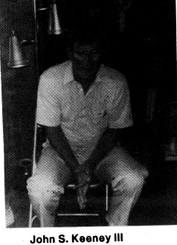
Memorial Obituary
John S Keeney III
John S Keeney III, 63 of 2023 Carson St., died October 28, 1989, in General Division, CAMC, after a short illness.
He was a superintendent for Robert G. Agsten Inc. He was a member of Calvary Baptist Church, where he was a former scoutmaster. He was a member of the carpenters union and Holiday Ramblers. He was a veteran of the Korean War.
Surviving: wife, Muriel Hodges Keeney sons, Scott of Charleston and Gary Wayne of Hurricane; sisters, Trudy Ritchie of Orange, California, Helen Cline of Nitro, Rachel Brubaker of Medina, Ohio, and Mary Susan Crawford of Belle; three granddaughters.
Friends may call from 2 to 4 p.m. and 6 to 8 p.m. Monday at Bartlett-Burdett-Cox Funeral Home

Bernice C. Keeney
Mrs. Bernice C. Keeney, of Malden, died Tuesday, Sept. 26, 1989, in CAMC, General Division, after a short illness.
She was a member of St. John’s United Methodist Church, Rand.
Surviving: son, James L Walker of Charleston; seven grandchildren; ten great-grandchildren; two great- great grandchildren
Friends may call from 7 to 9 p.m. Thursday at Stevens-Grass Funeral Home, Malden

Richard M. Crandall
Richard Matthews Crandall, 58, of 4402 Malden Drive, died Nov. 15, 1989, in Thomas Memorial Hospital after a short illness.
He was a member of Kanawha Salines Presbyterian Church, Malden, NRA, American Association for Advancement of Science and a graduate of Hampden-Sydney College, Hampden-Sydney, VA. He was a retired physicist for C&O Railway lab, Russell Kentucky with 30 years’ service.
Surviving brother, John W. “Jack” of Malden
Service will be 11 a.m. Saturday at the Stevens-Grass Funeral Home, Malden, with the Rev. John Smith officiating. Burial will be in Mountain View Memorial Park, Charleston. Friends may call from 7 to 9 p.m. today at the funeral home.

Clifford B. White
Clifford B. White, 78, of 463 Witcher Rd., Belle, died Aug. 29, 1989, in Memorial Division, CAMC, after a short illness.
He was a retired riverboat captain and owner of White Brothers River Contractors. He was a member of Witcher Baptist Church where he served as Deacon, trustee, Sunday school teacher and past Sunday school superintendent. He was a Mason, Shriner and a member of Scottish Rite Bodies.
Surviving: wife, Marie; brother, Capt. Harry F. of Witcher; sisters, Grace Jarrett and Irene Calameria, both of Houston, Texas; seven grandchildren; four great-grandchildren.
Service will be 2 p.m. Friday at Witcher Baptist Church, with the Rev. Billy Wilburn and the Rev. Glen Matthews officiating. Burial with Masonic rights will be in the White family cemetery, Witcher. Friends may call after 6 p.m. today at Fiddler-Frame Funeral Home, Belle.

JOHN S. III, grandson sake of John S. & Hanna Keeney (p. 104); BERNICE C., w/o David T. (Dave) Keeney (p. 88); Richard Crandall, great-great-grandson of William S. & Francis Keeney Brawley; CLIFFORD WHITE, great-grandson of Robert “Bull Bob” Keeney and Mary J. Bowles Keeney (41)
(page references in 2,597 KEENEY RELATIVES)

SILVER PEN
Charleston, WV DAILY MAIL
◙ The Silver Pen Award for July goes to George M. Keeney of Hurricane, for his defense of the U.S. Supreme Court’s ruling on flag-burning.

Injustice truly desecrates the flag
My most vivid and moving memory of our Stars & Stripes is Joe Rosenthal’s picture of the Marine flag- raising on Iwo Jima. It symbolized the dedication and sacrifices of all men, everywhere for their convictions
As we returned from World War II we were zealously determined to broaden our liberties, fight injustice, make our own “kinder, gentler society,” before the mundane tasks of daily living dimmed our zeal.
The person who burned the flag to attract attention to his cause in defiance of the law sacrificed himself. Most of us do not subscribe to his cause, but many of us offered to sacrifice our lives to protect his right to express himself, regardless of the unpopularity of his beliefs. Civil disobedients whom we admire including Mahatma Gandhi, Martin Luther King, Paul Revere, and the Chinese students.
Too often, it is the injustice, rather than the protest, that desecrates our flag.
As we attempt to burden our society with laws protecting our flag, at what point, in a physical sense, do we draw the line? Are we to protect the tawdry imitation flags that, if set on fire, would melt instead of burn? Cheap trinkets that cheapen our flag? Flag insignia on clothing?
Let the Supreme Court ruling stand. Few of us will burn our flags. When it does occur, the burning could conceivably make our flag and our liberty and our beliefs even more precious to us.
George Keeney
Hurricane

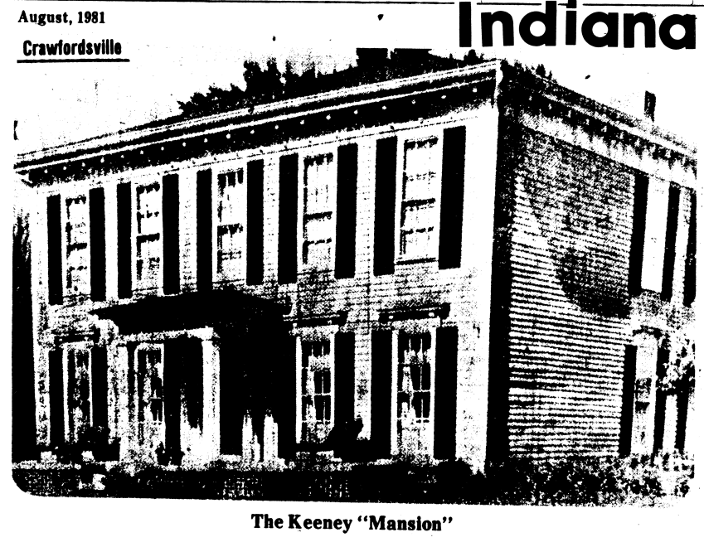
Home built in the early 1860s
The land on which the Keeney home was built originally belonged to the pioneer Dunn family and was sold to James Thompson, the prime mover in the founding of Wabash College. The land was platted as the Thompson Addition on Feb. 14, 1849, and included 14 lots composing the square between Walnut, Perry, West and Elm Streets and two lots north of Perrysville Road.
This addition was enlarged by the inclusion of land to the east of Elm Street. This portion is located on a Union Township map of 1864 with four and a half acres labeled as the Jere Keeney property. The well-known newspaper editor had purchased the land from the Thompson family and sometime in the early 60s erected the “Keeney mansion.”
Like Lane Place, the Keeney home recalls both in exterior and interior design, the southern tradition. The last-named structure, because of its longer hall and better proportioned rooms creates the atmosphere of spaciousness. This home, like its contemporaries, depended on fireplaces which were the heating units for every room. The home was located at the crest of a gently sloping hill and set off by a giant beech and a pair of arrow-straight poplars.
The Highlands at that time was a heavily wooded area. A century ago if a resident ventured beyond the section known as old town, he found wide-spreading stands of private forests, including groves of walnut, poplar, oak, maple, and ash. Walnut was so common, it was used as fuel and the giant ash, poplar and oak trees fell victim to the girdless axe. Log cabins were built of such hardwoods and when the sawmill appeared, the large trees cleared for building lots were used in the construction of homes.
Walnut and poplar that had been felled on the spot were used in the interior construction of the Keeney home. The baseboards and other wood trim were made of poplar while the stairway was created from walnut in a pattern that sets off the generous portions of the hall. A window set above the stairwell afforded a lighting the effect that emphasized the depth of the long passageway.
The house, which resembles the original executive mansion of the Confederacy located in Montgomery, Ala., faces the west with the front and back parlor on the south and a music room and dining room on the north. While the windows of these rooms do not have the obvious functional design assigned to some modern picture windows, they do impress the observer as adequate and appropriate features of the building.
The Jeri Keeney reputation for individualism and eccentricity is intentionally or accidentally expressed in the structure for the floor joists run in length rather than the width of the foundation. This departure from the conventional construction methods, however, does not impair the strength of the under pinnings of the joists are made of walnuts and are massive enough to carry the weight of the structure despite the builder’s departure from conventional methods.
The exterior of the home has an entry graced by a small but well-defined Doric portico.
A most attractive feature of the exterior were the green blinds or shutters that made a pleasant contrast to the siding. Today the shutters are brown which are attractive against the beige siding.
At the time of its building, the Keeney Home was a country home. Today the surrounding area still has some of the qualities that justified the name, The Highlands.
Ownership of the popularly known Keeney home has changed several times over the years. In 1952 it was sold to Addington Vance. A Mr. Scott owned it later and made some changes and removed the porch on the north side. When Don Ellingwood owned the property, he added the three-car garage in the back. The home was vacant for about two years and last February, it was purchased by Mrs. Moreland Hudson.
Mrs. Hudson said the nine room mansion now has only one fireplace in operation. No major changes are planned but there is considerable work to be done since it was vacant for a period of time. The home has three-acres of lawn and orchard surrounding it with many trees and bushes.

Past Times
OREGON

By Patricia Hainline

Another Stanard story concerns pioneer Jonathan Keeney, the tough mountain man who settled east of Brownsville, Courtney Creek way. He was helpful to pioneers just arriving in the valley, but his “itchy feet” kept him from settling permanently in the area, and he later went to Vale, where he operated a ferry across the Malheur River.
Let’s read Stanard’s story: “Although the pioneer proved conclusively that he could defend his home and loved ones, and also carry an aggressive warfare to the Redskins of Eastern and Southern Oregon, it is not a fact that the early day Oregonians were greatly in love with military life. The typical early settler wanted to get the war over and done with, that he could return to his home and take up things where he left them off.
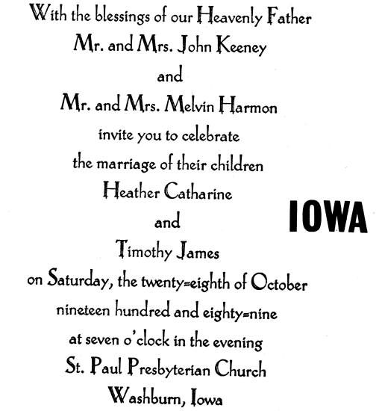
“In what rough and ready fashion Capt. Jonathan Keeney from Linn county interpreted orders from his superiors during the Rogue river war may be seen from a historian’s report as follows: Captain Keeney’s company, amid the winter’s rain and mud, in the damp and growing to resemble greyhounds in figure, Keeney received orders to take the horses to grass and recruit them up for the spring campaign. Captain Keeney observed that he knew of some right good grass in Linn county, and he ordered his company home. This was not construed as desertion, and the Linn County boys proved their full fidelity some months later.’
“But the whole truth is not to be found in the above version, Keeney’s ‘boys’ returned to the war in 1856, but the redoubtable Jonathan did not lead them. James Blakely was given command that year while it appears that Keeney went to the Yakima war. Whether he was ousted, or of his own volition, resigned his command it is not known.”

PATRONS
grateful thanks to the Keeney clan members attributed to payment for this issue: $20 each-Ethel K. Quenon, Lexington, Kentucky; Carol Keeney Waltz, Cassel, CA; Patricia R. Austin, Laceyville, PA; $25: Kenneth R. Keeney, San Francisco, CA; $15-Mary Ann Keeney, Raleigh, NC; $10-Ruth K. Campbell, Belle, WV; Dorothy J. Higgins, Lancaster, OH; $5-John W. Foulke, Wilton, CT; Conrad Riffle, Clinton, OH

